Denton Community Primary School
Specialist facility consultation

To pupils, parents/carers, staff, governors and stakeholders

East Sussex County Council is proposing to establish a specialist facility at Denton Community Primary School from 1 September 2023. The facility would accommodate up to 8 pupils with Autistic Spectrum Disorder.

Why do we need to establish a specialist facility at Denton Community Primary School?
Local authorities have a statutory duty to ensure there are sufficient good school places for all pupils, including for those with Special Educational Needs and Disabilities (SEND). East Sussex County Council (the local authority)’s SEND forecasts provide clear evidence that we will continue to see an increase in the number of pupils with SEND in the coming years.

The numbers of school aged children and young people aged 4-19 in East Sussex with an Education, Health and Care Plan (EHCP) have been rising steeply in recent years, from 3,126 in 2018-19 to 3,494 in 2021-22, an increase of 12%. In 2021-22, there were also 400 young people aged 19-25 in East Sussex with an EHCP.
In the next four years, the local authority forecasts that overall numbers of school-aged children and young people aged 4-19 with EHCPs will grow by around 15%, to approximately 4,000.

Chart 1: Overall Numbers with EHCPs – Age 4-19 years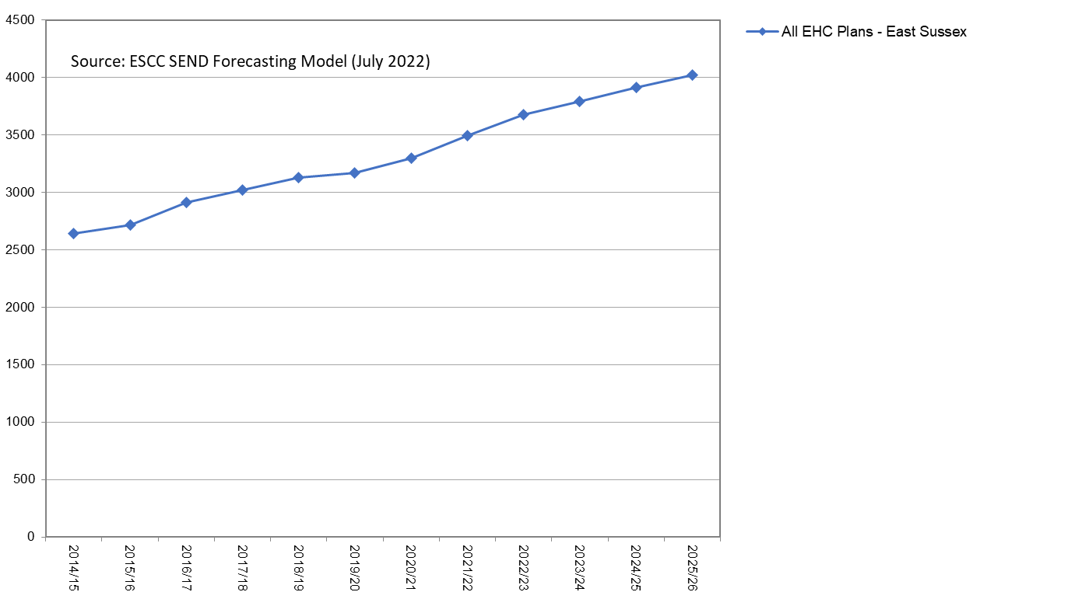

The following chart shows that the group with the biggest increase continues to be Autistic Spectrum Disorder (ASD). Rising ASD pupil numbers reflect increases in diagnosis and an increase in parental and professional awareness of these needs.

Chart 2: EHCPs by Primary Need Group
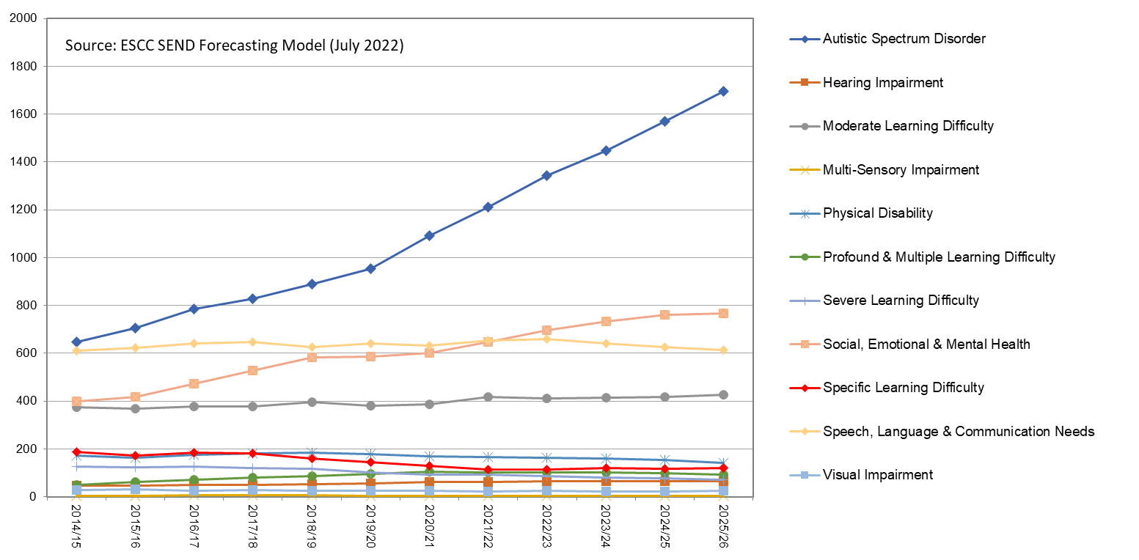

Over the last few years, the local authority has been implementing its strategy to develop more places for SEND pupils. This includes securing new special free schools and the development of more specialist facilities in mainstream schools. Feedback from the local authority’s recent consultation on its SEND place planning strategy agreed that a priority for the local authority should be the creation of specialist provision in mainstream primary schools for pupils with ASD in the Peacehaven and Newhaven area. The local authority would like to establish a facility for up to 8 pupils at Denton Community Primary School in Newhaven to address this.

What are specialist facilities?
Specialist facilities are located within a mainstream school and provide specific support to a limited number of pupils with an EHCP naming a specific primary special educational need. Pupils within the facility are on the roll of the mainstream school and are in addition to the published admission number. The school receives additional funding from the local authority to support the child. Placements are determined by the local authority according to clear criteria and will be drawn from a wider geographical area than the school’s usual catchment.

Specialist facilities promote an ethos of inclusion and help integrate their pupils into the mainstream school for as much of their learning time as their needs allow. Specialist facilities also provide access to a base within the school for more intensive learning and support when required. The expertise of staff within specialist facilities provides significant benefits to the rest of the school and other schools in the local area to support all pupils with a special educational need and create a fully inclusive learning environment.

Pupils in the facility will have their special educational needs reviewed regularly in discussion with parents/carers and professionals to ensure that the facility remains the most appropriate placement to meet these needs.

What will be the impact of the new facility on other pupils in the school?
We would expect the new facility to have a positive impact on provision at the school. Specialist staff would work with pupils in the new facility and also work with teaching staff across the school to develop skills and expertise in responding to special educational needs and creating an inclusive environment.

Will building work be required to establish the new facility and, if so, how will this be funded?
The school and the local authority have identified the existing modular classroom on the site as suitable to accommodate the new facility. Some adaptation work would be required to the building and the local authority would work closely with the school to ensure these are completed in time for the facility to open.

How can I give my views?
The consultation period runs from 13 January to 10 February 2023.

You can give your views by:

- Completing the online survey on the ESCC consultation hub

- Emailing the local authority at: school.consultations@eastsussex.gov.uk

All comments must be received by 10 February 2023, or they cannot be considered.

If you would like a paper copy of the consultation document, please email: school.consultations@eastsussex.gov.uk

What happens next?
Following the consultation period, a report on the outcome of the consultation will be considered by the Lead Member for Education, Inclusion and Special Educational Needs and Disability at a meeting in March 2023. The Lead Member will decide whether to proceed with the proposal. If approved, a statutory notice would be published on the ESCC website, probably in April 2023, which would be followed by a representation period lasting four weeks when further comments or objections to the proposal could be submitted. The Lead Member would consider any responses received during this time before making a final decision on whether to approve the proposal at a meeting likely to be held in June 2023.

Denton Community Primary School
Specialist facility consultation

Our proposal is to establish a specialist facility at Denton Community Primary School from 1 September 2023 for up to 8 pupils with Autistic Spectrum Disorder.

East Sussex County Council would welcome your views on the proposal. The consultation period finishes on 10 February 2022. If you would prefer to complete a paper copy, please print this form, and send it to: School Consultations, Standards and Learning Effectiveness Service, Children’s Services Department, East Sussex County Council, East G, County Hall, St Anne’s Crescent, Lewes BN7 1UE.

- Do you support the proposal to establish a specialist facility at Denton Community Primary School for up to 8 pupils with Autistic Spectrum Disorder?

Yes

No

Undecided

- Please provide any comments below:

- Which of the following best describes you?

Pupil at Denton Community Primary School
Parent / carer of a child at Denton Community Primary School
Member of staff at Denton Community Primary School

Governor at Denton Community Primary School
Member of the local community
Other (please say) ………………………………………………………………………
About you
You don’t have to answer the questions in this section, but it will help us to make sure that everyone is treated fairly and equally if you do. Your information will only be used and reported anonymously to support the consultation, engagement or feedback activity you are taking part in. We will keep your individual information for a period of up to five years and we won’t keep it any longer than is necessary. Please contact school consultations at school.consultations@eastsussex.gov.uk if you would like more information. Read the full privacy notice here: www.eastsussex.gov.uk/privacy/about-you-survey/

4 Are you......? |  | Male |  | Female |  | Prefer not to say

5. How old are you? |  | Tick here if you prefer not to say

6. What is your postcode? |  | Tick here if you prefer not to say

7. Which of these ethnic backgrounds do you feel you belong to? (Your ethnic background is about lots of things like where your family comes from and the language you speak.)
White |  | Mixed |  | Asian or Asian British |  | Black or Black British
 | British |  | White & Black Caribbean |  | Indian |  | Caribbean
 | Irish |  | White & Black African |  | Pakistani |  | African
 | Gypsy/Roma |  | White & Asian |  | Bangladeshi |  | Other*
 | Irish Traveller |  | Other* |  | Other*
 | Other*
 |  |  | Arab |  | Chinese |  | Prefer not to say
*Other Ethnic Group If your ethnic group was not specified in the list, please describe your ethnic group:

8. Would you say that you have a disability? (A disability is if you have a problem or illness to do with your mind or body and it makes it hard for you to do everyday things.)
 | Yes |  | No |  | Prefer not to say

9. If you answered yes to question 8, please tell us what problems you face. You may have more than one type, so please select all that apply. If none of these apply to you, please select other and give brief details.
A disability to do with your body (like problems walking, moving, getting around…)
Problems with hearing or seeing
Having a bad illness for a long time (like cancer, epilepsy, HIV or another serious sickness)
Mental health problems (This is a problem to do with your mind and the way you feel. For example, if you feel upset, worried or angry a lot)
Learning difficulties
I do not want to say
Something else, please specify

10. Do you regard yourself as belonging to any particular religion or belief?
 | Yes |  | No |  | Prefer not to say

11. If you answered yes to question 10 which one?
 | Christian |  | Hindu |  | Muslim |  | Any other religion, please specify
 | Buddhist |  | Jewish |  | Sikh

Thank you for providing this information.

