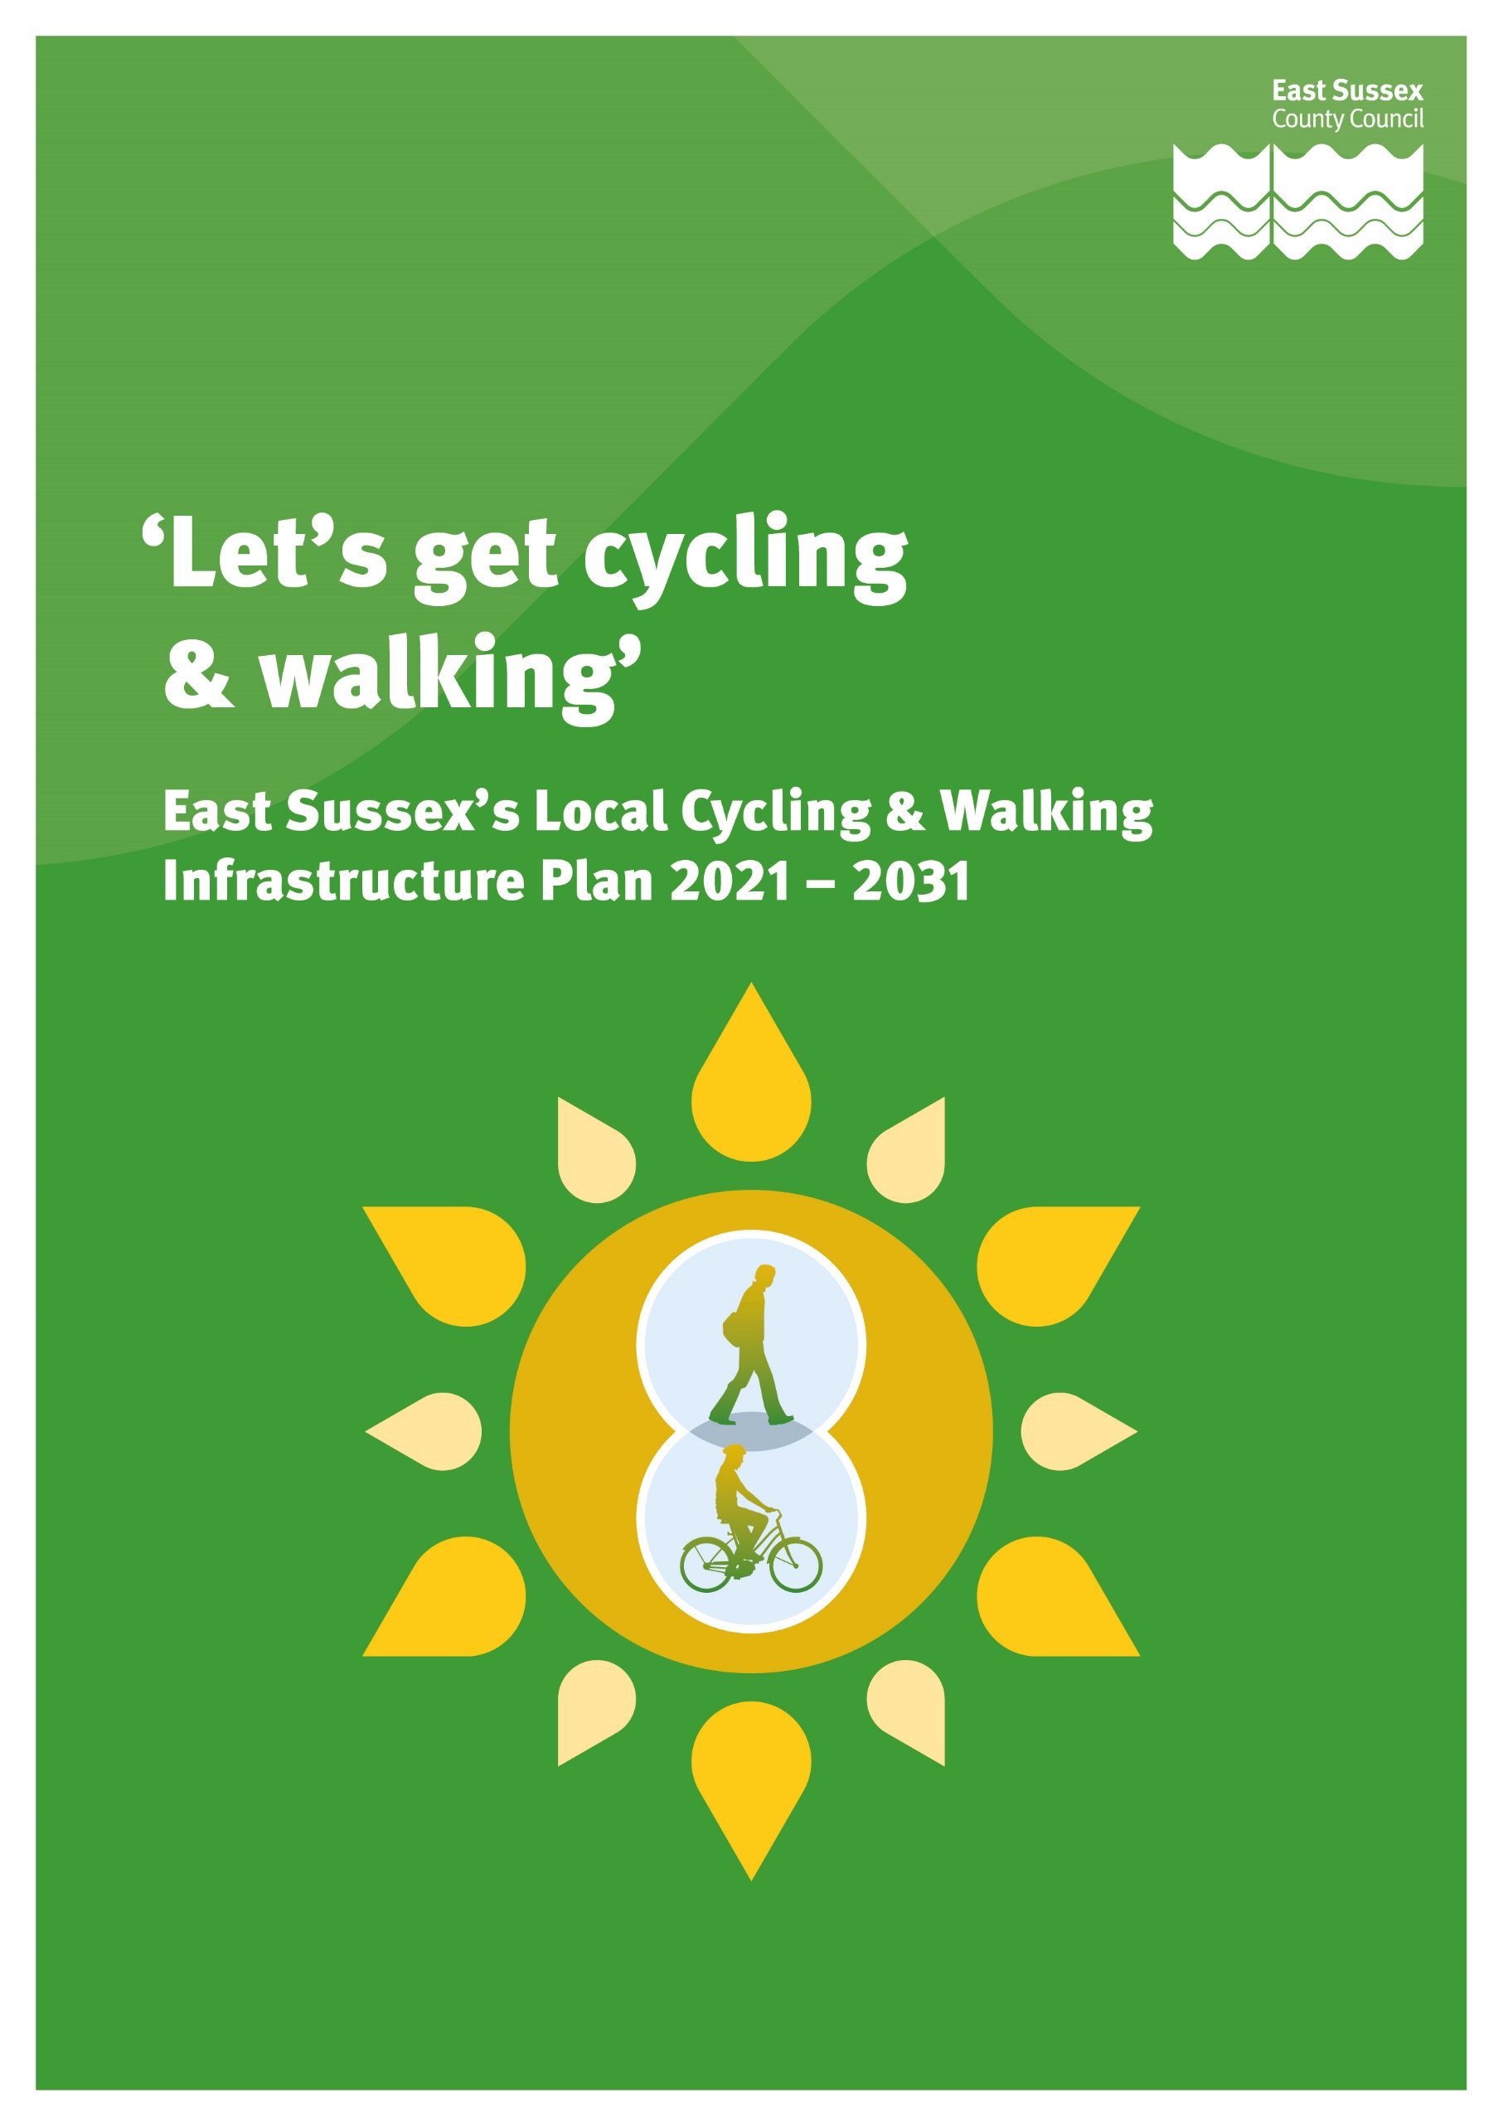
September 2021

Contents
Page Number

- Foreword 4

- What is an LCWIP and how has it been developed? 5 - 6

- Why are we developing an LCIWP? 7 - 11

- Where is the LCWIP focussed? 12 - 13

- What is the LCWIP proposing? 14 - 37

- How will the LCWIP be delivered? 38 - 40

- What next? 40 - 41

Appendices
Appendix A - LCWIP Part 1 Strategy
Appendix B - LCWIP Part 2 Infrastructure Plan
Appendix 1 - ESCC LCWIP Policies
Appendix 2 - Policy Review
Appendix 3 - Equality Impact Assessment
Appendix 4 - Governance
Appendix 5 - Network & Measures Development
Appendix 6 - LCWIP Prioritisation Framework
Appendix 7 - Active Modes Appraisal Tool Outputs
Appendix 8 - East Sussex Active Access for Growth Programme Case Study

Equality Impact Assessment

Having due regard to the Equality Act 2010 has been essential in the development of the LCWIP. This will also be important during the development and delivery of identified cycling and walking infrastructure and initiatives, when measures will be subject to an Equality Impact Assessment (EQiA) at scheme level.

An EQiA) has been undertaken to ensure that the LCWIP does not discriminate, but advances equality for people who are defined as having a protected characteristic.

In order to support the Department for Transport’s ‘Inclusive Transport Strategy’ 2019, the principle of inclusiveness, i.e. to support people with both physical and hidden disabilities, alongside other groups where cycling is often underrepresented, including people of an older age, women, and Black, Asian and minority ethnic (BAME) groups, is a critical element of the plan.

The outcome of the EQiA is outlined in Appendix 3.

1. Foreword

East Sussex County Council’s (ESCC) Local Cycling and Walking Infrastructure Plan (LCWIP) sets out a proposed network of cycling and walking routes and measures in specific areas of the County. Importantly this will sit alongside our wider plans to improve mobility and transport over the next ten years, as outlined in the ESCC Local Transport Plan.

The opportunity to enable more people to walk and cycle has never been so important. The COVID-19 pandemic has had huge an impact on the way people work, socialise and, ultimately, travel. For some this has meant that they have been able to re-think about how they travel and cycling, and walking has become more of an option. We want to maintain this momentum by improving and adding to our existing network, and this LCWIP is a significant step to achieving this.

The benefits associated with more people walking and cycling are evident. We know that it can improve our physical and mental health and wellbeing, through the fun and enjoyment and will directly contribute to moving us towards net zero carbon emissions.

We must also not underestimate the importance that active travel will have in supporting the recovery of the economy. It will achieve this by improving connections and travel options for people to access education, training and employment opportunities, which will contribute to creating a healthy more reliable workforce. Individuals will benefit from financial savings arising from not having a need for vehicular travel, and supporting future clean growth through tourism and place making in housing and employment development. Despite all of these benefits we do understand that for most people, choosing to cycle or walk is only going to be a realistic option if it is convenient and fits easily into their lives

So, PEOPLE are at the centre of this plan. We will focus as much on understanding people’s needs and the PLACES that they want to get to, as this will influence how we can encourage more to cycling and walking. This will also help inform us about the types of measures we need to deliver to help make this happen.

 | Councillor  Keith Glazier  Leader of  East Sussex  County Council |  | Councillor Claire Dowling  Lead Member for Transport and Environment
This plan is a live document. It will continue to evolve, and new schemes and different areas of the county will be considered and included where possible. We cannot deliver this plan alone, so we will be working in partnership with district and borough councils and the business sector alongside our local communities, to help us plan, secure future funding and deliver the measures that people need to enable them to walk and cycle more.

2. What is an LCWIP and how has it been developed?
CYCLING & WALKING NETWORKS
The LCWIP indicates the proposed cycling and walking networks within specific areas of the County. These networks are at an early stage of feasibility and only indicate the potential alignment of a route or a measure and should not be considered as detailed proposals.
EVOLUTIONARY DOCUMENT
The LCWIP will be a ‘live document’ and updated regularly as opportunities to enhance the networks evolve. This will be alongside including measures, which meet with new government guidance.
FUNDING & CONSULTATION
The LCWIP is dependent on ESCC and their partners to secure funding to develop and deliver cycling and walking infrastructure improvements. Once funding is secured for specific schemes these will then be subject to local consultation.

2.1 The Department for Transport (DfT) identified LCWIP’s in their Cycling & Walking Investment Plan, which was published in 2017. Whilst local authorities are not required to develop LCWIPs, these plans are helpful in making it clear where we can develop and deliver improvements to our cycling and walking networks and the funding, we require to deliver these. This will place us and our partners in a much stronger position to secure future funding.

2.2 In the current climate where a resulting impact of COVID – 19 pandemic has seen people wanting to walk and cycle more, the government is placing a greater emphasis on active travel for all or part of people’s daily journeys wherever possible. In August 2020, the DfT published a new Cycling & Walking Strategy, ‘Gear Change’, to accelerate their ambitions to increase levels of active travel. The strategy emphasises the need to re-allocate and prioritise more space for people cycling and walking. To support this new cycle infrastructure design guidance, ‘Local Transport Note (LTN) 1/20’ was published in autumn 2020 which promotes the provision of more segregated routes for cyclists.

2.3 East Sussex’s LCWIP sets out an ambitious network of additional cycling and walking routes and measures integrated with existing cycling and walking infrastructure. This is set alongside the wider plans for the transport network in our Local Transport Plan, and alongside the opportunities to maximise the potential to support new housing and employment space coming forward through district and borough Local Plans and Neighbourhood Plans

2.4 This LCWIP will be focussed on those areas where there are the greatest opportunities to increase levels of cycling and walking, particularly in our key towns across the coastal strip and important market towns There is an emphasis on delivering infrastructure improvements which will support those people who currently do not cycle or walk. At a national level, cycling is underrepresented in people of an older age, women, and Black, Asian and minority ethnic (BAME) and often the barriers which prohibit them from cycling, including concerns around safety and risk, are interrelated.

2.5 Whilst the LCWIP is focussed on delivering cycling and walking routes and measures, we recognise that people will often only change how they travel if it is convenient and easy. By providing training, information and initiatives can help people make this change. Working with our key partners this plan will also develop programmes of cycling and walking training, information and initiatives that link with the infrastructure measures coming forward.

2.6 The LCWIP will be a ten-year document, covering the period from 2021 to 2031, and will identify a prioritised programme of work over the following timeframes:
- short - 0 to 3 years,
- medium – 3 to 5 5 years and
- long term - 5 to 10 years.

2.7 It is important to note that our LCWIP document will be treated as a ‘live document’ and updated regularly as opportunities to enhance the cycling and networks evolve. The document we are currently consulting on is the first version. Future scheme identification and development will consider recent government guidance

2.8 DfT provided guidance on how local authorities should develop an LCWIP and recommended that several different stages of work should be undertaken. ESCC has followed these stages to develop the LCWIP. Figure 1 indicates the work that has been undertaken by ESCC at each stage and the current stage of the plan.

Figure 1 - LCWIP Development Stages
Stage 1 | Determining Scope  Identifying where in the County the LCWIP should be focussed.
Stage 2 | Gathering Information  Reviewing existing data related to cycling and  walking alongside existing policies and strategies.
Stage 3 | Network Planning for cycling  Reviewing existing networks and trips, and  identifying the places that should be connected.
Stage 4 | Network Planning for walking  Reviewing existing networks and identifying the places  that should be connected alongside improvements  for specific areas, including town centres.
Stage 5 | Prioritising Improvements  Undertake a further review, following the consultation on which schemes could come forward in the short, medium and long term.
Stage 6 | Integration and application  Seek approval of the document from ESCC Cabinet in early 2021 and set out a plan on how we will deliver the LCWIP and continue to update the plan. | ← We are here.

3. Why are we developing an LCWIP?

3.1 East Sussex LCWIP will be at the forefront of taking positive action to support several key challenges and opportunities which are facing us internationally, nationally and locally.

Figure 2 – Key Challenges & Opportunities
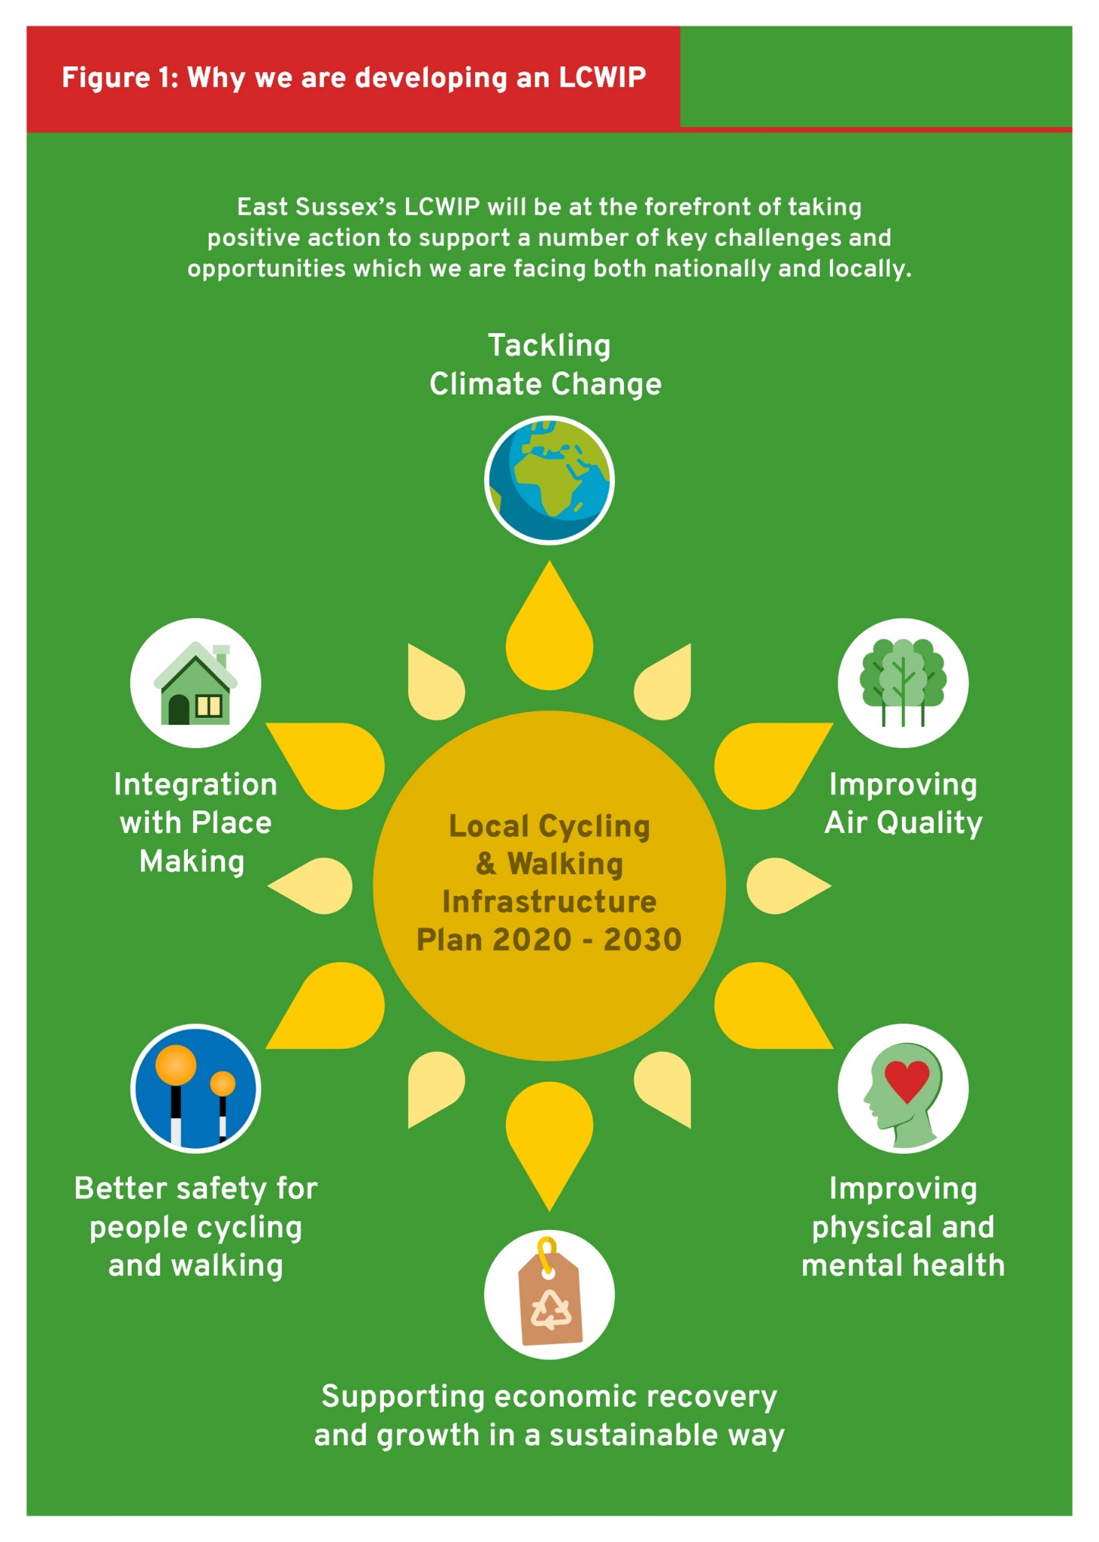
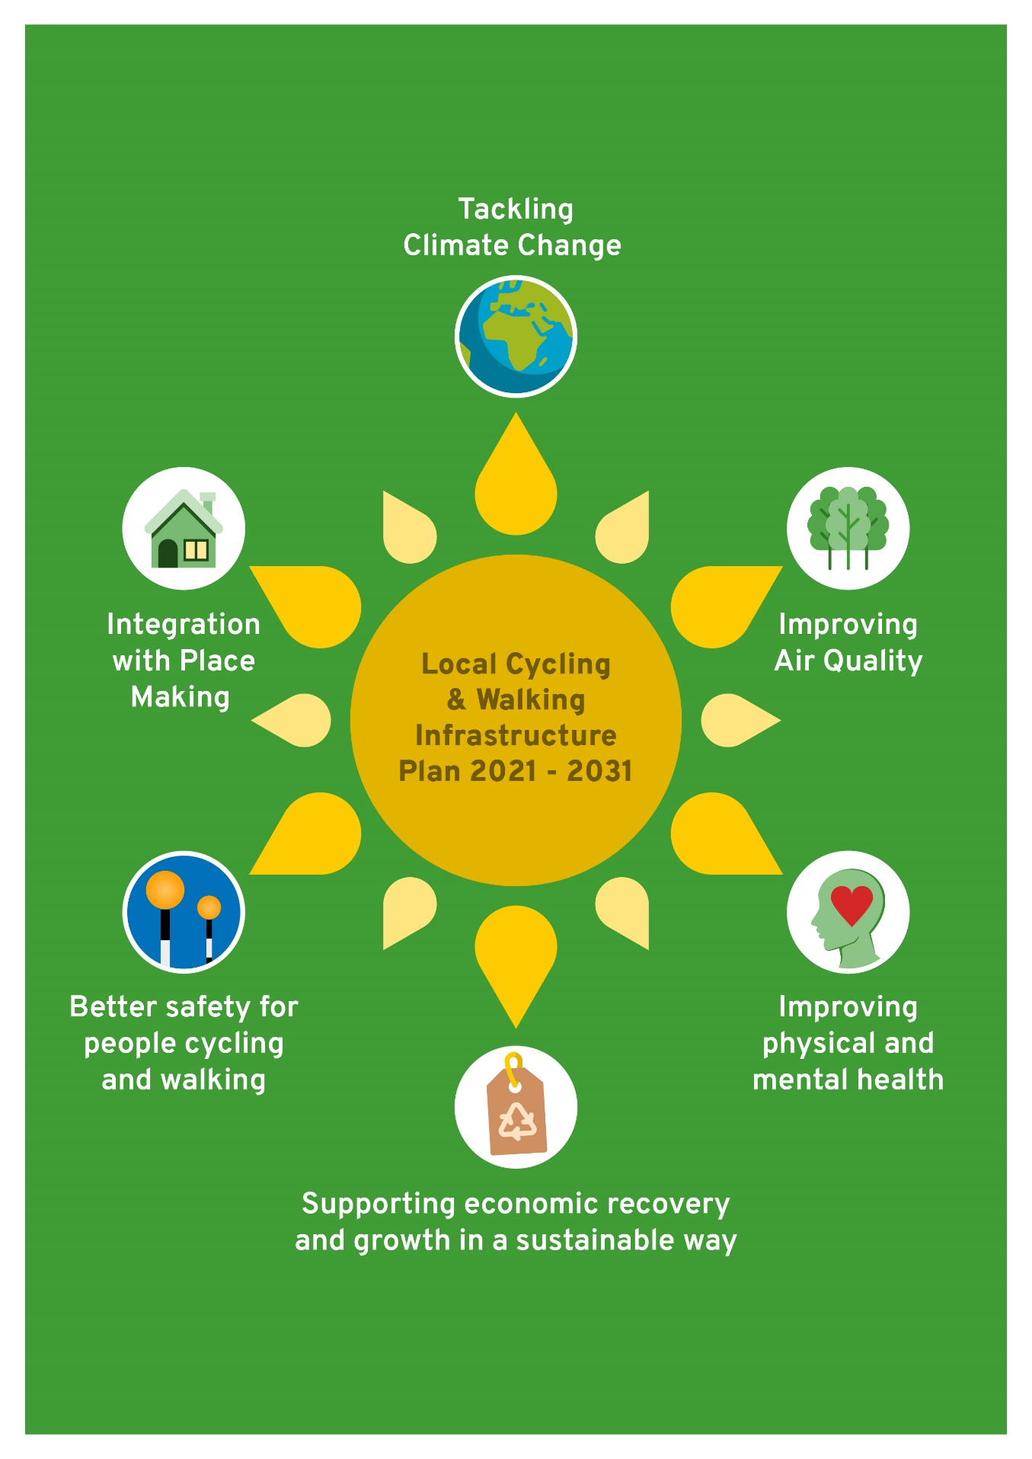

National and Local Evidence
3.2 As outlined in Figure 2 the LCWIP supports several key challenges and opportunities that we are facing at an international, national, and local level. This section provides an overview of what these are, but more information can be found in Appendix 2.
COVID-19 Pandemic
3.3 The current COVID-19 pandemic is altering the way people work, socialise and organise their daily lives with many of these changes likely to continue in the future. Its presence has had a severe impact on the physical and mental health and wellbeing of people, as well as a serious impact on the economy. However, this situation has also raised awareness of the importance of improving physical health and wellbeing, as well as the benefits of cleaner air and quieter streets through less people travelling for work or leisure purposes. The positive feeling and enjoyment people get from active travel should not be underestimated.

3.4 Active travel can help us to be more resilient to illness, and we have an opportunity to develop this plan to get more people fit and healthy by improving our walking and cycling networks, as well as improve confidence and perceptions of safety, to support those that wish to make positive changes to their travel habits.

Tackling Climate Change
3.5 The impacts of Climate Change are evident and in June 2019, the UK Government committed to a target to bring all greenhouse gas emissions to net zero by 2050, compared with the previous target of at least 80% reduction from 1990 levels. With transport accounting for over a third of all carbon dioxide emissions nationally we have an important role to play in helping to reduce these emissions.

3.6 We need to act now, which is why it is important to integrate deliverable measures which align local environmental policy with wider policy agendas.This LCWIP, along with other localised walking and cycling improvement plans across the country, will be instrumental in reducing carbon emissions and supporting the declarations of a climate emergency. Lewes – Eastbourne, Rother & Hastings have set a carbon neutrality target for 2030, and the rest of the County has set it for 2050
Improving Air Quality
3.7 Exposure to poor air quality is not a lifestyle choice, and often affects the health of people who are more vulnerable, including children and people with pre-existing health conditions, as well as those people that live or work nearer to congested roads. Initiatives to encourage more active travel, particularly on the commute to work or to access education, is therefore important. Not only will this reduce congestion from vehicles on the road, thereby lowering emission levels locally, but it will improve the physical health and wellbeing of people locally. This is especially important in our air quality management areas (AQMAs) within Newhaven and Lewes (both of which are managed by Lewes - Eastbourne –Council).

Improving physical and mental health
3.8 Leading an active lifestyle is proven to support both physical and mental health. East Sussex’s LCWIP will align with existing Public Health programmes to improve the cycling and walking environment, and initiatives to help people use active travel for everyday journeys and to access green space. The Plan will embrace Public Health England’s approach of ‘proactive, predictive, and personalised prevention’ to reduce long term health conditions and reduce the burden on our economy. With physical inactivity costing the NHS up to £1bn per annum enabling more people to be physically active will benefit not only the individual but relieve the growing pressures on our healthcare system and the economy.

Supporting economic recovery and growth in a sustainable way
3.9 Most local journeys to work in East Sussex are at or below 5km. This enables cycling and walking for journeys of up to 2km to be an achievable option for all or part of journeys to and from work. The East Sussex LCWIP will be an integral element of economic strategic plans with overall support towards the policy of ‘levelling up’ local economies and reducing social inequalities in terms ofsupporting access to new and existing employment, boosting productivity through a healthier and more active workforce, and broadening people’s horizons with access to education and training.

3.10 The provision of improved cycling and walking infrastructure will be a fundamental element of ‘place making,’ within our high streets, town centres, existing residential areas and as part of new developments. The plan will also look to integrate sustainable transport within regional economic planning focussed on ‘promoting greater inclusion and change by harnessing economic opportunities in coastal communities’ and will focus on areas where there are the greatest opportunities to get more people cycling and walking.

Better safety for people cycling and walking
3.11 It is often the case that people will choose to not cycle (or walk) because they are concerned about safety. Therefore, better safety for people cycling and walking through the provision of well-developed infrastructure combined with training and initiative programmes is an integral element of the East Sussex LCWIP. Utilising existing multi-agency partnerships across the county will help us to support and enable more people to walk and cycle with confidence.

Integration with place making
3.12 There is increased pressure to deliver more housing and employment opportunities in the county. Currently in East Sussex over 2,000 additional homes are proposed to be built per year alongside additional employment workspace. Revisions to Local Plans areconsidering even higher housing targets to meet local needs, and the integration of the LCWIP networks and the review of these are being included as a fundamental element of the wider assessment of mobility and transport and the mitigation measures resulting from this.

3.13 This will ensure that cycling and walking are an achievable way to travel for all or part of journeys from people’s homes to their places of work, and to other key trip attractors such as educational and leisure facilities.

Local Evidence
3.14 The way that people travel is largely determined by whether it convenient and easy and can fit into a person’s daily life. As part of the assessment stage of the LCWIP, with key local partners we reviewed the issues and opportunities related to some of the barriers to cycling and walking in the County alongside data related to people’s health, the economy, and the environment.

Table 1 outlines a summary of this review. This information has been used to help inform the development of the cycling and walking networks. (For further information on the evidence review for each settlement included in the LCWIP, please refer to Appendix B - East Sussex LCWIP – Infrastructure Plan section 2.7 Key Issues & Opportunities – Specific Geographic Areas.)

Table 1 – County wide issues and opportunities
Issues
Limited cycling and walking network on key corridors of movement, within key growth areas.
Limited and inconsistent provision for cycling and walking connecting residential areas and key local trip attractors.
Inconsistent provision for cycling and walking to support inclusive access.
A lack of high-quality segregated routes and suitable (width of) highway space to be able to introduce such routes
Safety issues – volume and speed of traffic
Inconsistent provision connecting new development and the existing cycling and walking network.
Poor maintenance of existing infrastructure for cycling and walking
Town centres dominated by traffic movements, impacting on ambience, safety and air quality.
Poor legibility in key centres.
Limited cycle parking provision at key destinations.
Higher than average levels of obesity at reception and Year 6 children in certain district and boroughs.
Prevalence of mental health issues in certain district and boroughs.
Reluctance to cycle on the road due to fear of conflict with vehicular traffic and lack of education and awareness to help combat this perception, especially in vulnerable groups.
Opportunities
Maintain the momentum of increased active travel since the COVID-19 pandemic through improved infrastructure and training and initiatives.
Distances between residential areas - key centres / business areas - localised trip attractors between 3 - 5km or less, making cycling and walking feasible.
Declaration of a climate emergency – Lewes – Eastbourne, Rother & Hastings 2030, the rest of the County 2050.
Increased growth in housing and employment connected to the existing sustainable transport network.
Focus on town centre and high street regeneration – prioritise cycling, walking, public transport integrated with inclusive access.
Integrate active travel alongside smart mobility measures.
Appetite for active travel from local populations.
Untapped opportunities to promote accessible cycling and walking alongside cultural, leisure and tourist offer.
Continued integration of travel behaviour change programmes and training with the delivery of transport infrastructure projects.
Reduce health issues and related financial impact on the NHS through a more active population.
Cleaner streets and reduction in carbon emissions and congestion through a reduction in car dependency.

4. Where is the LCWIP focussed?

4.1 The government has asked local authorities to focus their LCWIP’s on areas where there are the greatest opportunities to get as many people as possible cycling and walking. This means developing a network that enables people to cycle and walk for everyday short local journeys or as part of longer journeys, whether this be for getting to school, work, shopping trips or for leisure. With the need for housing and employment in the county, networks will also need to support the plans for these.

4.2 Our first version of the LCWIP prioritises areas largely located on the coastal strip and the larger market towns in the County. We anticipate that focussing on these areas will provide us with the greatest opportunities to secure larger scale external funding for cycling and walking infrastructure programmes, especially from central government.

4.3 Focussing on the coastal strip and larger market towns in the first version of the LCWIP does not mean that we do not recognise that there are opportunities for cycling and walking trips within rural areas. We are committed to working with our key local partners, to seek and secure funding from a variety of sources to deliver the infrastructure and measures identified in the LCWIP. Aside from Government funding, potential sources include our Local Transport Plan, District and Borough Councils Local Plans, and Neighbourhoods Plans.

4.4 The County has been subdivided into the following areas, and these are represented in Figure 3 below.

Figure 3 – LCWIP Areas
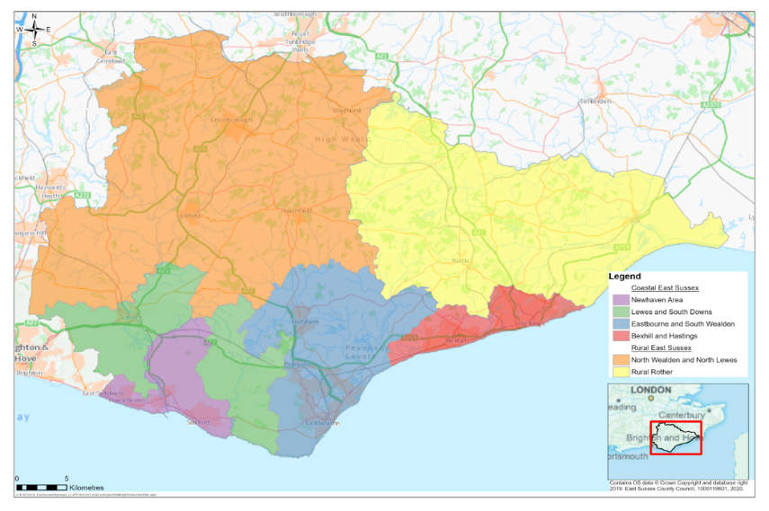
The towns where we have undertaken network development for cycling and walking are listed below in Figure 4.

4.6 Further priority has been assigned to the coastal areas within the County, as they offer the greatest opportunities to increase levels of cycling and walking.

Figure 4- LCWIP Geographic Areas
Coastal East Sussex – Priority LCWIP AREAS

- Newhaven Area
- Newhaven, Peacehaven & Seaford
- Lewes & South Downs National Park
- Lewes
- Eastbourne & South Wealden
- Eastbourne
- Hailsham & Polegate
- Bexhill & Hastings
- Bexhill
- Hastings

Rural East Sussex

- North Wealden & North Lewes area
- Uckfield
- Heathfield
- Crowborough
- Rural Rother
- Battle & Rye

5. What is the LCWIP proposing?

This stage of the LCWIP has required:

- The development of proposed cycle network maps for each of the areas,
- The development of proposed walking network maps for Newhaven, Lewes, Eastbourne, Hailsham, Bexhill and Hastings, and
- A programme of cycling and walking infrastructure improvements.

5.2 The networks were developed using several transport assessment tools, as recommended by the DfT. (For further information on how the networks were developed and the tools which were used, please refer to Appendix B -ESCC LCWIP Infrastructure Plan – stages 3 & 4 network planning.)

Stakeholder engagement
5.3 To ensure that the initial interests of local stakeholders were considered in the preparation of the first version of the LCWIP, the district and borough councils, alongside local cycling, walking and access groups were engaged with the development of the proposed networks.

It is important to understand that the proposed cycling and walking networks in the LCWIP indicate the potential alignment of a route or measure, with an emphasis on demonstrating how they can connect people with the places they may travel for everyday journeys. They do not contain detailed proposals. Once funding is secured for specific schemes these will then be subject to local consultation.

Proposed Cycle Network Maps
5.4 A proposed cycle network map of preferred routes for each priority area has been developed. These maps outline the proposed cycle networks for each settlement, alongside a table with the name of each route that is referred to on the map.

5.5 Whilst network planning for walking has been undertaken for some of the specific geographic areas, as outlined in Appendix B, the cycling network development work also identified improvements on these routes for pedestrians. For example, where a shared cycling and pedestrian route may be the most appropriate option, or where there is an opportunity to either improve or install new dropped kerbs, or where a toucan crossing is proposed.

Coastal East Sussex – Priority LCWIP Areas

Newhaven Area - Newhaven, Peacehaven & Seaford

5.6 In the Newhaven area the preferred network is focussed on having several key routes connecting the three towns, to support the strategic connections on the A259 corridor in the longer term. This is alongside having more localised networks in each town to support with access to schools, shops and local facilities.

Figure 5 - Newhaven area proposed cycle network
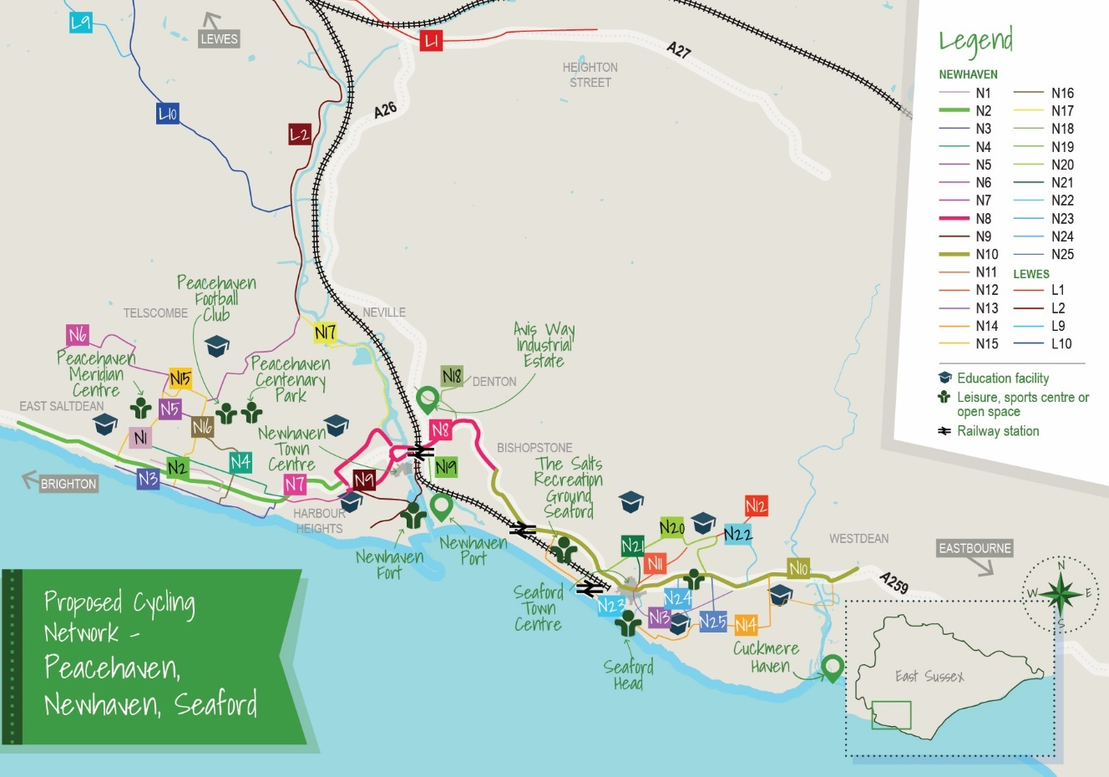

Table 2 – Proposed infrastructure
Table 2  Scheme Number | Scheme Names - Newhaven, Peacehaven & Seaford
N1 | Telscombe Link
N2 | South Coast Road (A259) Peacehaven
N3 | Coastal Path
N4 | Arundel Road NCN2
N5 | Firle Road
N6 | Saltdean – Peacehaven - Southease
N7 | Peacehaven – Newhaven via The Highway
N8 | Newhaven East/West Corridor
N9 | Gibbon Road – Court Farm Road to the Newhaven Swing bridge
N10 | Seaford East/West Corridor
N11 | Seaford Northern Loop
N12 | Alfriston Road – Southdowns
N13 | The Station – A259 via Sutton Avenue
N14 | Marine – Exceat Bridge via Seaford Seafront
N15 | Peacehaven Loop
N16 | Piddinghoe Avenue
N17 | Egrets Way
N18 | A259 to Denton
N19 | Railway Road
N20 | Seaford Northern Loop
N21 | Town Centre – Belgrave Road via Avondale Road and Blatchington Hill
N22 | A259 – Alfriston Road via Walmer Road
N23 | Town Centre – Seafront via Dane Road and The Causeway
N24 | Southdown Road
N25 | Arundel Road
(Further information on the development of this network is in Appendix 5A.)

Lewes & South Downs National Park
Lewes
5.7 It is important that the preferred routes within this area are sympathetic to the historic nature of Lewes and take into consideration the impact of infrastructure within a national park setting. With the highest levels of cycling for work and leisure within this area of the County, the routes are focussed on supporting more strategic links to the existing National Cycle Network, together with links to nearby settlements and supporting access to local facilities.

Figure 6 - Lewes proposed cycle network
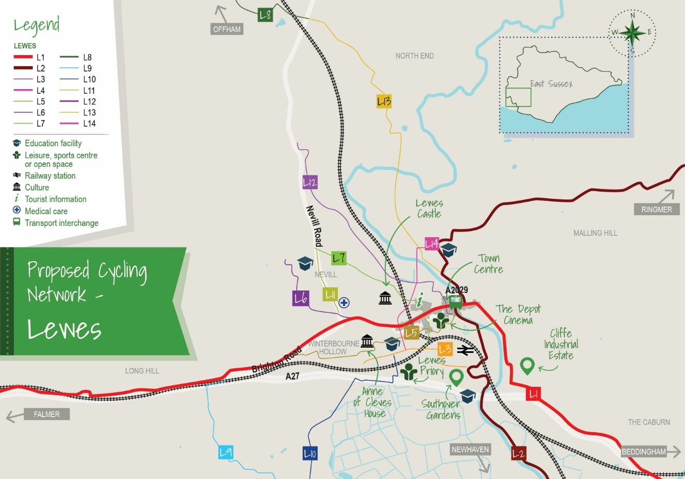

Table 3 – Proposed infrastructure
Table 3  Scheme Number | Scheme Names Lewes
L1 | A27 and Lewes Town Centre
L2 | Ringmer – Southease
L3 | South Downs Way – Lewes
L4 | Montacute Road - Town Centre
L5 | South Downs - Spital Road
L6 | South Downs – Station
L7 | Ditchling – Cooksbridge
L8 | A27 – Swanbourough
L9 | Lewes – Southease
L10 | Nevill - Southover  Cooksbridge - Lewes Riverside
L11 | Offham - Town Centre
L12 | Cooksbridge - Lewes Riverside
L13 | Malling - Southover
(Further information on the development of this network is in Appendix 5B.)

Eastbourne & South Wealden
Eastbourne, Hailsham & Polegate
5.8 In Eastbourne, by taking advantage of an essentially flat topography, routes will support access for localised journeys as well as to support the visitor economy. There is also an emphasis on supporting improved access to the town centre and seafront area.

5.9 With South Wealden being the only area of the county where significant growth in housing can come forward, the preferred routes will support existing local journeys to local services as well as connecting to future development.

5.10 There is also an opportunity to create a high-quality corridor linking each of these areas by utilising the Cuckoo Trail which is an existing and popular walking and cycling path.

Figure 7 - Eastbourne proposed cycle network
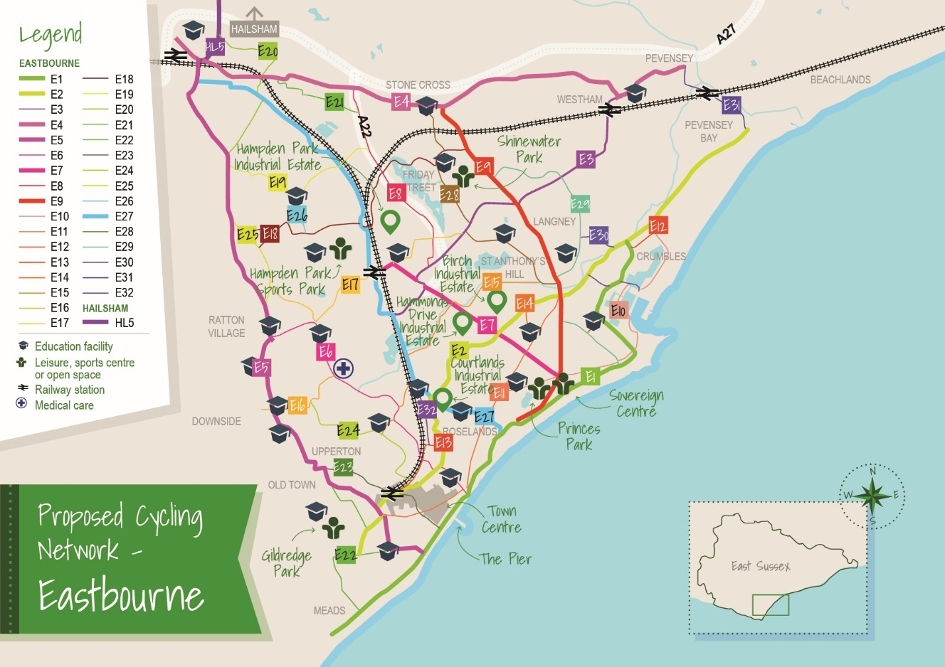

Table 4 - Proposed infrastructure
Table 4  Scheme Number | Scheme Names Eastbourne
E1 | South Downs Way – Sovereign Harbour via Seafront
E2 | University – Pevensey Bay
E3 | Hospital – Westham
E4 | Polegate High Street - NCN21 and A22
E5 | Polegate-Seafront
E6 | Willingdon Road - Seafront
E7 | Hampden Park – Sovereign Centre
E8 | A22 / Dittons Road - NCN21 – Willingdon Drove
E9 | Stone Cross – Royal Parade via Langney
E10 | Seaside Road – Sovereign Harbour – Eastbourne Road
E11 | Town Hall – Langley Roundabout
E12 | Ramsay Way – Route 200 – Pacific Drive
E13 | Station – Upper Avenue
E14 | Horsey Way – Seaside
E15 | Upperton – Eastbourne Park – Sevenoaks Road
E16 | Victoria Drive – Hospital
E17 | Willingdon Roundabout – South Shinewater Park
E18 | Willingdon – The North Shinewater Park – Friday Street
E19 | Lower Willingdon - Willingdon Upper
E20 | Eastbourne Road - Polegate Recreation Ground - Cuckoo Trail
E21 | Dittons Road - Cuckoo Trail – A22
E22 | Borough Lane - King Edward’s Parade
E23 | Old Town-Library and Council Offices - Terminus Road - Seafront
E24 | Rodmill - Eastbourne Rail Station
E25 | Coopers Hill – Wish Hill
E26 | Hazelwood Avenue and Hampden Park – Eastbourne Station link
E27 | Polegate – New North Railway Path – Hampden Park – Ringwood Road - Seafront
E28 | Stone Cross – Larkspur Drive – Sevenoaks Road,  Friday Street – Pennine Way – Seafront
E29 | Friday Street – Pennine Way – Seafront
E30 | Netherfield Avenue – Sovereign Harbour - Seafront
E31 | Pevensey – Pevensey Bay
(Further information on the development of this network is in Appendices 5C & 5D)

Figure 8 - Hailsham proposed cycle network
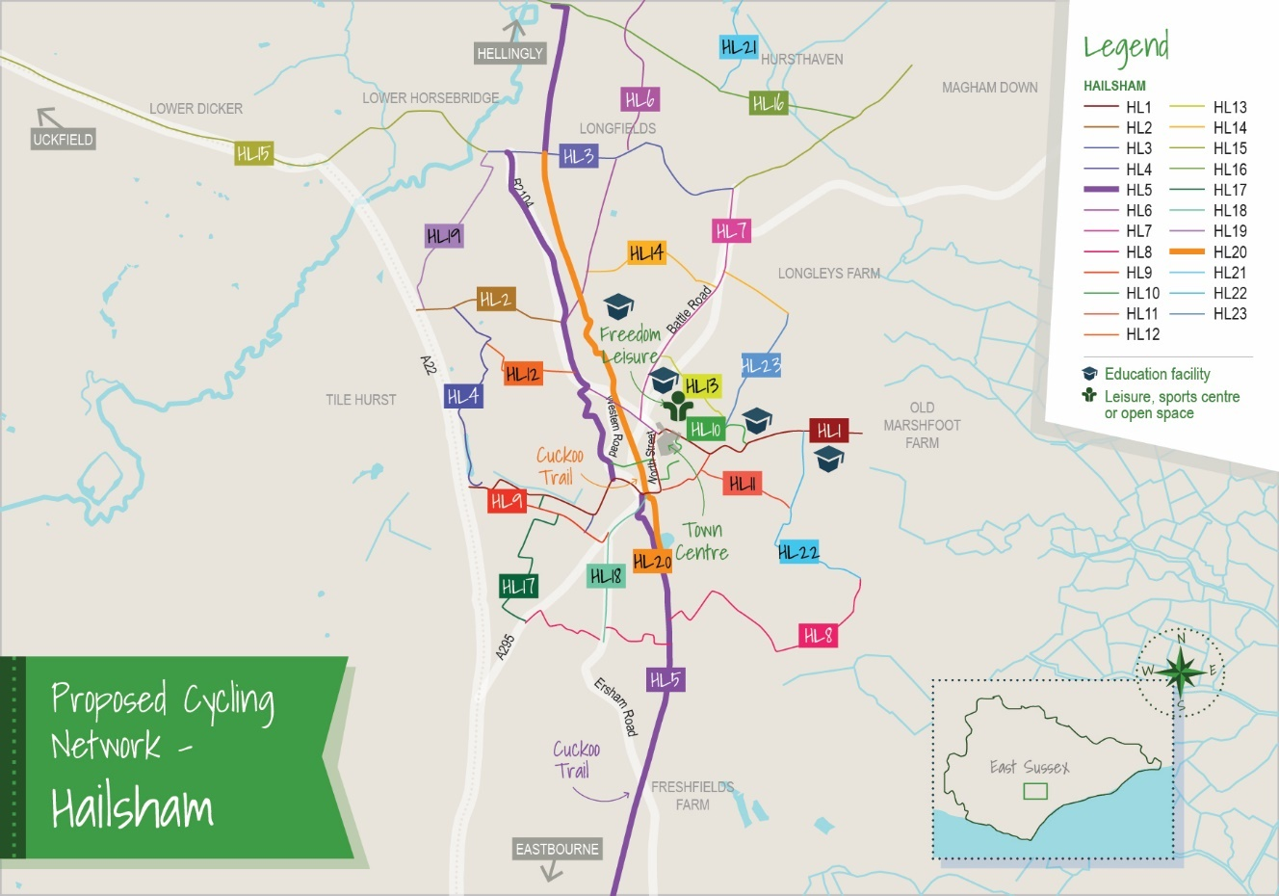

Table 5 - Proposed infrastructure
Table 5  Scheme Number | Scheme Names Hailsham
H1 | Diplocks Way (A22) — Phoenix Academy
H2 | Hempstead Lane
H3 | Cuckmere Close — Battle Road
H4 | Diplocks Way / A22 — Hempstead Lane
H5 | Polegate – Hellingly
H6 | High Street — Hellingly
H7 | London Road — Battle Road — Hawkswood Road
H8 | South Road — Mill Road
H9 | A22 — Vicarage Lane
H10 | Summerheath Road — High Street
H11 | Vicarage Road — Hamlins Park Close
H12 | Gleneagles Drive — London Road
H13 | Battle Road — White House School
H14 | Hawks Road — Harebeating Lane
H15 | Lower Dicker — Park Gate Road
H16 | Hellingly — Park Gate
H17 | Arlington Road East — Upper Horsebridge Road
H18 | Ersham Road — South Road
H19 | Hempstead Lane - Upper Horsebridge Road
H20 | South Road Car Park — Upper Horsebridge Road
H21 | New Road - The Drive
H22 | Mill Lane - Marshfoot Lane
H23 | White House School - Harebeating Lane
(Further information on the development of this network is in Appendices 5E & 5F)

Bexhill & Hastings
Bexhill & Hastings
5.11 With existing links in place connecting Bexhill & Hastings to the north and south, the focus of the preferred routes will be on supporting access to local services. Whilst the topography is challenging, especially in some areas of Hastings, there will be an emphasis on supporting wider projects that aid regeneration, including growth in housing and employment and support to the visitor economy.

Figure 9 - Bexhill proposed cycle network
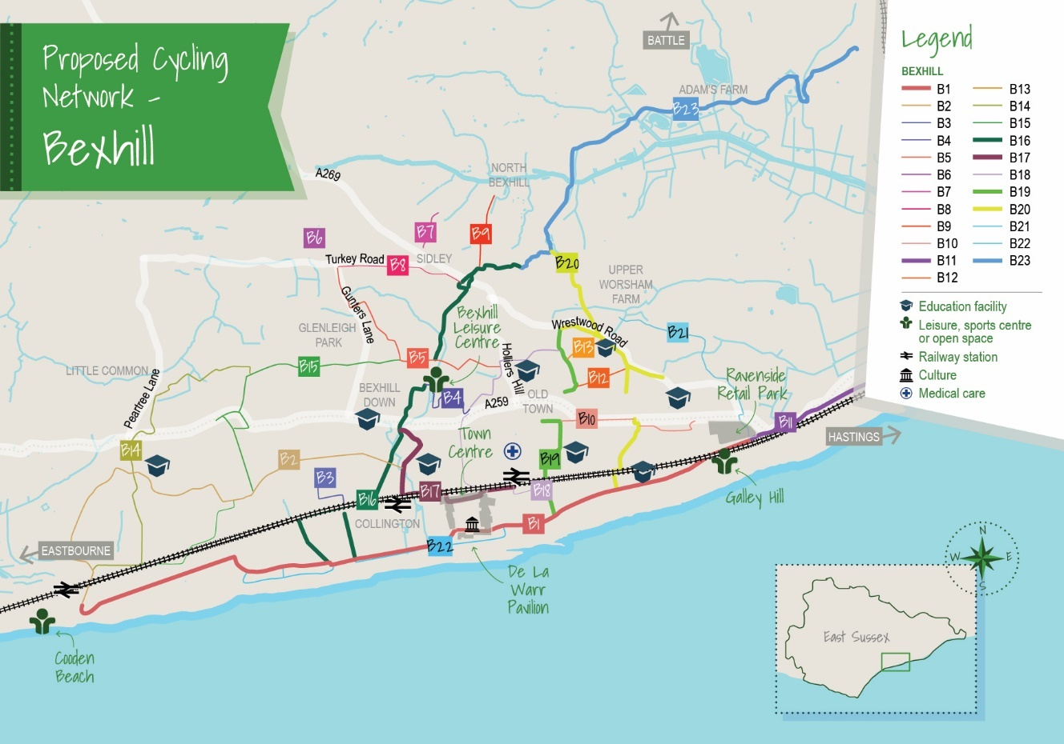

Table 6 - Proposed infrastructure
Table 6  Scheme Number | Scheme Names Bexhill
B1 | NCN2
B2 | Cooden Beach, Collington, Cranstoun Avenue, Windsor Road
B3 | Withyham Road, Little Common, Recreation Ground
B4 | Cooden Sea Road, Broadoak Lane, Woodsgate Park
B5 | NCN2/West Parade, King Offa Primary, NBDA West
B6 | Collington Rail Station – Hastings Direct
B7 | Bancroft, Hillside, Bankside
B8 | Bexhill Railway Station to Little Common Road
B9 | Bexhill Hospital, Gunters Lane
B10 | Gunters Lane, Highlands
B11 | Norfolk Close, NBDA
B12 | Gunters Lane - Sidley
B13 | Buckholt Lane - NBDA
B14 | NCN2/De La Warr Parade, King Offa Way & NBDA Central
B15 | NCN2/De La Warr Parade & NBDA Central
B16 | NCN2/De La Warr Parade NBDA East & Central
B17 | Retail Park, Pebsham Lane, NBDA East & Central
B18 | NCN2/De La Warr Parade, King Offa Way & NBDA Central
B19 | NCN2/De La Warr Parade NBDA East & Central
B20 | NCN2/De La Warr Parade NBDA East & Central
B21 | Retail Park, Pebsham Lane, NBDA East & Central
B22 | NCN2/De La Warr Parade, King Offa Way & NBDA Central
B23 | Bexhill – Hastings Greenway (Coombe Valley Way)
(Further information on the development of this network is in Appendix 5G.)

Figure 10 - Hastings proposed cycle network
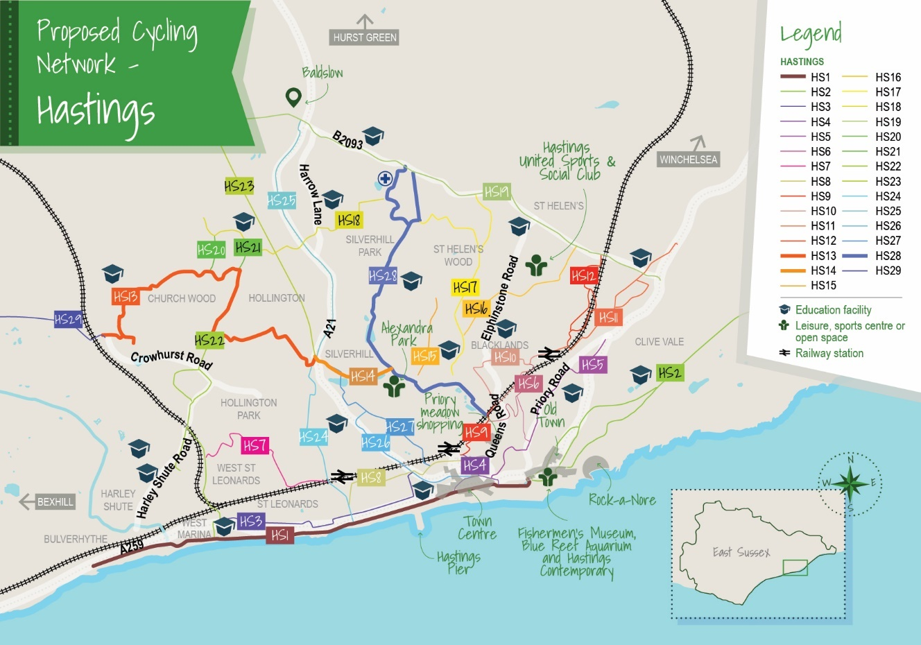

Table 7 - Proposed infrastructure
Table 7  Scheme Number | Scheme Names Hastings
HS1 | NCN2 Bulverhythe – Old Town
HS2 | NCN2 Bulverhythe - Fairlight
HS3 | Robertson Street – Wellington Place
HS4 | West Hill
HS5 | Hastings Station – St Helens Road
HS6 | St Helens Road – Ore Road
HS7 | Ore Station – The Ridge
HS8 | Ore Station – The Ridge (Alternative)
HS9 | Robsack Wood - Hastings
HS10 | Silverhill – Alexandra Park
HS11 | The Ridge
HS12 | Wishing Tree Road – NCN2
HS13 | Battle Road - Silverhill
HS14 | Silverhill – St Leonards – NCN2
HS15 | A21 – The Ridgeway - Silverhill
HS16 | A21 – Silverhill – Hastings Station
HS17 | Conquest Hospital – Alexandra Park – Bethune Way
HS18 | West St Leonards – A21
HS19 | Hughenden Road – Queens Road
HS20 | West St Leonards – London Road
HS21 | St Leonards Warrior Square – Hastings Centre
HS22 | Ashford Road
HS23 | St Helens Park Road
HS24 | St Helens Park Road
HS25 | Tilekin – Conquest Hospital
HS26 | Tile Barn Road Spur
HS27 | Wishing Tree Road Sur
HS28 | Briscoes Walk  Friday Street – Pennine Way – Seafront
BHG | Bexhill – Hastings Greenway (Combe Valley Way)  Friday Street – Pennine Way – Seafront
(Further information on the development of this network is in Appendix 5H.)

Rural East Sussex

North Wealden & North Lewes area
Uckfield, Heathfield, Crowborough
5.12 With further housing growth likely to be a considerable focus for these areas, the emphasis of the preferred routes is on supporting access to existing localised services. The preferred routes will also form the basis for further work to be undertaken by ESCC, Wealden District Council and developers in the near future, to develop a more comprehensive network which supports future growth in housing and employment.

Figure 11 - Uckfield proposed cycle network
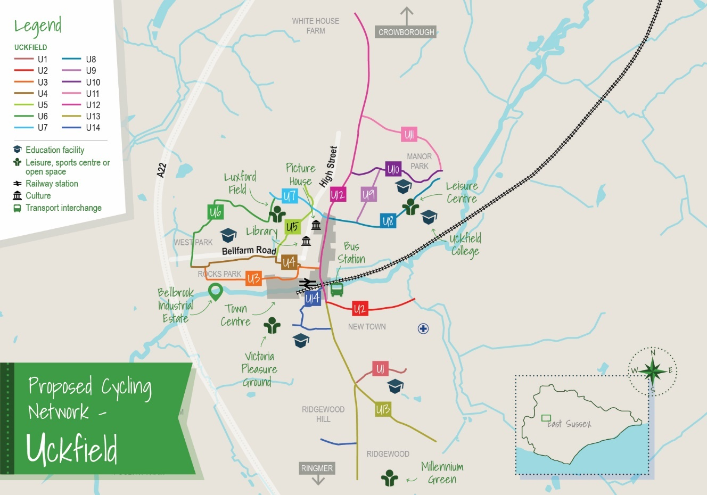

Table 8 - Proposed infrastructure
Table 8  Scheme Number | Scheme Names Uckfield
U1 | Mallard Drive
U2 | Framfield Road
U3 | Belfarm Road to Bell Lane
U4 | Bellfarm Road Greenway
U5 | Belmont Road - Manor Way
U6 | Batchelor Way - Rocks Park
U7 | Church Street
U8 | Hempstead Lane
U9 | Lime Tree Avenue
U10 | Southview Drive/ Downsview Crescent
U11 | Browns Lane
U12 | B2102 Ringles Cross – Framfield Road
U13 | New Town - Ridgewood
U14 | New Town to Railway Station (via Victoria Pleasure Ground)
(Further information on the development of this network is in Appendix 5I)

Figure 12 - Heathfield proposed cycle network
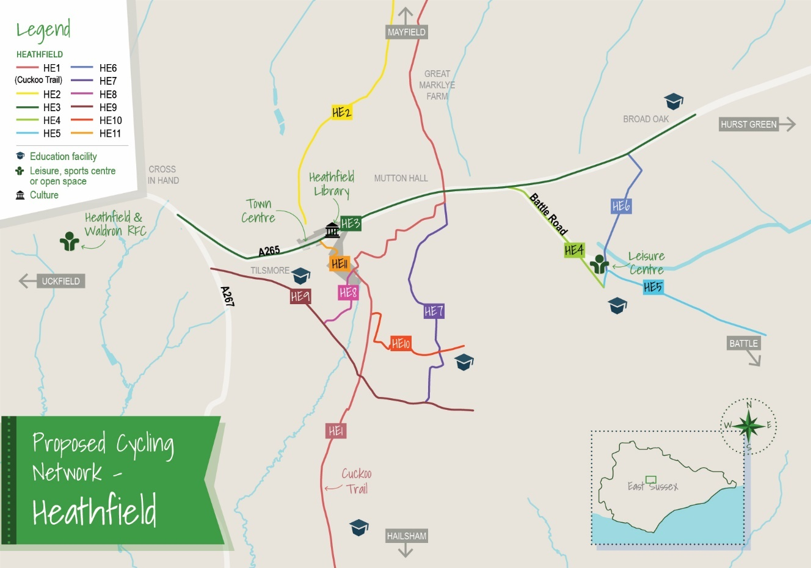

Table 9 - Proposed infrastructure
Table 9  Scheme Number | Scheme Names Heathfield
HE1 | NCN Route 21
HE2 | Cuckoo Trail Extension
HE3 | A265 Snatchells Farm – Broad Oak
HE4 | Battle Road West
HE5 | Battle Road East
HE6 | Halley Road
HE7 | A256 – Sandy Cross Lane
HE8 | Leeves Common
HE9 | Sheepsetting Lane – Sandy Cross Lane
HE10 | Cuckoo Drive – Green Lane
HE11 | Thorny Close Link
(Further information on the development of this network is in Appendix 5J.)

Figure 13 - Crowborough proposed cycle network
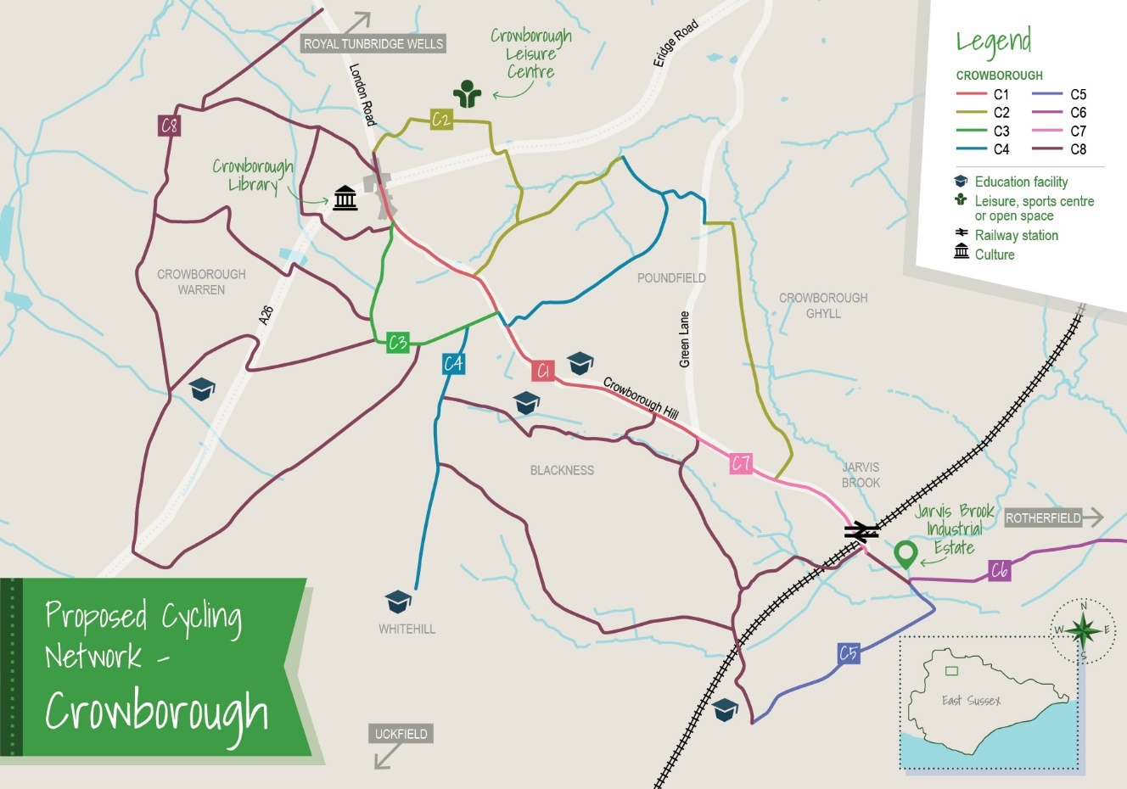

Table 10 - Proposed infrastructure
Table 10  Scheme Number | Scheme Names Crowborough
C1/C3/C7 | B21 from the A27 - junction Green Lane and the Croft Road/Church Road Triangle
C2 | Jarvis Brook – St Johns via Medway and Millbrook Road
C4 | North/South link via Queens Road and Poundfield
C5 | Jarvis Brook – Mount Pleasant – via Tubwell Lane
C6 | Jarvis Brook - Rotherfield
C8 | Area based improvements – residential areas
(Further information on the development of this network is in Appendix 5K.)

Rural Rother
Battle & Rye
5.13 These historic smaller settlements are set within a more rural environment which is surrounded by Areas of Outstanding Natural Beauty. Alongside the large numbers of tourists which these towns attract they also provide a role as a service centre for nearby rural villages. Therefore, the routes are focussed on supporting local access both within and to the settlements.

Figure 14 - Battle proposed cycle network
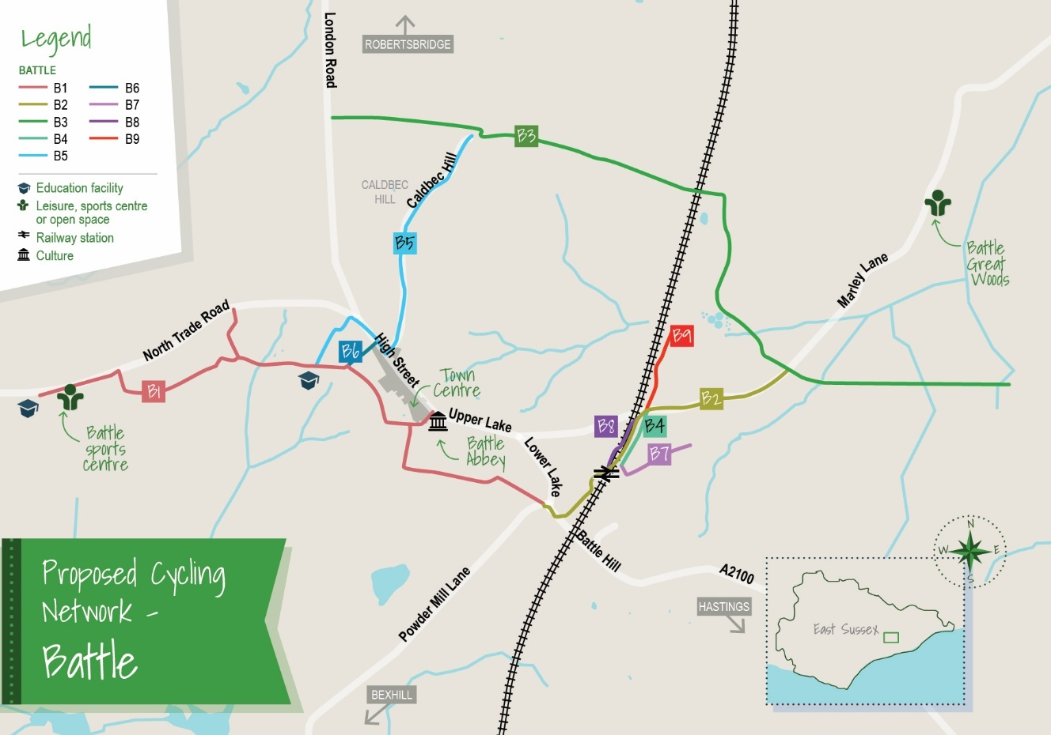

Table 11 - Proposed infrastructure
Table 11  Scheme Number | Scheme Names Battle
B1/B2 | Battle Schools Greenway
B3 | Uckham Lane, Marley Lane, Great Wood
B4/B7/B8/B9 | Links to Blackfriars Re-development
B5 | Battle North
B6 | Link Automotive Estates
(Further information on the development of this network is in Appendix 5L.)

Figure 15 - Rye proposed cycle network
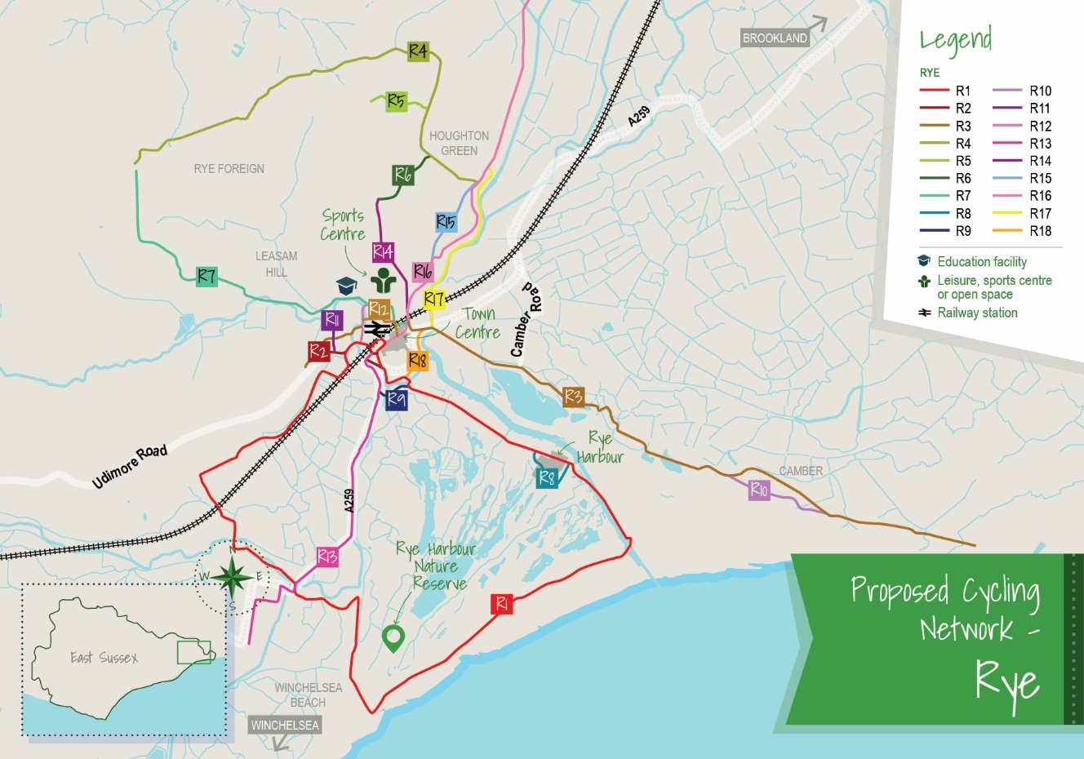

Table 12 - Proposed infrastructure
Table 12  Scheme Number | Scheme Names Rye
R1 | Rye - Rye Harbour - Winchelsea Loop
R2 | Valley Park - Rock Channel
R3 | Valley Park - Camber - Jury's Gap
R4 | Peasmarsh - Military Road
R5 | Playden Lane
R6 | School Lane
R7 | Peasmarsh - Landgate
R8 | Rye Harbour Alternative
R9 | Winchelsea Road - Harbour Road
R10 | Camber Alternative
R11 | Mason Road
R12 | Ferry Road - Love Lane
R13 | Cinque Ports Street - Winchelsea
R14 | Rye - Playden
R15 | Military Road
R16 | Rye - Iden Lock
R17 | New Road - Scots Float Sluice
R18 | Rock Channel
(Further information on the development of this network is in Appendix 5M.)

Proposed Walking Network Maps
5.14 A proposed walking network map of preferred routes for each priority area has been developed. Please see below a map outlining the proposed walking networks for each settlement, alongside a table with the name of each route.

5.15 The aim is to improve the existing walking network and core walking zones (such as town centres) or, where feasible, to extend the walking network. These maps will be adopted as strategic planning documents.

Coastal East Sussex

Newhaven Area - Newhaven
5.16 Whilst the quality of the existing infrastructure for pedestrians is generally good in some locations, there are some specific issues related to accessibility. This includes the height of kerbing, severance issues caused by limited step free access on the most direct routes, lack of pedestrian crossings, and poor quality of footway surfacing.

Figure 16 - Newhaven proposed walking network
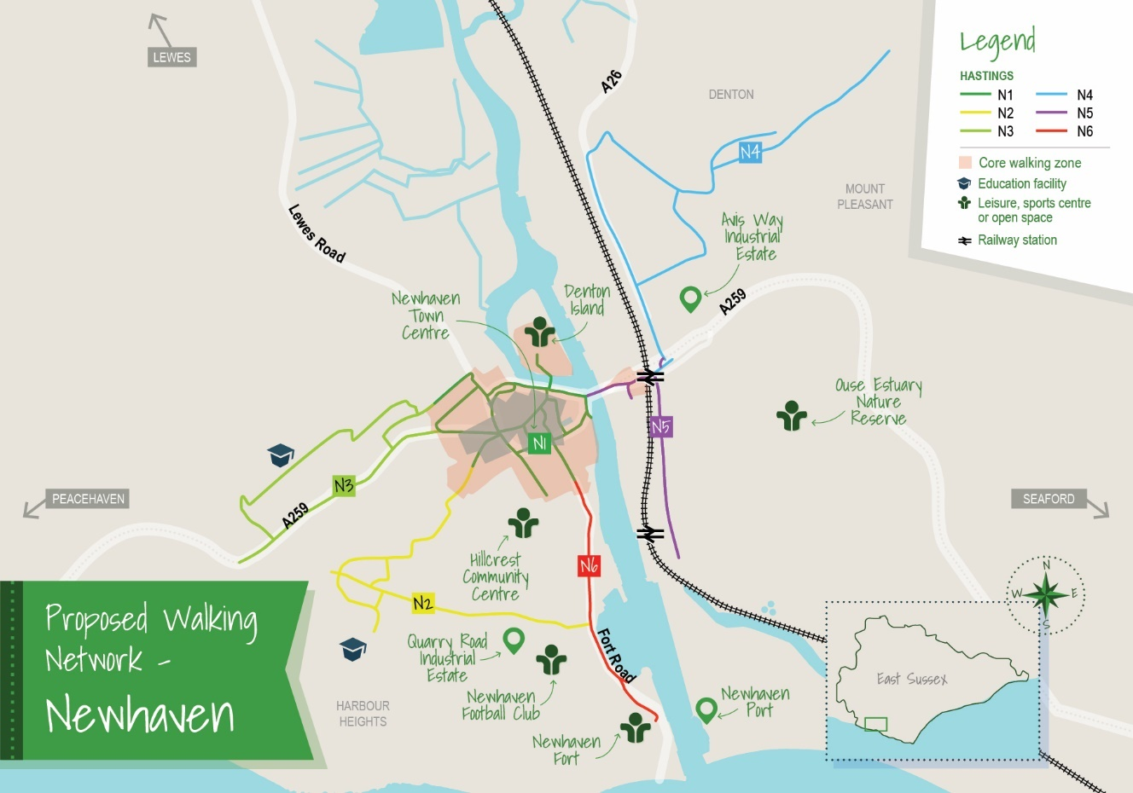

Table 13 - Proposed infrastructure
Table 13  Scheme Number | Scheme Name
N1 | Core Walking Zone
N2 | Church Hill to Southdown Rd
N3 | Eveyln Ave to Brighton Rd
N4 | Drove Rd to Denton Rd
N5 | North Way to Beach Rd
N6 | South Rd to Fort Rise
(Further information on the development of this network is in Appendix 5O.)

Lewes & South Downs National Park - Lewes
5.17 Lewes is a historic town and therefore the current pedestrian environment is reflective of this. Key issues include narrow footway widths, quality of footway surfacing, and the need for increased footway provision.
Figure 17 - Lewes proposed walking network
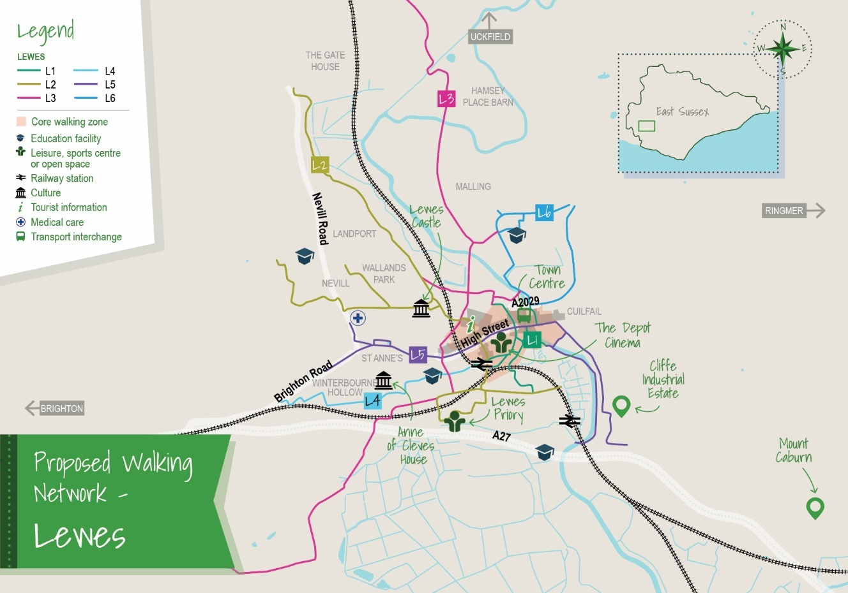

Table 14 - Proposed infrastructure
Table 14  Scheme Number | Scheme Name
L1 | Core Walking Zone
L2 | Cockshut Road to The Drove
L3 | Wellgreen Lane to Whitfield Lane
L4 | Elm Grove to Brighton Rd
L5 | Brighton Road to Southerham Lane
L6 | Phoenix Causeway to Mill Road
(Further information on the development of this network is in Appendix 5O.)

Eastbourne & South Wealden – Eastbourne
5.18 ESCC and LDC-EBC are currently undertaking a number of projects to prioritise people accessing the town centre using more active travel. Specific issues identified include the need for more pedestrian crossing points between destinations to improve the directness of routes, reduction of traffic speeds, footway resurfacing, and provision of footways where there are gaps.

Figure 18 - Eastbourne proposed walking network
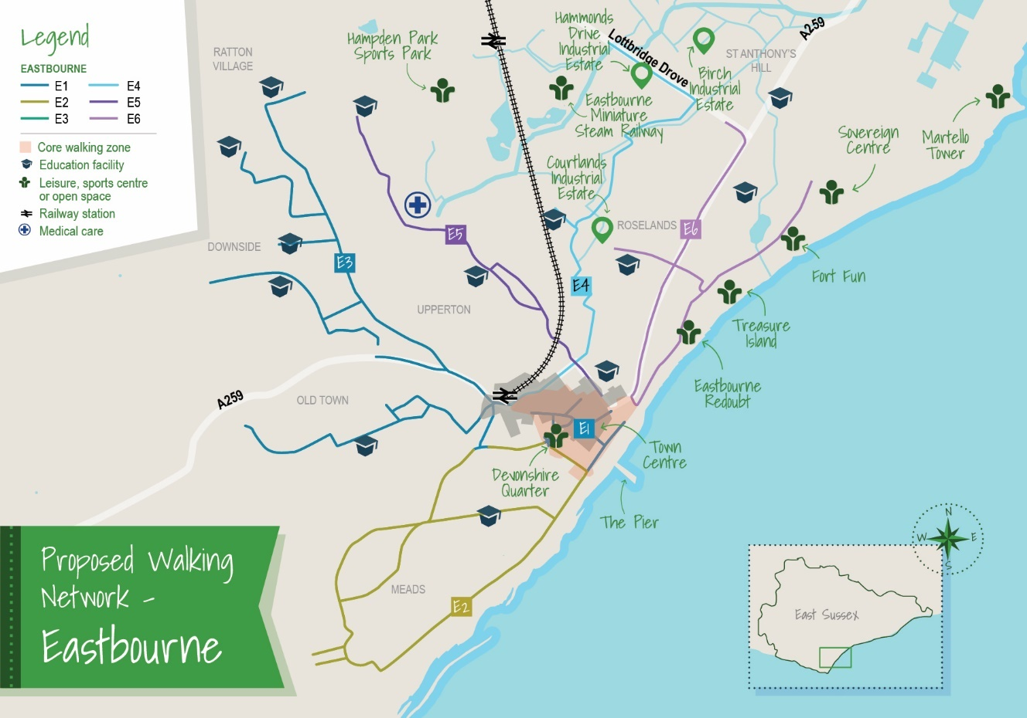

Table 15 - Proposed infrastructure
Table 15  Scheme Number | Scheme Name
E1 | Core Walking Zone
E2 | Devonshire Place to Wellcombe Crescent
E3 | Terminus Road to Park Avenue
E4 | Ashford Road to Lottbridge Drive
E5 | Cavendish Place to King's Drive
E6 | Marine Parade Rd to Birch Roundabout
(Further information on the development of this network is in Appendix 5O.)

5.19 With the ambition to be a ’10-minute town’ where people can access the local services, they need using active travel, pedestrian accessibility in Hailsham is crucial. Key improvements identified for this town include the need to provide greater access to the Cuckoo Trail, increased dropped kerb provision, improved footway widths at certain locations, and the provision of crossing facilities on busier roads.

Figure 19 - Hailsham proposed walking network
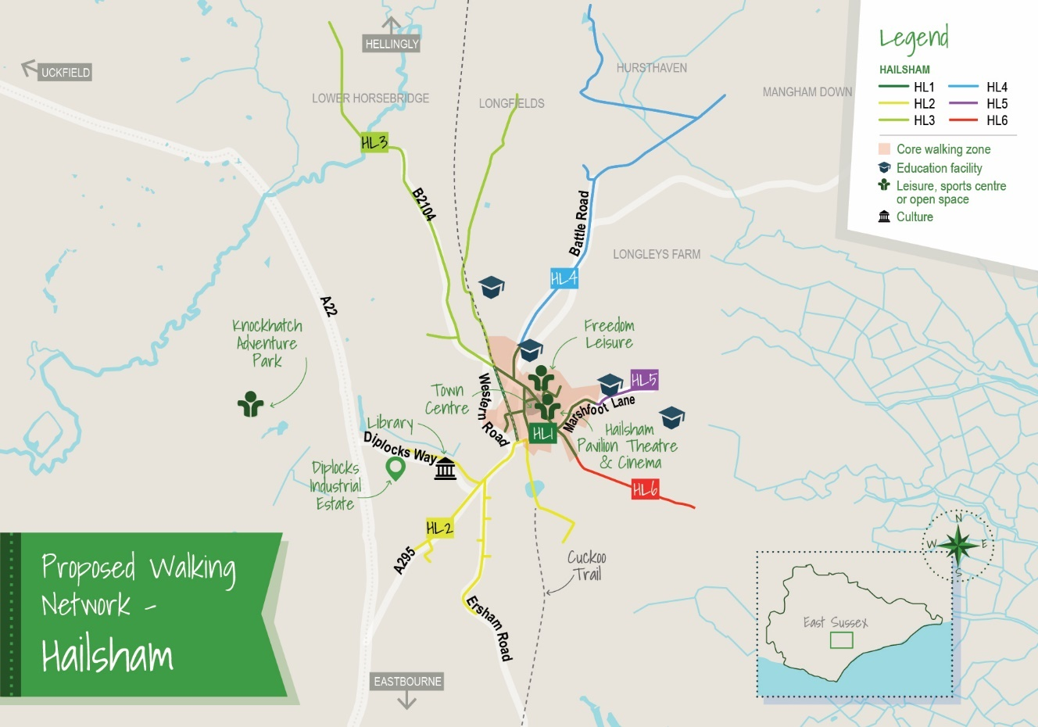

Table 16 - Proposed infrastructure
Table 16  Scheme Number | Scheme Name
H1 | Core Walking Zone
H2 | South Rd to Arlington Road East
H3 | London Road to Church Road
H4 | Battle Road New Road
H5 | Marshfoot Lane
H6 | Mill Road
(Further information on the development of this network is in Appendix 5O.)

Bexhill & Hastings – Bexhill
5.20 With generally an older population living in Bexhill compared to other areas of the county, accessibility is essential. A key issue identified is the need for enforcement to limit parking on existing footways. In both Hastings and Bexhill, it was identified that there was a need for the resurfacing of footways, increased footway widths, increasing pedestrian crossing points and expansion of dropped kerb provision. This would help both Rother District Council and Hastings Borough Council in the regeneration of their town centre areas, and the enhancement of the public realm.

Figure 20 - Bexhill proposed walking network
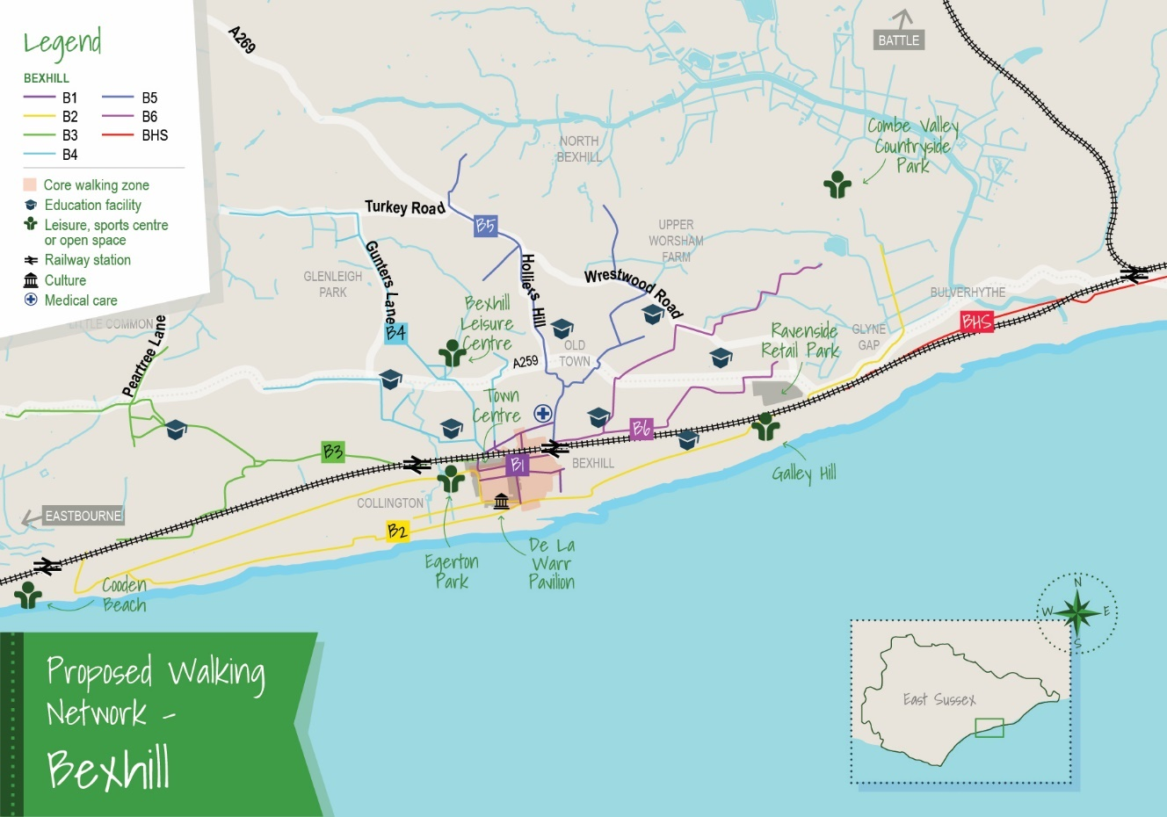

Table 17 - Proposed infrastructure
Table 17  Scheme Number | Scheme Name
B1 | Core Walking Zone
B2 | Cooden Sea Road to Freshfields
B3 | Station Road to Barnhorn Road
B4 | Buckhurst Place to Turkey Road
B5 | Sea Road to Watermill Lane
B6 | Upper Sea Road to Pebsham Lane
(Further information on the development of this network is in Appendix 5O.)

Bexhill & Hastings – Hastings

Figure 21 - Hastings proposed walking network
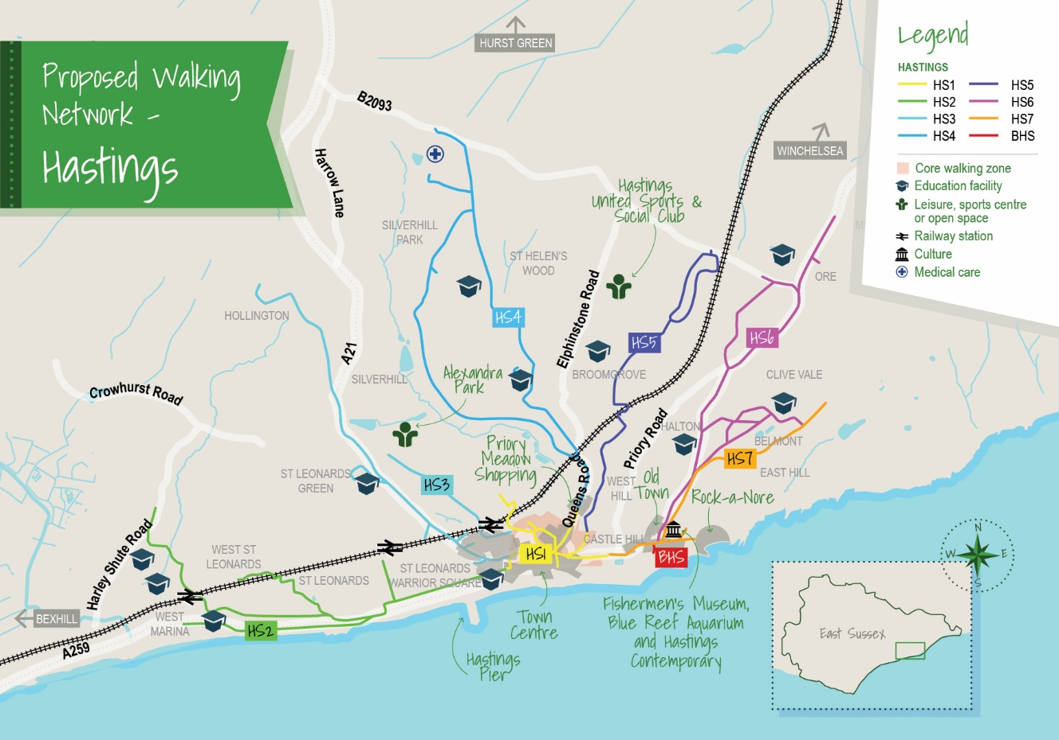

Table 18 - Proposed infrastructure
Table 18  Scheme Number | Scheme Name
H1 | Core Walking Zone
H2 | White Rock to Harley Shute Road
H3 | Cornwallis Gardens to Hollington Old Lane
H4 | Queens Rd to The Ridge
H5 | Milward Road to Ivyhouse Lane
H6 | The Bourne to Rye Road
H7 | Pelham Place to Barley Lane
BHS: | Bexhill-Hastings Seafront
(Further information on the development of this network is in Appendix 5O.)

Future Walking Network Development Work – Other Areas
5.21 As outlined above the LCWIP network development for cycling also identified improvements for pedestrians where possible, but the walking network development work has been more focussed on urban centres. ESCC and their partners will review the opportunities to undertake more detailed walking network development assessments in Peacehaven, Seaford, Uckfield, Heathfield, Crowborough, Battle and Rye in the future.

Cycling & Walking Training, Information & Initiatives
5.22 To maximise the use of the potential infrastructure projects listed above, ESCC and their partners will look to continue delivering a programme of cycling and walking training, information and initiatives. This will be subject to funding being secured. (Further details in regards to this is in Appendix 2 East Sussex LCWIP Part 2 Infrastructure Plan Stage 6.)

6. How will the LCWIP be delivered?

6.1 As we have previously stated the LCWIP is dependent on the ability of ESCC and their partners to secure funding. However, to place us in a stronger position to secure the funding necessary to deliver the LCWIP, the plan is underpinned by the following four key factors.

1. Embed within strategy and policy documents
6.2 To help ESCC and their partners deliver the LCWIP the first step will be to ensure that it is referenced in other County council and partner strategy and policy documents. When making the case for funding there is a requirement to demonstrate the wider impacts that cycling and walking can support, especially in relation to the environment, health and wellbeing, the economy and planning. So, it is important that it is referenced in documents that cover these key policy areas. For example, we will work with district and borough councils to ensure that the cycle and walking network maps are adopted as part of their Local Plans. (For further information about the specific documents that the LCWIP links to, are included in Appendix 2.)
2. High Quality Infrastructure Design & Engagement
6.3 Ensuring that we deliver high quality schemes that are inclusive for all users alongside being safe, attractive and convenient is essential, so that people regardless of their ability or age feel comfortable in using it.

6.4 The government has recently published new design guidance for cycling infrastructure referred to as LTN 1/20. This has a greater emphasis on providing routes that are of a higher quality and are physically separated (e.g. by a kerb or barrier) from the highway or footway. ESCC is already reviewing all programmed new cycle infrastructure schemes against LTN 1/20 and integrating the design guidance where this is feasible. LTN 1/20 will also be utilised as part of the development of new schemes. ESCC will look to follow this guidance where it is feasible or where there are opportunities to adapt the approaches.

6.5 Early engagement with key stakeholders and the general public, especially those people that will be the key beneficiaries of a scheme, will remain as a high priority. We will also seek to look at more innovative ways of engaging with people to obtain their views, to ensure acceptability and most importantly to ensure the future use of schemes.

3. Targeted cycling and walking initiatives
6.6 Installing new infrastructure, particularly cycling and walking infrastructure, is not always enough to help encourage more people to cycle or walk. How someone chooses to travel is determined by a person’s personal circumstances (i.e. their type of employment, how far they need to travel, the need to undertake multiple trips) and importantly how convenient new infrastructure is in enabling them to make those every day journeys.

6.7 So we are committed to provide people with walking and cycling initiatives, information and skills to give people the right opportunities to give cycling and walking a try and to move people to changing their travel behaviour towards more active travel for short local journeys or as part of longer journeys. This will build upon existing work, which has been undertaken through previous programmes outlined in section 5.22 above.
4. Partnership working will ensure the delivery of East Sussex’s LCWIP
6.8 Partnership working is fundamental in determining the success of ESCC and their partners in securing funding from a range of sources, to enable the delivery of the LCWIP. ESCC is leading on the LCWIP to support an increase in cycling and walking, but significant change will only occur by collaborative working with our key internal and external partners, including the public, commercial and voluntary sector along with embracing any new future partnerships.

Prioritising Schemes
6.9 To help us meet DfT guidance the plan will need to include an indication of those schemes which are of a higher priority over others, particularly for ESCC when applying for national funding. The current prioritised list of schemes is as outlined in figure 22, page 41.

However, whilst this prioritisation process is important, it is also recognised that the schemes may not always come forward according to this prioritisation. It is essential that there is a degree of flexibility in the delivery of the plan. This because the plan is dependent on:

- the types of funding which come forward in the future (capital/revenue),
- the purpose and criteria of these funds (i.e. aligned to policies, themes etc.), and
- the process associated with accessing the funding and who can access these (ESCC, District & Boroughs, SDNPA, voluntary sector)

Types of funding
6.10 With ESCC and their partners working collaboratively, this will enable a greater range of funding sources to be secured for cycling and walking infrastructure and initiatives.

National Funding
6.11 This will include direct applications for funding from the government and larger or smaller scale national or local funding organisations. Examples of potential funding sources include the DfT’s Active Travel Fund; the Ministry of Housing, Communities & Local Government - High Streets Fund; Highways England’s Designated Funds; the Energy Savings Trust, and British Cycling.

6.12 To support the delivery of its ‘Gear Change’ strategy, with LCWIP’s being a key element of this, the Government has allocated £2bn of ‘Active Travel Funding’ (both revenue and capital) over the next four years.
6.13 Revenue funding from the Active Travel Fund, to support the development of LCWIP’s and to deliver cycling and walking initiatives in 2021/22, has been allocated to all local authorities. Following the submission of an application earlier this year, ESCC has secured £219,774 of revenue funding to deliver a programme of cycling and walking initiatives and LCWIP development in 2021/22. This includes active steps with workplaces and communities, cycle/electric cycle hire, ‘walk once a week’ programme’ with schools and further development to the ESCC Cycle Hubs at Eastbourne & Peacehaven.
6.14 A key element of an LCWIP is the prioritised programme of infrastructure improvements (outlined in 6.9) for future investment. The DfT advise that this should inform cycling and walking capital funding applications to the Active Travel Fund. ESCC has been invited to bid for capital funding in 2021/22 for spend by end March 2023. For East Sussex an application was submitted to Government in August 2021 to use these monies to support the delivery of Phase 1 of the Hailsham – Polegate – Eastbourne Movement & Access Corridor Scheme and Eastbourne Town Centre Movement & Access Package Phase 2a, both of which are prioritised schemes within the Eastbourne & South Wealden area of the LCWIP, with a bid request for £1.8m. The outcome of the application is expected in autumn 2021. It is expected that further applications to Government will need to be developed and submitted to Government to unlock the further three years of revenue and capital Active Travel Fund monies.
Local Plans - Community Infrastructure Levy & Section 106 Funding
6.15 Funding will also be sought through the planning process for new development by securing development contributions. To enable this to happen, the networks will need to be included as part of the district and borough Local Plans and potential schemes included in the accompanying Infrastructure Development Plans, which list the infrastructure required to support future development. This will enable ESCC to specifically request potential schemes included in the LCWIP, as appropriate, when providing responses to planning applications from the district and boroughs. This will be alongside any potential opportunities for communities to allocate Community Infrastructure Levy (CIL) funding they receive, to support the delivery of cycling and walking infrastructure, identified within their Neighbourhood Plans.
6.16 To support the collaborative nature of the plan ESCC and their partners will be supportive of local organisations in securing and delivering more localised measures and initiatives to support more cycling and walking in the county.

Governance
6.17 The plan will be monitored on an annual basis through the governance arrangements as outlined in Appendix 4; progress and future projects will be reported through ESCC’s Capital Programme of Local Transport Improvements.

Figure 22 – Initial scheme prioritisation
Scheme name and location (e.g. postcode and road/street address) | Scheme type | No.of units (Scheme length, area covered, no. of cycle racks etc.) | Total cost (£) | Delivery timescale (1, 4 or 10 years) | Prioritised in LCWIP (y/n)? | Anticipated funding source(s)
Coastal East Sussex – Priority LCWIP AREAS
Eastbourne & South Wealden
Eastbourne Walking and Cycle Network - Horsey Way Phase 1B (Cavendish  Place to Ringwood Road) | Cycle Route | 1,825m | £1.3m | 1-4 | Yes | Local Growth Funding - Secured
Eastbourne Walking and Cycle Network - Langney Rise cycle route | Cycle Route | 1,600m | £900k | 1-4 | Yes | Local Growth Funding - Secured
Eastbourne Walking and Cycle Network- Willingdon Drove cycle route | Cycle Route | 800m | £350k | 1-4 | Yes | Local Growth Funding - Secured
Eastbourne / South Wealden cycling and walking improvements - Stone Cross-  Royal Parade via Langney | Cycle Route | 3,500m | £3.8m | 1-4 | Yes | Local Growth Funding - Secured
Eastbourne / South Wealden cycling and walking improvements - Eastbourne town  centre cycle routes | Cycle Route | 1,300 | £500k | 1-4 | Yes | Local Growth Funding - Secured
Hailsham – Polegate – Eastbourne  Movement & Access Corridor Scheme (HPE MAC – PHASE 2 Victoria Drive bus lane | Multi Modal – Bus/Cycle/Pedestrian improvements | Unknown at this stage | - | 4 | Yes | Active Travel Funding  BSIP Funding  Other national funding  ESCC Capital Programme  Development Contributions
HPE MAC – PHASE 3 Ersham Road roundabout, Hailsham | Multi Modal – Bus/Cycle/Pedestrian improvements | Unknown at this stage | - | 4 | Yes | Active Travel Funding  BSIP Funding  Other national funding  ESCC Capital  Programme  Development Contributions
Eastbourne Town Centre (Liveable Towns)  Phase 2b: Terminus Road – Langney Road to Grand Parade | Pedestrian/Bus/Cycling improvements – re-allocation of road space  Pedestrian/bus/cycling improvements – re-allocation of road space | Approx. 5,500sqm | £5.3m  £6m | 4  4 | Yes | Active Travel Funding  ESCC Capital Programme  Other National Funding - LUF  Development Contributions
HPE MAC – PHASE 4 A2021 Kings Drive/Rodmill Roundabout | Multi Modal – Bus/Cycle/Pedestrian improvements | Unknown at this stage | - | 4 & 10 | Yes | Active Travel Funding  BSIP Funding  Other national funding  ESCC Capital Programme  Development Contributions
Eastbourne Town Centre (Liveable Towns)  Little Chelsea (Grove Road) South Street corridor, Memorial roundabout pedestrian improvements | Pedestrian/Bus/Cycling improvements – re-allocation of road space | Approx. 3,000 sqm | Memorial Roundabout  £1.8m | 4 (Memorial) 10 (Little Chelsea South St) | Yes | Active Travel Funding  ESCC Capital Programme  Other National Funding  Development Contributions
Eastbourne Seafront Cycle Route | Cycle Route | Unknown at this stage | £2m | 4 and 10 | Yes | Active Travel Funding  ESCC Capital Programme  Other National Funding  Development Contributions
HPE MAC – PHASE 5 – Rodmill roundabout to town centre | Multi Modal – Bus/Cycle/Pedestrian improvements | Unknown at this stage | - | 10 | Yes | Active Travel Funding  BSIP Funding  Other national funding  ESCC Capital Programme  Development Contributions
Newhaven Area
Avis Road – Newhaven | Cycle Route/Toucan crossing/bus stop improvements | 825m cycle route | £500k | 4 | Yes | Active Travel Funding  ESCC Capital Programme  Development Contributions
A259 – Newhaven – Pevensey | Multi Modal – Bus/Cycle/Pedestrian improvements | Unknown at this stage | £2m | 4 and 10 | Yes | Active Travel Funding  BSIP Funding  Other national funding including (MRN)  ESCC Capital Programme  Development Contributions
Hastings & Bexhill
Hastings Walking and Cycle Network - Queensway to Silverhill (western) route | Cycle Route | 2.7 miles | £500k | 1 | Yes | Local Growth Funding - Secured
Hastings Movement & Access Route Schemes (MARS) – Seafront Connectivity | Pedestrian improvements at junction and widened footway | Footway widening scheme approx. 90m | £790K | 1 | Yes | Local Growth Funding - Secured
Hastings Movement & Access Route Schemes (MARS) – Station to Seafront | Pedestrian improvement and cycle parking | Realigned pedestrian crossings and upgraded footway approx. 275m eastern side and 175m western side. Cycle parking provision for up to 10 bicycles. | £1.1m | 1 | Yes | Local Growth Funding - £774k Secured, DC’s/CIL – £51k Secured
Bexhill Walking and Cycling Network: Collington Avenue/Sutherland Avenue  junction pedestrian crossing | Pedestrian refuge scheme | 1 no. pedestrian refuge | £80k | 1 |  | Local Growth Funding - Secured
Bexhill Walking and Cycle Network - Cycle Routes 1 - 9 (East & North Bexhill) | Cycle Routes | 6.3km, 3.9m | £1.5m | 1 – 4 | Yes | Local Growth Funding - Secured
Alexandra Park – Conquest Hospital – Hastings | Cycle Route | 5km in length. 3.1 miles  No of cycle racks yet to be determined | £2m | 4 and 10 | Yes | Active Travel Funding  ESCC Capital Programme  Development Contributions
Lewes & South Downs National Park
Regional Route 90 - Lewes | Cycle Route | 3.5kms, 2.1 miles | £1.8m | 4 and 10 | Yes | Active Travel Funding  ESCC Capital Programme
A27 – Falmer - Ashcombe | Shared cycling/walking route | Unknown at this stage | - | 4 and 10 | Yes | Active Travel Funding  HE Designated Funding
Lewes Wayfinding | Pedestrian Improvement | Unknown at this stage | £250k | 4 | Yes | Active Travel Funding  ESCC Capital Programme
County Wide
School Streets County Wide Programme | Pedestrian/cycling – re-allocation of road space | Unknown at this stage | £500k | 4 | To be included in subsequent updates in 2021. | Active Travel Funding  Other national funding – public health  ESCC Capital Programme

7. What next?

7.1 In section 2, figure 1, the stages that have been undertaken to help develop the plan were outlined, so that the plan is in accordance with the DfT guidance. Figure 23 indicates the next stages which will be undertaken by ESCC and their partners to ensure that the LCWIP is managed accordingly to be a ‘live’ document and utilised to support applications for funding and to ensure that schemes are developed, consulted upon, delivered and monitored.

Figure 23 – Ongoing LCWIP Development
Stage 6 | LCWIP Funding & Network Review  - Begin to develop a pipeline programme of schemes, outlined in 6.9, for inclusion in future applications for national funding.  - ESCC and partners to apply for funding as it becomes available.  - Review and update the cycling and walking network: -  - as part of local plan development,  - strengthen the walking element of the plan,  - potentially identify cycling schemes which align with the new government Local Transport Note (LTN) 1/20 ‘Cycle Infrastructure Design’, and  - potentially include schemes which will provide greater priority for people cycling and walking outside of schools, within neighbourhoods or key centres.  - Review the prioritised list of schemes on an annual basis  - Evaluate schemes and initiatives.  - Monitor the outputs of the LCWIP on an annual basis.
Active Travel England
7.2 In July 2020 the DfT published a new cycling and walking strategy, referred to a ‘Gear Change’. The strategy is focussed on providing more space for people cycling and walking by reallocating more road space for either fully segregated cycle routes or closing roads to traffic to create low traffic neighbourhoods. To help support this the DfT is establishing a national funding body and inspectorate referred to as ‘Active Travel England’.
7.3 The role of this will be to:
- provide expert advice regarding scheme design and stakeholder consultation,
- administer funding & review funding applications,
- enforce scheme design standards and time limits on scheme delivery, and
- publish annual reports on highway authority’s performance in relation to cycling and walking infrastructure.

7.4 To respond to this ESCC will be commissioning a study to review the opportunities for delivering these types of schemes in the County. This will commence in 2021/22.
East Sussex Local Transport Plan 2020 Review

7.5 ESCC will commence a review of their Local Transport Plan 2011 – 2026 during 2021/22 to reflect the changes in policy and the likely impacts of the Covid – 19 Pandemic, which will change future travel patterns in the short and longer term. The LCWIP will be subject to further updates, to reflect this document.

Cycling UK's Cycling Statistics - 2017-201?
Draft SE LEP Local Industrial Strategy 2020

