|  |
| --- |
| **Proposed changes to parking restrictions** |

February 2017 Our ref: PkM 2017/036

Dear Sir or Madam

**Lewes (High Street) Parking Review 2017 – initial consultation**

We have received a number of complaints regarding cars and other vehicles parked on footways in the High Street. We are writing to seek your views and whether you would support the introduction of measures to address these issues.

Parking on footways can make life difficult and dangerous for pedestrians. It causes difficulty for the partially sighted, for parents pushing buggies, the elderly, and wheel chair users, often forcing them off the footway and requiring them to to use the carriageway. Unlike road surfaces, footways and verges are not designed to take the weight of cars or other motor vehicles. Much of the damage to footway and verges (cracked or sunken paving slabs etc.) is caused by vehicles driving over or parking on them.

To address these issues we are considering the introduction of a footway parking ban in the High Street (on the north side from Westgate Street to Eastgate Street). This would mean parking on the footway would not be allowed. We realise that this means vehicles stopping to load or unload would be parked wholly on the carriageway, leading to increased congestion. To prevent the congestion a loading ban will also be proposed on the north side of High Street. This would be supplemented with new loading bays placed outside the White Hart Hotel and opposite Albion Street. The existing loading bays outside Lewesiana and near the memorial will remain in place.

Enclosed with this letter is a map and a questionnaire. Please return your completed questionnaire to us by 10 March 2017. You can do this by writing to us at the address above, or by handing in your completed questionnaire to the Parking Shop at Causeway House, Wellers Yard, 46-48 Malling Street, Lewes, East Sussex BN7 2RH.

You can also email your responses to [parking.escc@eastsussex.gov.uk](mailto:parking.escc@eastsussex.gov.uk) or complete the online consultation at <https://consultation.eastsussex.gov.uk/economy-transport-environment/high-street17>

We will be happy to answer any questions, please call us on 01323 466244. Full details of all our consultations and the background behind them can be found at: <https://consultation.eastsussex.gov.uk/>

Your views will determine whether these parking controls are introduced in the area, no decision

will be made until the results of this questionnaire have been assessed. I therefore

encourage you to participate in the consultation process.

**Lewes (High Street) Parking Review 2017 – initial consultation**

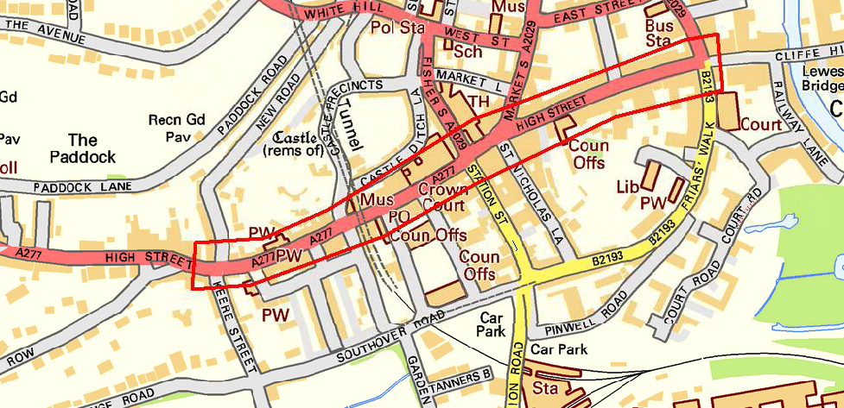

The map above shows the area (edged in red) where we are consulting.

We are still at an early stage and no decisions have been made. We would like to know if you think the introduction of such measures would be beneficial to the area and your comments will help us reach a decision about whether to proceed with the proposal.

If a majority of responses to this questionnaire are in favour of the proposed changes we will draw up detailed plans and consult with you again before any formal changes are advertised.

Yours faithfully



**David Weeks**

Team Manager, Parking

T: 01323 466244

E: [parking.escc@eastsussex.gov.uk](mailto:parking.escc@eastsussex.gov.uk)

**Lewes (High Steet) Parking Review 2017 – initial consultation**

|  |  |  |  |  |  |  |
| --- | --- | --- | --- | --- | --- | --- |
| Q1 | What is your name? | | ……………………………………………………………. | | | |
| Q2 | What is your address? | | ………………………………………………………………………………. | | | |
| Q3 | What is your email address? | | ………………………………………………………………………………. | | | |
| Q4 | Do you normally have deliveries during the day? | | | | | |
|  | □ Yes, before 8am | | | □ Yes, between 4pm and 6pm | | |
|  | □ Yes, between 8am-12pm | | | □ Yes, after 6pm | | |
|  | □ Yes, between 12pm-4pm | | | □ Yes, at anytime | | |
|  | □ No | | |  | | |
| Q5 | How many times a week do you receive deliveries? | | | | | |
|  | □once only □two or three times | | | □more than four times | | |
| Q6 | If a footway and verge parking ban and a loading ban was introduced, loading would not be permitted during the operational times (other than in the dedicated loading bays). Do you think the loading ban should be operational between these times? | | | | | |
|  | □8am-6pm | □between 8am-10am and 4pm-6pm | | | □at all times | |
| Q7 | We try to minimise the amount of signs and posts needed. If the proposals go ahead, would you give permission for a sign to be fixed to your wall? | | | | | |
|  | □ Yes | | □ No | | | □ N/A |
| Q8 | Do you consider yourself to be disabled as set out in the Equality Act 2010? | | | | | |
|  | □ Yes | | □ No | | | □ Prefer not to say |
| Q9 | Are there any further comments you wish to add? | | | | | |
|  |  | | | | | |
|  |  | |  | | |  |
|  |  | |  | | |  |
|  |  | |  | | |  |
|  |  | |  | | |  |
|  |  | |  | | |  |
|  |  | |  | | |  |

**Please note the closing date for the consultation is 10 March 2017**