EAST SUSSEX

Pharmaceutical Needs Assessment


October 2025

Document summary
This document is an analysis across East Sussex regarding the need for and use of community pharmacy services for the period 2025-2028.
The document has 11 sections, an executive summary, one appendix and a glossary.

Document Control
Version | Date | Purpose | Author
1 | 16/04/2025 | For steering group review. | G Evans
2 | 24/04/2025 | Updated following steering group review. | G Evans
3 | 07/05/2025 | Updated following review by Director of Public health and accessibility checks, ready for public consultation. | G Evans

Distribution of PNA Draft for Consultation
Organisation | Date
Sussex Local Pharmaceutical Committee | 9/5/2025
Surrey and Sussex Local Medical Committee | 9/5/2025
Healthwatch East Sussex | 9/5/2025
East Sussex Healthcare NHS Trust | 9/5/2025
Sussex Community NHS Foundation Trust | 9/5/2025
Sussex Partnership NHS Foundation Trust | 9/5/2025
Brighton & Hove Health and Wellbeing Board | 9/5/2025
West Sussex Health and Wellbeing Board | 9/5/2025
Kent Health and Wellbeing Board | 9/5/2025
Surrey Health and Wellbeing Board | 9/5/2025
Approval:
This document has been approved by:
Name: Darrell Gale
Designation: Director of Public Health Date: 07/05/2025
Document version number: 3
Related information:
Enquiries: Graham Evans, Head of Public Health Intelligence, Adult Social Care & Health Department, East Sussex County Council
Author: Graham Evans
Email: graham.evans@eastsussex.gov.uk
Contents
Document summary 2
Acknowledgements 9
Executive summary 10
Introduction 10
Process 10
Key findings 10
Demography 10
Health and care needs 11
Current pharmaceutical services provision 12
East Sussex residents survey 14
Gap analysis 15
Conclusions 17
Recommendations 18
1. Introduction 19
1.1 What is a Pharmaceutical Needs Assessment (PNA) 19
1.2 The role of the PNA in the provision of services 19
1.3 Commissioning of community pharmacy 20
1.4 NHS pharmaceutical services provision 20
1.5 The Community Pharmacy Contractual Framework 21
1.6 Definition of types of pharmaceutical services 21
Essential pharmaceutical services 21
Advanced services 21
Enhanced services 22
GP dispensing service 23
Locally Commissioned Services 23
2. The Pharmaceutical Needs Assessment process 25
2.1 Aim 25
2.2 Objectives 25
2.3 Methodology 26
2.4 Key Steps 26
2.5 Defining “necessary services” for the PNA 27
3. Strategic Context 28
3.1 The geography of East Sussex 28
3.2 Health and care sites 29
4. Demography 31
4.1 Age and sex 31
Age structure 31
Key age groups across East Sussex 32
Births 35
4.2 Ethnicity 37
4.3 Population change 2025-2028 40
4.4 Housing development plans 2025/26 to 2027/28 43
Eastbourne borough 43
Hastings borough 45
Lewes district 46
Rother district 49
Wealden district 52
4.5 Rural and urban areas 56
4.6 Access to a car / van 58
4.7 Deprivation (IMD 2019) 60
5. Health and care needs 64
5.1 Life expectancy 64
5.2 Disease and poor health 67
Bad health 67
Disability 67
Chronic disease 70
6. Current pharmaceutical services provision 71
6.1 Pharmacy provision in East Sussex 71
Location of community pharmacies in East Sussex 71
Pharmacy changes since the last PNA 73
Provision compared to neighbouring areas 74
Provision across East Sussex boroughs and districts 75
Pharmacy Access Scheme (PhAS) 75
6.2 Opening Hours 76
100-hour contract changes 76
Contracted hours in East Sussex 77
Opening times 79
6.3 Travel times to access pharmacies 84
Method 84
Weekday access 84
Evening access 87
Weekend access 89
6.4 Necessary Services 94
Dispensing activity 94
Discharge Medicines Service (DMS) 94
Pharmacy First service (Advanced service) 95
6.5 Enhanced services 98
Bank holiday provision 98
COVID-19 Vaccination Service 98
6.6 Advanced services 99
New Medicine Service (NMS) 99
Flu vaccination 100
Hypertension Case-Finding service 100
Smoking Cessation Service (SCS) 101
Pharmacy Contraception Service (PCS) 102
Lateral Flow Device (LFD) tests supply service 102
6.7 Locally commissioned services 103
End of life care / palliative care drugs – NHS Sussex ICB 103
Supply of oral antiviral medication for the treatment of COVID-19 and management of Influenza – NHS Sussex ICB 104
C-Card for under 25s – ESCC 105
Emergency Hormonal Contraception (EHC) to under 25s - ESCC 106
Smoking Cessation - ESCC 107
Opiate reversers (naloxone) - CGL 108
Needle and syringe exchange programme (NSP) - CGL 109
Distribution of oral substitution therapy and supervised consumption - CGL 110
6.8 Other services affecting demand for and which supply pharmaceutical services 112
NHS Acute Trust Hospitals 112
NHS Community Hospitals 113
Mental health services 113
Residential and Nursing Care homes 113
Other services 114
7. East Sussex Residents’ Survey 2025 115
Methodology 115
7.1 Findings 116
Area of residence 116
Equalities questions 117
Where do you usually get your prescription from? 120
How often do you use a pharmacy for health reasons? 121
How do you usually travel to the pharmacy? 121
What time do you usually go to the pharmacy? 122
How easy was it to access a pharmacy at different times 123
Access for people with physical disabilities 124
Experience for people with communication needs 125
Helping others access pharmacies 126
Any other comments about pharmacy services in East Sussex 127
10. Gap analysis 128
10.1 Geographical gaps in the location of pharmacies 128
10.2 Geographical gaps in the provision of services 128
10.3 Gaps in the times at which, or days on which, services are provided 129
11. Stakeholders’ consultation 130
Appendices 130
Glossary 130
List of Pharmacies and GP dispensing practices included in this PNA 133

Acknowledgements
Steering group members
Dr. Chrissie Clayton - Surrey & Sussex Local Medical Committee (LMC)
Ellen Mason - Senior Medicines Optimisation Pharmacist, NHS Sussex ICB
Emma King - Consultant in Public Health, ESCC (Chair)
Graham Evans - Head of Public Health Intelligence, ESCC
Joshua Bluck - Consultation and Insight Officer, ESCC
Julia Powell - CEO, Community Pharmacy, Surrey & Sussex (LPC)
Katie Perkins - Pharmacy & Optometry Commissioning, NHS Sussex ICB
Vanessa Taylor - Non-Executive Director, Healthwatch East Sussex
The East Sussex Health and Wellbeing Board would like to acknowledge the contribution of staff from: ESCC departments (Adult Social Care, Marketing and Communications, Public Health); NHS Sussex Integrated Care Board; Community Pharmacies; GP Practices; the Sussex Local Pharmaceutical Committee; the Local Medical Committee; and all other stakeholders and members of the public towards the development of the 2025 Pharmaceutical Needs Assessment (PNA).

Executive summary

Introduction
Since 1st April 2013 every Health and Wellbeing Board (HWB) in England has a statutory responsibility to publish every three years and keep up to date a statement of the need for pharmaceutical services in its area, otherwise referred to as a pharmaceutical needs assessment (PNA).
From July 2022, the NHS Sussex Integrated Care Board (ICB) is responsible for managing the Community Pharmacy Contractual Framework and is expected to refer to the PNA when making decisions about market entry for new service providers, as well as in the commissioning of enhanced services from pharmacies.
The required content for PNAs is set out in Schedule 1 to the NHS (Pharmaceutical and Local Pharmaceutical Services) Regulations 2013.
The aim of the East Sussex PNA is to describe the underlying need for and current provision of pharmaceutical services in East Sussex, to ensure that the minimum statutory requirements for PNAs are met, to identify systematically any gaps in services and, in consultation with stakeholders, make recommendations on future development.

Process
To oversee the process, a PNA Steering Group was formed consisting of key professionals drawn from the Public Health department at East Sussex County Council (ESCC), the Insight, Information and Communication Team at ESCC, NHS Sussex ICB, Healthwatch, the Local Pharmaceutical Committee (LPC), and the Local Medical Committee (LMC).
The PNA has reviewed and analysed East Sussex’s demographic changes, health needs, mapped current pharmaceutical service provision and consulted the public and other stakeholders through surveys.
To comply with the Regulations a public consultation of the PNA document was undertaken from 9th May to 31st July 2025. Views from the public and other stakeholders were sought and responded to in drafting the final document.

Key findings

Demography
East Sussex has a mixture of urban and rural areas, with the concentration of urban areas located on the coast, in the central corridor north from Eastbourne up to Heathfield, and the market towns of Lewes, Uckfield and Crowborough in the West and North.
East Sussex has a total resident population of 551,007 and a much older age profile compared to England.
All districts have an older age profile compared to England, but Rother has a particularly older profile with almost 1 in 3 residents aged 65 years or older, compared to fewer than 1 in 5 for England.
Within the county, older age groups are more concentrated in Seaford, Bexhill, Eastbourne and Eastern Rother.
The more ethnically diverse communities in East Sussex are located in Eastbourne, Hastings & St Leonards, the Havens, Lewes town and Forest Row.
Between 2025 and 2028 there is estimated to be an extra 13,180 residents that will be living in East Sussex which represents a 2.4% increase over the three-year period. The greatest percentage increases will occur in the older age groups.
Wealden is estimated to see the largest percentage increase in population at 4.6%. Lewes (2.2%) and Rother (2.2%) are projected to experience similar increases to the East Sussex average (2.4%). Hastings (1.3%) is estimated to see a smaller increase, whilst Eastbourne is estimated to see a slight decrease (-0.1%).
Around 9,000 new housing completions are currently planned for the period of the PNA. 46% of new completions are currently planned for Wealden, with 19% in Rother, 16% in Lewes, 11% in Hastings and 8% in Eastbourne. No single area within East Sussex has close to a further 2,000 planned developments.
The areas with low percentages of households with access to a car/van are all in the more densely populated urban areas of East Sussex.
Hastings is the most deprived local authority in the South East and amongst the most deprived nationally.
In East Sussex, the most deprived areas are mainly in urban coastal areas.

Health and care needs
Life Expectancy (LE) at birth is higher at an East Sussex level compared to England for both males and females.
At a district and borough level, male LE for 2021-2023 ranges from 76.7 years in Hastings to 81.9 years in Wealden. For females LE ranges from 80.9 in Hastings to 84.5 in Wealden.
31,149 residents in East Sussex responded that their health was bad or very bad, which represents 5.7% of the population. This was higher than for England (5.2%). Higher percentages were seen in Hastings (7.3%), Eastbourne (6.3%) and Rother (6.0%).
In East Sussex there were 110,553 residents who self-reported to be disabled, representing 20.3% of the population. This was higher than for England (17.3%). Higher percentages were seen in Hastings (22.6%), Eastbourne (21.6%) and Rother (21.6%).
Looking at a more local level, the higher percentages of disabled people are in the coastal areas of East Sussex and also Hailsham.
Prevalences of chronic diseases are higher in East Sussex compared to England. This may be due to the older age profile in East Sussex and the fact that many chronic conditions are age-related.
Rother has the highest prevalence rates of chronic diseases with the exception of depression, where Hastings is highest.

Current pharmaceutical services provision
As at April 2025, there were 92 community pharmacies included in the pharmaceutical list for East Sussex and three distance selling pharmacies. There are 16 GP Dispensaries in East Sussex, and no Dispensing Appliance Contractors providing services within East Sussex.
There has been a gradual reduction in provision of pharmacies at a local, regional and national level. In East Sussex since the last PNA in 2022 there are seven fewer community pharmacies, which is a 6% reduction, whilst the number of distance selling pharmacies and dispensing practices have remained the same. The greatest decrease has been in Eastbourne where there are 3 fewer pharmacies.
The rate of pharmacies in East Sussex is 17.1 per 100,000 population which is lower than the England rate of 18.1. Looking at neighbouring areas to East Sussex both Brighton and Hove (18.2) and Medway (17.8), which are both more urban densely populated areas, have higher rates than East Sussex. However, compared to more similar neighbouring counties (West Sussex, Surrey and Kent), East Sussex has the highest rate of provision. Note that it’s not possible to add in dispensing practices to the national data as it is not routinely available.
Looking at pharmacy provision across the districts and boroughs in East Sussex, where we can also include the local dispensing practices. This shows highest provision per 100,000 population in Rother (24.2), which has the oldest population profile, followed by Hastings (22.0) which has the most population living in areas of deprivation. The lowest rates are in Eastbourne (16.4) and Lewes (16.8).
Of the 92 community pharmacies in East Sussex, four are on 100 hours (amended) contracts. This is a reduction of four from the eight that were in place at the last PNA. Pharmacies with 40-hour contracts can choose to open for longer under supplementary hours arrangements. (see section 6.2)
All 92 community pharmacies and 16 dispensing practices are open weekdays.
Across East Sussex 39% of pharmacies and GP dispensaries are open evenings (open for at least one day beyond 6pm Monday to Friday) and this ranges from 48% in Wealden to 31% in Lewes.
77% of pharmacies and GP dispensaries are open on a Saturday and this ranges from 88% in Eastbourne to 64% in Rother.
15% of pharmacies and GP dispensaries are open on a Sunday and this ranges from 35% in Eastbourne to 3% in Wealden.
As well as the neighbouring city of Brighton and Hove, the towns of Burgess-Hill, Haywards Heath, East Grinstead and Royal Tunbridge Wells all boost access to pharmacies for East Sussex residents, including in the evenings and weekends.
There are no populated areas of East Sussex that are not within a 30 minute drive by car of an open community pharmacy or dispensing practice, both within and outside rush hour during weekdays and after 6pm.
When looking at access via public transport on weekdays the analysis showed that 10,738 (1.9%) residents did not have access within 30 minutes.
Whilst there are no services open in the evening in Lewes town, the analysis showed that travel times by car and public transport are sufficient to nearby towns such as Uckfield and Brighton.
Whilst rural areas are boosted by dispensing practices, not all are open every evening for long beyond 6pm. This particularly affects areas in rural Rother.
When looking at access via public transport on weekday evenings the analysis showed that 32,324 (5.9%) residents did not have access within 30 minutes.
There are no populated areas of East Sussex that are not within 30 minute drive by car of a community pharmacy or dispensing practice on either a Saturday or Sunday.
When looking at access via public transport on Saturdays the analysis showed that 69,747 (12.7%) of residents did not have access within 30 minutes. This increased to 218,288 (39.6%) on a Sunday.
There were 10.3 million items dispensed by pharmacies in East Sussex during 2024. Pharmacies in Eastbourne dispensed the greatest number of items per pharmacy (9,857 per month per pharmacy) and Rother the fewest (7,734).
On average there were 18.5 prescription items dispensed per head of population per year in East Sussex during 2024. This was highest in Hastings (24.1) and Eastbourne (20.5) and lowest in Rother (14.7) and Lewes (16.1).
Pharmacy First services are available across all community pharmacies in East Sussex, although some pharmacies experience more activity than others. ‘Urgent medicine supply’ consultations saw the greatest activity in terms of numbers, followed by the ‘Minor illness referral’ consultations. Of the seven common condition clinical pathways ‘acute sore throat’ and ‘uncomplicated UTI’ both saw the greatest activity.
The other advanced and locally commissioned services although not defined as necessary, provide geographical coverage across East Sussex and secure additional benefits for residents.

East Sussex residents survey
947 residents responded to a survey during the 6 weeks between 6th February and 20th March 2025. The survey received slightly more responses from residents living in Wealden and Rother, compared to their share of the general population in East Sussex. Responses from residents living in Eastbourne and Hastings were slightly lower than their share of the East Sussex population.
71% of respondents reported they got their prescription from a pharmacy/chemist shop, with 14% getting it directly from a GP Surgery. Of those who got their prescription from a GP, 57% lived in Rother and 37% lived in Wealden which reflects the availability of dispensing practices for more rural patients.
The vast majority of respondents visited their pharmacy monthly (65%), with 17% every few months, 10% weekly and 7% once a year or less.
For those who visited a pharmacy in person, 53% travelled by car and 42% walked. Only 2% travelled by public transport. Use of public transport is highest in Eastbourne (6%) and lowest in Rother (2%) and Wealden (0%). This reflects the access to car/van statistics in those areas.
The vast majority of respondents (86%) go to their pharmacy on weekdays between 9am and 6pm. 3% usually go on a weekday evening and another 3% on the weekend (8% did not answer or were unsure).
Most respondents found it easier to access the pharmacy weekdays between 9am and 6pm (66% found it easy) and at weekends (49% found it easy), whilst only 29% found it easy weekdays after 6pm and 28% on bank holidays.
Looking at the responses by district/borough and which area scored poorest on access for each time option, Hastings respondents found it hardest to access weekdays, Lewes respondents found it hardest in the evenings and bank holidays, and Rother respondents found it hardest on the weekends.
27% (259) of people responded that they had a physical disability with 79% (204 people) of those reporting that the pharmacy always met their needs.
For those that said their needs were sometimes or never met, 35% stated difficulties accessing the building because of steps, 25% insufficient/no seating, 18% difficulty opening the door and 10% long queues.
21% (194) of people responded that they had communication difficulties (such as hearing impairment or need information in another language), and of those, 79% (154 people) reported that the pharmacy always met their needs.
The most common reason for why the pharmacy did not meet their needs related to some form of telecommunication need not being met. This might include the pharmacy not calling/messaging to update/respond to customers, no longer being able to call the pharmacy, or the pharmacy being slow at responding to emails/calls.
33% (311) of people help someone to use pharmacy services, and of those 6% (18 people) reported they found it difficult to meet that person's needs.
When respondents were asked what makes it easy or difficult to collect on behalf of someone else, there were four times more positive responses to negative ones.

Gap analysis
Guidance from the Department of Health and Social Care suggests there are three types of gaps in provision that can be articulated in the PNA:
- Geographical gaps in the location of premises.
- Geographical gaps in the provision of services.
- Gaps in the times at which, or days on which, services are provided.
This section summarises the analysis in East Sussex.

Geographical gaps in the location of pharmacies
Section 6.1 contains analysis of provision (pharmacies and dispensing practices) per 100,000 population across the districts and boroughs in East Sussex. This shows highest provision per 100,000 population in Rother (24.2), which has the oldest population profile, followed by Hastings (22.0) which has the most population living in areas of deprivation. The lowest rates are in Eastbourne (16.4) and Lewes district (16.8).
Section 4.5 shows a map of all pharmacy locations overlaid onto population density. This shows that all highly populated areas of the county have sufficient pharmacy locations nearby. Access in more rural areas, such as rural Rother and the northern areas of Wealden, is boosted with dispensing practices.
Access for residents is boosted by provision in towns outside East Sussex but within 5km of the county border (section 6.2).
Current planned housing developments will not create a gap during the lifetime of the PNA (section 4.4).
Conclusion: No gaps in the location of pharmacies.

Geographical gaps in the provision of services
- Section 6.4 has shown that there are no gaps in the provision of necessary services which included all essential services, and the Pharmacy First advanced service provided from the majority of premises to give good geographical coverage.
- In terms of advanced services (section 6.6) and locally commissioned services (section 6.7), existing pharmacies should be further supported by commissioners to enhance provision and uptake of services for residents in East Sussex.
Conclusion: No gaps in provision of necessary services and no identified needs for additional pharmaceutical services

Gaps in the times at which, or days on which, services are provided
- Section 7.1 shows that the vast majority of survey respondents (86%) go to their pharmacy on weekdays between 9am and 6pm. 3% usually go on a weekday evening and another 3% on the weekend (8% did not answer or were unsure).
- Section 6.2 shows opening times for pharmacies across East Sussex. Coverage is best on weekdays when the vast majority of residents access services.
Evenings (open after 6pm at least one weekday)
- Across East Sussex 39% of pharmacies and GP dispensaries are open evenings and this ranges from 48% in Wealden to 31% in Lewes. Access for residents is boosted by provision in towns outside East Sussex but within 5km of the county border (section 6.2).
- The travel analysis in section 6.3 showed no areas were more than 30 minute drive from an open location and only 5.9% of the population did not have access via public transport within 30 minutes.
- The resident survey analysis in section 7.1 showed that 47% found it hard to access a pharmacy in the evening. This ranged from 39% in Eastbourne to 50% in Lewes district.
Weekends
- 77% of pharmacies and GP dispensaries are open on a Saturday and this ranges from 88% in Eastbourne to 64% in Rother. 15% of pharmacies and GP dispensaries are open on a Sunday and this ranges from 35% in Eastbourne to 3% in Wealden (section 6.2).
- Access for residents is boosted by provision in towns outside East Sussex but within 5km of the county border. This is far better on a Saturday than a Sunday.
- The travel analysis in section 6.3 showed no areas were more than 30 minute drive from an open location on a Saturday or Sunday.
- When looking at access via public transport on Saturdays the analysis showed that 69,747 (12.7%) of residents did not have access within 30 minutes. This increased to 218,288 (39.6%) on a Sunday.
- The resident survey analysis in section 7.1 showed that 23% found it hard to access a pharmacy on the weekends. This ranged from 16% in Eastbourne to 29% in Rother.
Bank holidays
- There is an enhanced service commissioned by NHS Sussex ICB to ensure suitable access is available across East Sussex.
- The resident survey analysis in section 7.1 showed that 54% found it hard to access a pharmacy on a bank holiday. This ranged from 46% in Eastbourne to 60% in Lewes district.
Access to car/van
- Section 4.6 shows that the areas with low percentages households with access to a car/van are all in the more densely populated urban areas of East Sussex which have better access to pharmacies during the evenings and weekends.
Conclusion: No gaps in the times at which, or days on which, services are provided.

Conclusions
The main conclusion of this PNA is that there are:
- No geographical gaps in the location of premises.
- No geographical gaps in the provision of services.
- No gaps in the times at which, or days on which, services are provided.

The regulations require a series of statements that are detailed in the table below:
Statement required by regulations | PNA response
Pharmaceutical services that the Health and Wellbeing Board has identified as services that are necessary to meet the need for pharmaceutical services | Necessary services include all essential services, and the Pharmacy First advanced service provided from the majority of premises to give good geographical coverage.
Pharmaceutical services that have been identified as services that are not provided but which the Health and Wellbeing Board is satisfied need to be provided to meet a current or future need for a range of pharmaceutical services or a specific pharmaceutical service | The PNA has not identified any current or future needs [between 2025 to 2028] for a service that is not currently provided.  From the current planning estimates there is no gap in pharmaceutical provision during the lifetime of this PNA (2025-2028).
Pharmaceutical services that the Health and Wellbeing Board has identified as not being necessary to meet the need for pharmaceutical services but have secured improvements or better access | Enhanced, advanced and locally commissioned services currently in place in East Sussex are securing improvements and better access for residents to key services, and current pharmacies should be supported to continue and expand delivery of these services.
Pharmaceutical services that have been identified as services that would secure improvements or better access to a range of pharmaceutical services or a specific pharmaceutical service, either now or in the future | The PNA has not identified any new services that would secure improvements or better access.
Other NHS services that affect the need for pharmaceutical services or a specific pharmaceutical service. | These are described in section 6.8 and include NHS acute, community and mental health trusts, residential and nursing care homes in East Sussex.

Recommendations
- Commissioners to support current pharmacies to enhance access to the advanced and locally commissioned services currently available in East Sussex.
- Commissioners and current providers to continue to support ongoing good quality services that are highly valued by residents in East Sussex. This includes considerations for those with physical or communication needs and those who support others to access pharmaceutical services.
- Commissioners and current providers to ensure information on available pharmacy provision, especially on Sundays and Bank Holidays, is clearly communicated, up-to-date and accessible to residents.
- East Sussex County Council to maintain and improve, where possible, access to public transport, particularly for villages and towns in more rural areas of East Sussex.
- NHS Sussex ICB to consider the need for an out of hours locally commissioned service from existing pharmacies, including reviewing provision in Lewes on weekday evenings and rural Rother on Sundays.
- NHS Sussex ICB to regularly review the commissioning of bank holiday provision in East Sussex to ensure it appropriately meets resident needs.

1. Introduction

1.1 What is a Pharmaceutical Needs Assessment (PNA)
Since April 2013 every Health and Wellbeing Board (HWB) in England has a statutory responsibility to publish every three years, and keep up to date, a statement of the need for pharmaceutical services in its area, otherwise referred to as a pharmaceutical needs assessment (PNA). Here are the regulations:
- The NHS (Pharmaceutical and Local Pharmaceutical Services) Regulations 2013 and amendment regulations
- Statutory Instrument 2013 No 349
- http://www.legislation.gov.uk/uksi/2013/349/contents/made
- Relevant sections are:
  - Part 1 – regulation 2 – contains definitions of words and phrases.
  - Part 2 – regulations 3 to 9
  - Schedule 1 – information to be included in the pharmaceutical needs assessment (PNA)

1.2 The role of the PNA in the provision of services
If a person (a pharmacy or a dispensing appliance contractor) wants to provide pharmaceutical services, they are required to apply to NHS Sussex ICB to be included in the pharmaceutical list for the Health & Wellbeing Board’s area in which they wish to have premises.
In general, their application must offer to meet a need that is set out in the Health & Wellbeing Board’s PNA, or to secure improvements or better access similarly identified in the PNA. However, there are some exceptions to this, such as applications offering benefits that were not foreseen when the PNA was published (‘unforeseen benefits applications’).
In April 2016, NHS England published (updated in February 2023) the Pharmacy Manual which outlines the procedures to be followed by pharmacy contractors, including market entry, applications to join the pharmaceutical list, change of ownership and no significant change relocation of premises.
As well as identifying whether there is a need for additional premises, the PNA will also identify whether there is a need for an additional service or services, or whether improvements or better access to existing services are required. Identified needs, improvements or better access could either be current, or will arise within the three-year lifetime of the pharmaceutical needs assessment.

1.3 Commissioning of community pharmacy
Whilst the PNA is primarily a document for commissioners of pharmaceutical services to use in making commissioning decisions, it may also be used by others to understand the needs for community pharmacy services in the county.
Integrated Care Systems (ICSs) with Integrated Care Boards (ICBs) and Integrated Care Partnerships (ICPs) have been established across England. Commissioning responsibilities for community pharmacies have been delegated to ICBs.
PNAs are key reference documents as regards the development and improvement of local pharmaceutical services. ICBs must consider local PNAs while dealing with applications from potential new pharmaceutical service providers to join the pharmacy list.
Applicants may challenge ICB decisions not to approve new pharmacies and PNAs need to provide a robust summary of evidence which may subsequently be contested when legal challenges to ICB decisions are made. The NHS Resolution (formerly NHS Litigation Authority) will refer to the PNA when hearing appeals on ICB decisions.
Local commissioning bodies may also use the PNA in making decisions on which other NHS, ICB and local authority funded local services need to be provided by local community pharmacies, although this is not a statutory function of a PNA.

1.4 NHS pharmaceutical services provision
Pharmaceutical services are defined within the National Health Service Act 2006. NHS England commissions pharmaceutical services for the population.
Pharmaceutical services may be provided by:
- A pharmacy contractor who is included in the Local Pharmaceutical Services list for the area of the Health & Wellbeing Board.
- A dispensing appliance contractor (DAC) who is included in the pharmaceutical list held for the area of the Health & Wellbeing Board – There are no DAC’s currently operating in East Sussex.
- A doctor or GP practice that is included in the dispensing doctor list held for the area of the Health & Wellbeing Board.
NHS Sussex ICB is responsible for preparing and maintaining these lists and NHS England publishes them. Consolidated Pharmaceutical List - Datasets - Open Data Portal
To provide pharmaceutical services in England a person and the premises from which they will provide services must be included in the relevant pharmaceutical list.
The pharmaceutical services Section 126 of the 2006 Act places an obligation on NHS England to put arrangements in place so that drugs, medicines and listed appliances ordered via NHS prescriptions can be supplied to persons.

1.5 The Community Pharmacy Contractual Framework
Unlike for GPs, dentists, and optometrists, the relevant ICB does not hold contracts with pharmacy and dispensing appliance contractors for most services they provide. Instead, pharmacy services are provided under a contractual framework, referred to as the Community Pharmacy Contractual Framework (CPCF).
Community Pharmacy Contractual Framework: 2024 to 2025 and 2025 to 2026 - GOV.UK

1.6 Definition of types of pharmaceutical services
Under the CPCF, pharmacy contractors can provide several types of services that fall within the definition of NHS pharmaceutical services. There are several types of pharmaceutical services available:
- Essential services that must be provided by all pharmacies
- Advanced services that pharmacies may choose to provide
- Enhanced services that integrated care boards (ICBs) may commission from pharmacies as well as some commissioned by NHS England nationally
Other services available outside of the CPCF include:
- GP dispensing service provided by some GP practices
- Locally Commissioned Services – services commissioned from pharmacies by ICBs (other than enhanced services) and by local authorities

Essential pharmaceutical services
The following are Essential services that must be provided by all pharmacies:
- Dispensing of medicines and appliances
- Dispensing of repeatable prescriptions
- Disposal of unwanted medicines
- Promotion of healthy lifestyles
- Healthy Living Pharmacy
- Signposting to other providers of health and social care services
- Support for self-care
- Discharge Medicines Service

Advanced services
The following are Advanced services that pharmacies may choose to provide:
- New medicine service
- Stoma appliance customisation
- Appliance use reviews
- Flu vaccination
- Community pharmacy hypertension case-finding service
- Community pharmacy smoking cessation service
- Pharmacy First (replaced the community pharmacist consultation service) [New since last PNA]
- Community pharmacy contraception service [New since last PNA]
- Lateral flow device tests supply service [New since last PNA]

Enhanced services
The following are Enhanced services that integrated care boards (ICBs) may commission from pharmacies:
- Anticoagulant monitoring
- Care homes
- Disease specific medicines management
- Gluten free food supply
- Home delivery
- Language access
- Medication review
- Medicines assessment and compliance support service
- Minor ailment
- Needle and syringe exchange
- On demand availability of specialist drugs
- Out of hours
- Patient group direction
- Prescriber support
- Schools service
- Screening
- Stop smoking
- Supervised administration
- Supplementary prescribing
- Emergency supply service
- Antiviral collection points
There are two nationally specified enhanced services:
- COVID-19 vaccination service
- RSV and Pertussis Vaccination Service (not currently available in East Sussex)

GP dispensing service
GP practices may dispense medicines in certain circumstances and provision of the service is included in their medical contract.
Primarily, these services are provided to patients in rural areas or those who have limited access to a community pharmacy. To be eligible for dispensing services from a doctor, patients must generally live in a designated rural area (controlled locality) and more than 1.6km from a pharmacy or demonstrate "serious difficulty" in accessing a pharmacy.
The map below is used by some practices with a dispensary to support their patients who can apply to have their medicines dispensed by them if they live outside the blue areas. Patients will only be eligible if their registered practice is a dispensing practice.
Map: Mapping tool to support dispensing list validation, accessed April 2025
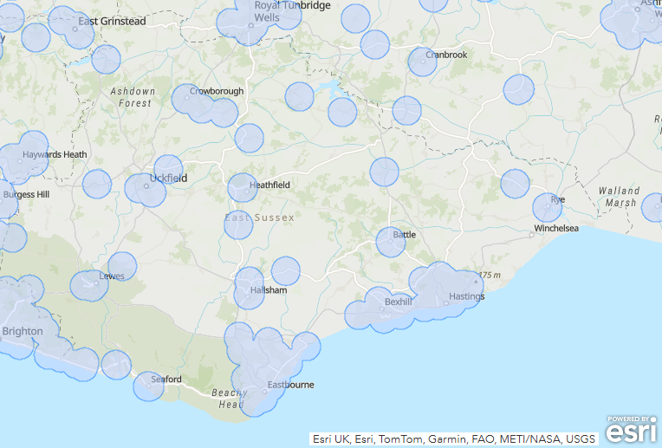
Source: South East ICBs: Mapping Tool to Support Dispensing List Validation, SCW CSU

Locally Commissioned Services
The following are locally commissioned by the NHS Sussex Integrated Care Board:
- Oral Antiviral Medication for the Treatment of COVID-19 and Management of Influenza
- End of life drugs
- Extended open hours for Bank Holidays (managed by the South East Commissioning Hub)
The following are locally commissioned by East Sussex County Council as Public Health Local Service Agreements:
- C Card
- Emergency Hormone Contraception (EHC)
- Smoking Cessation
The following are locally commissioned via Change Grow Live (CGL) who provide substance misuse treatment services in East Sussex for East Sussex County Council:
- Opiate reversers [naloxone]
- Needle exchange
- Distribution of oral substitution therapy and supervised consumption

2. The Pharmaceutical Needs Assessment process

2.1 Aim
The aim of the East Sussex PNA is to describe the current pharmaceutical services in East Sussex, systematically identify any gaps in provision in relation to population need and, in consultation with stakeholders, make recommendations on future development, and meet or exceed the minimum statutory requirements for PNAs and enable the HWB to have regard to all relevant matters.

2.2 Objectives
To state, on behalf of the HWB,
- which pharmaceutical services are necessary to meet the need for pharmaceutical services
- not provided but need to be to meet a current or future need for a range of or specific pharmaceutical service
- not necessary to meet the need for pharmaceutical services but have secured improvements or better access
- which would secure improvements or better access either now or in the future
- other NHS services that affect the need for pharmaceutical services or a specific pharmaceutical service
- examine the current and future demographics of the local population and their health needs in relation to pharmaceutical service provision
- state how localities have been determined and how their different needs have been identified, including the different needs of those who shared a protected characteristic
- compile a comprehensive list of pharmacies and review the services currently provided
- define choice and identify whether there is sufficient choice about obtaining pharmaceutical services
- compile a comprehensive list of GP dispensaries
- list other services including community pharmacies and services available in neighbouring Health and Wellbeing Board (HWB) areas that might affect the need for services in East Sussex
- identify service gaps that could be met by providing additional or new pharmacy services [including hours of opening], or potentially by opening one or more new pharmacies
- produce maps relating to East Sussex pharmaceutical services, location of pharmacies in relation to population deprivation indices, estimate travel/walking times
- consult and engage with stakeholders and the public throughout the process so that their opinions inform the PNA document
- collate the findings from and respond to the two-month statutory public consultation period, after completion of the draft PNA assessment, before consideration by the Health and Wellbeing Board and publication in October 2025

2.3 Methodology
The 2022 PNA report has been used in developing the 2025 PNA.
A key reference document for this PNA has been the Guidance for PNAs produced by the Department for Health and Social Care in October 2021.
District and borough council areas have been used where data are available to provide the local level analysis where required. For some of the population demographic maps, smaller geographies have also been used.
A steering group was formed to guide the PNA process. The steering group included representatives from the following organisations:
- NHS Sussex Integrated Care Board – Commissioning and Medicines Optimisation team
- East Sussex County Council – Public Health and Consultation teams
- Community Pharmacy, Surrey & Sussex (Local Pharmaceutical Committee)
- Surrey & Sussex Local Medical Committee
- Healthwatch East Sussex

2.4 Key Steps
The assessment has involved the following key steps:
- Reviewing current and predicted population demographics
- Looking at health and social care needs
- Collation of community pharmacy and GP dispensary information about current service provision including travel analysis
- Collation and summary of routine pharmacy contracting and activity data
- Survey of the public who use local pharmacy services
- Gap analysis for each District and Borough area in East Sussex
- Undertake professional and public consultation

2.5 Defining “necessary services” for the PNA
From: Pharmaceutical Needs Assessments guidelines
Necessary services are defined within the 2013 regulations as those that are necessary to meet the need for pharmaceutical services and could be provided within or outside of the health and wellbeing board’s area.
The 2013 regulations do not include a definition of what is a necessary service and what is not, so health and wellbeing boards have complete discretion as to how they go about this.
There are two potential ways to define which services are necessary services
(a) by the type of service, for example all essential services and certain advanced and enhanced services; or
(b) by pharmacy, location, or time and day of the week that services are provided. This may be harder where, for example, there are four pharmacies in a town all providing the same range of services at approximately the same times of the day and days of the week. The health and wellbeing board may have difficulty in deciding which are necessary and which are other relevant services.
For the purposes of this pharmaceutical needs assessment 2025, the Steering Group agreed that necessary services are:
- Essential services provided at all premises included in the pharmaceutical lists
- Pharmacy First advanced service provided from the majority of premises to give good geographical coverage
- The dispensing service provided by some GP practices

3. Strategic Context

3.1 The geography of East Sussex
East Sussex is located on the southeast coast of England. It is a two-tier local authority, with an upper tier local authority (East Sussex County Council) and five lower tier local authorities (Eastbourne Borough Council, Hastings Borough Council, Lewes District Council, Rother District Council and Wealden District Council) covering a population of approximately 550,700 residents (ONS mid-year estimates, 2022).
East Sussex lies between Kent to the north and east, and Brighton and West Sussex to the west. The most populated areas are along the coast with other inland towns surrounded by more rural areas. The county includes the iconic Seven Sisters coastline, the South Downs National Park and the High Weald area of Outstanding Natural Beauty. Within Lewes district there is a port at Newhaven with cross channel connections to Dieppe for both commercial and private passengers.
Map: County of East Sussex and details the major towns and roads within its boundary
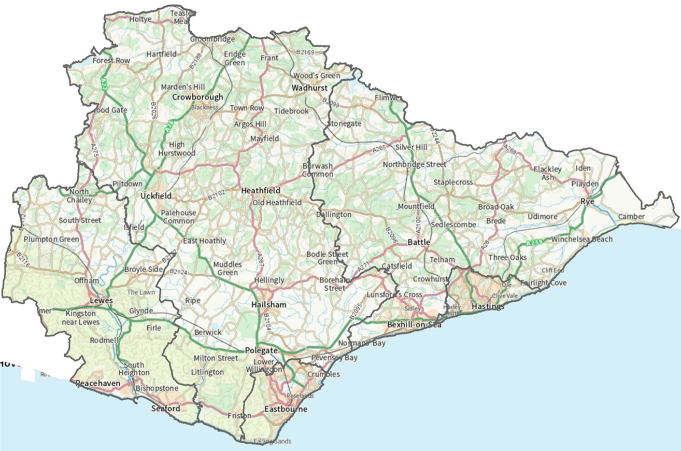
© Crown copyright – all rights reserved. AC000808855, 2025.

3.2 Health and care sites
Within East Sussex the health and care infrastructure across the county includes:
- 2 acute hospitals and 5 community hospitals
- 50 GP practices, 48 branch/satellite surgeries and 12 Primary Care Networks
- 93 community pharmacies, 3 distance selling pharmacies and 16 dispensing GP practices
- 282 care homes
Map: Key NHS Sites in East Sussex
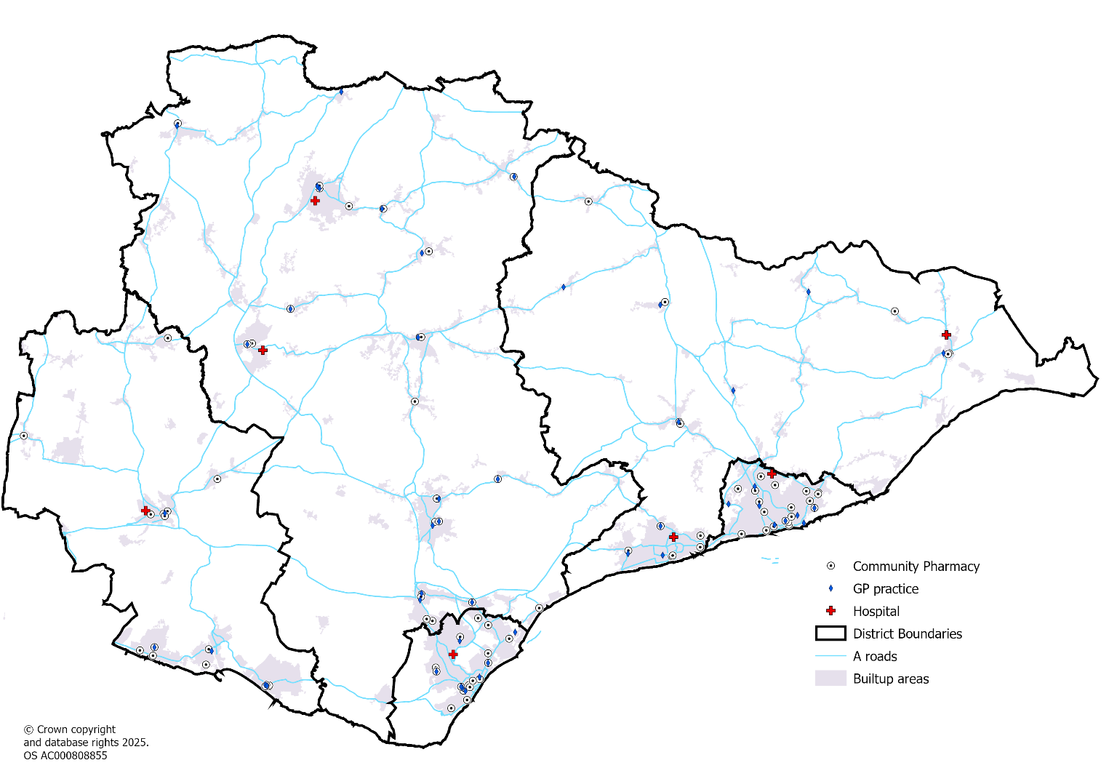

Map: Care homes in East Sussex
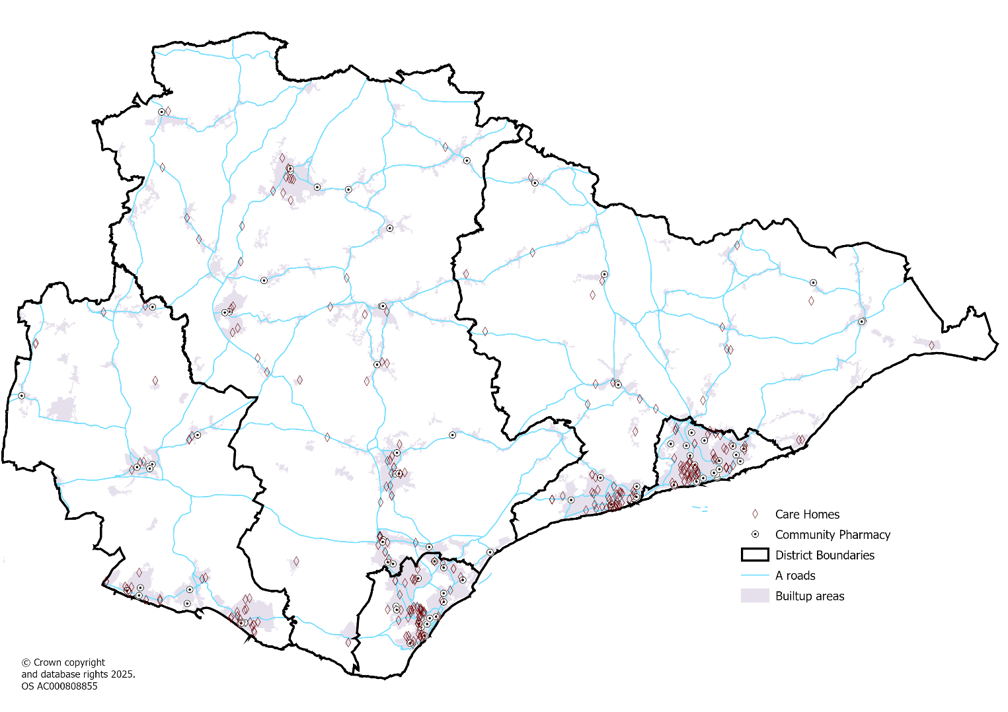

4. Demography

4.1 Age and sex

Age structure
East Sussex has a total resident population of 551,007 and a much older age profile compared to England.
Chart: Population pyramid for East Sussex and England, mid-2022 population estimates
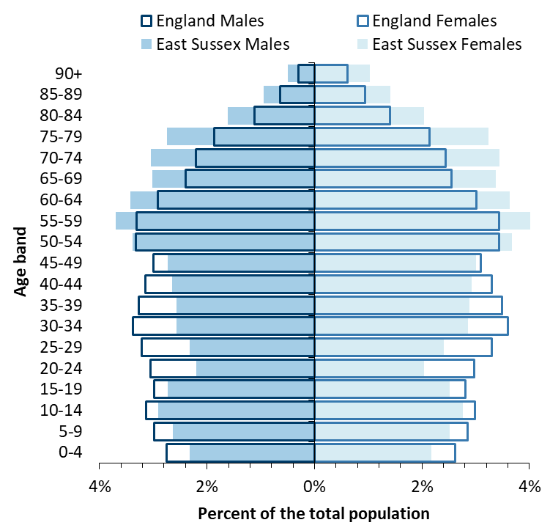
Source: Mid-2022 population estimates, Office for National Statistics
In terms of population size, Wealden is the largest district in East Sussex and Hastings is the smallest.
All districts have an older age profile compared to England, but Rother has a particularly older profile with almost 1 in 3 residents aged 65 years or older, compared to fewer than 1 in 5 for England.

Table: Resident population estimates, 2022
Area | 0-15 | 16-64 | 65-84 | 85+ | Total
Eastbourne | 17,110 | 59,930 | 21,125 | 4,199 | 102,364
Hastings | 16,144 | 55,716 | 16,385 | 2,376 | 90,621
Lewes | 16,635 | 57,032 | 22,840 | 4,172 | 100,679
Rother | 13,753 | 49,751 | 26,069 | 4,648 | 94,221
Wealden | 27,015 | 92,479 | 37,624 | 6,004 | 163,122
East Sussex | 90,657 | 314,908 | 124,043 | 21,399 | 551,007
England | 10,567,635 | 35,915,152 | 9,204,907 | 1,424,848 | 57,112,542
Source: Mid-2022 resident population estimates, Office for National Statistics
Table: Resident population estimates, 2022
Area | 0-15 | 16-64 | 65-84 | 85+ | Total
Eastbourne | 17% | 59% | 21% | 4.1% | 17%
Hastings | 18% | 61% | 18% | 2.6% | 18%
Lewes | 17% | 57% | 23% | 4.1% | 17%
Rother | 15% | 53% | 28% | 4.9% | 15%
Wealden | 17% | 57% | 23% | 3.7% | 17%
East Sussex | 16% | 57% | 23% | 3.9% | 16%
England | 19% | 63% | 16% | 2.5% | 19%
Source: Mid-2022 resident population estimates, Office for National Statistics

Key age groups across East Sussex
The following small area maps show the percentage of the population in specific more dependent age groups; 0-15 years, 65-84 years and 85 years and over. The younger age group is more concentrated in urban areas of Eastbourne, Hastings, Bexhill, Hailsham, Newhaven and Crowborough.
The older age groups are more concentrated in Seaford, Bexhill, Eastbourne and Eastern Rother.
Map: Population aged 0-15 years by MSOA in East Sussex, 2022
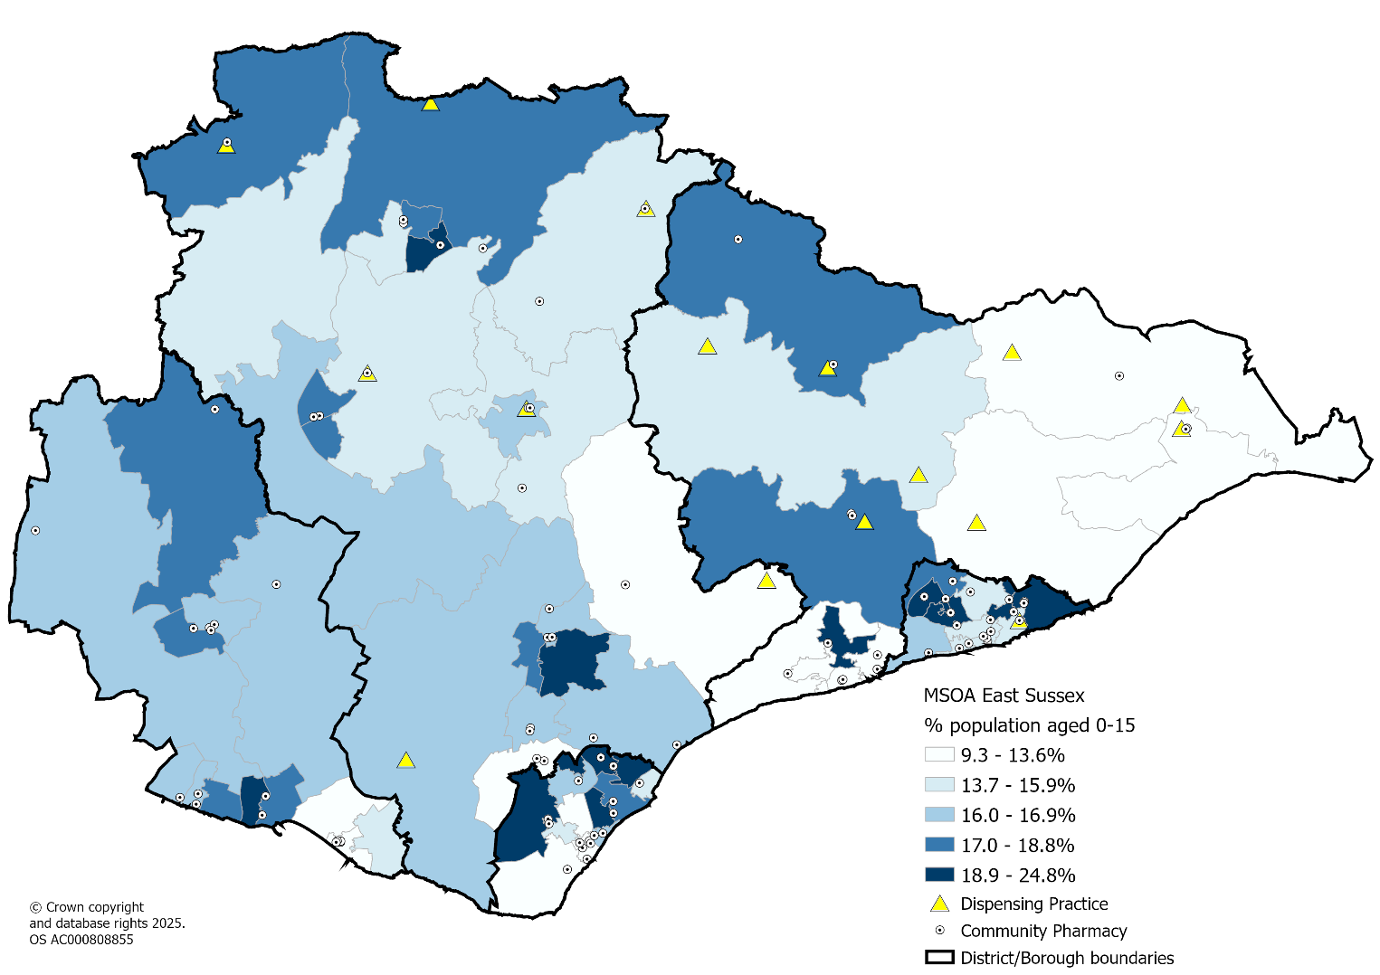
Source: Mid-2022 population estimates, Office for National Statistics

Map: Population aged 65-84 years by MSOA in East Sussex, 2022
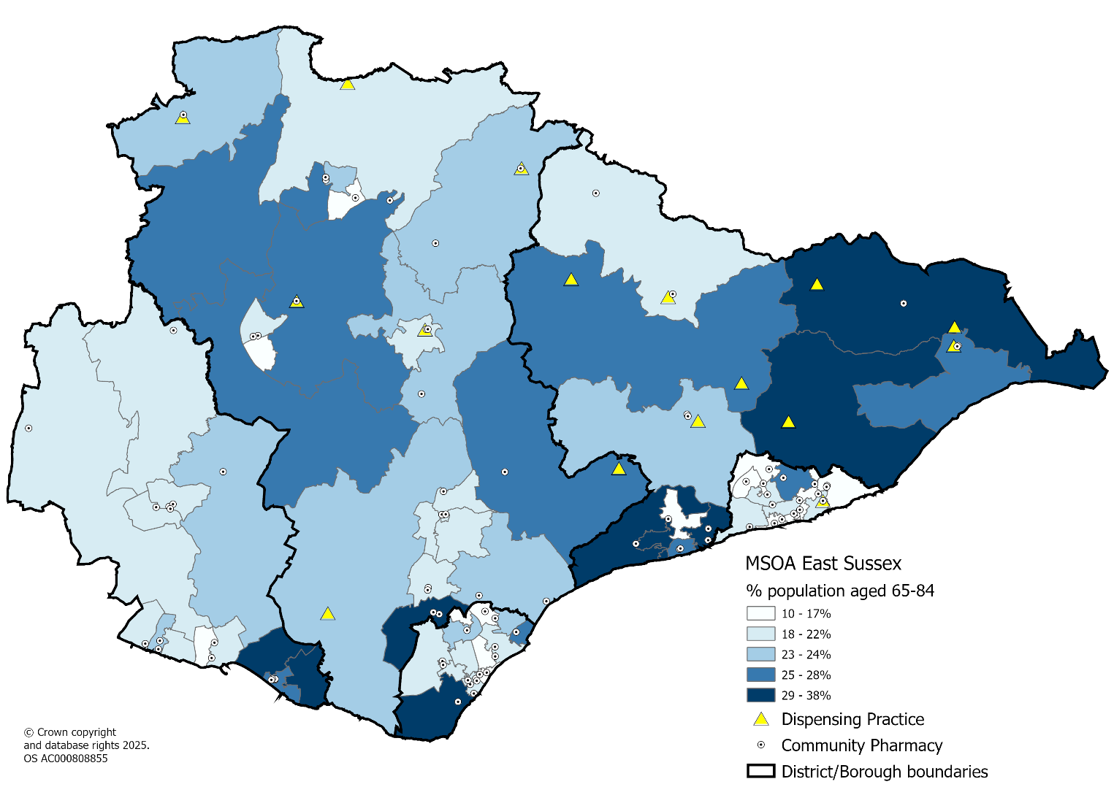
Source: Mid-2022 population estimates, Office for National Statistics

Map: Population aged 85 years and over by MSOA in East Sussex, 2022
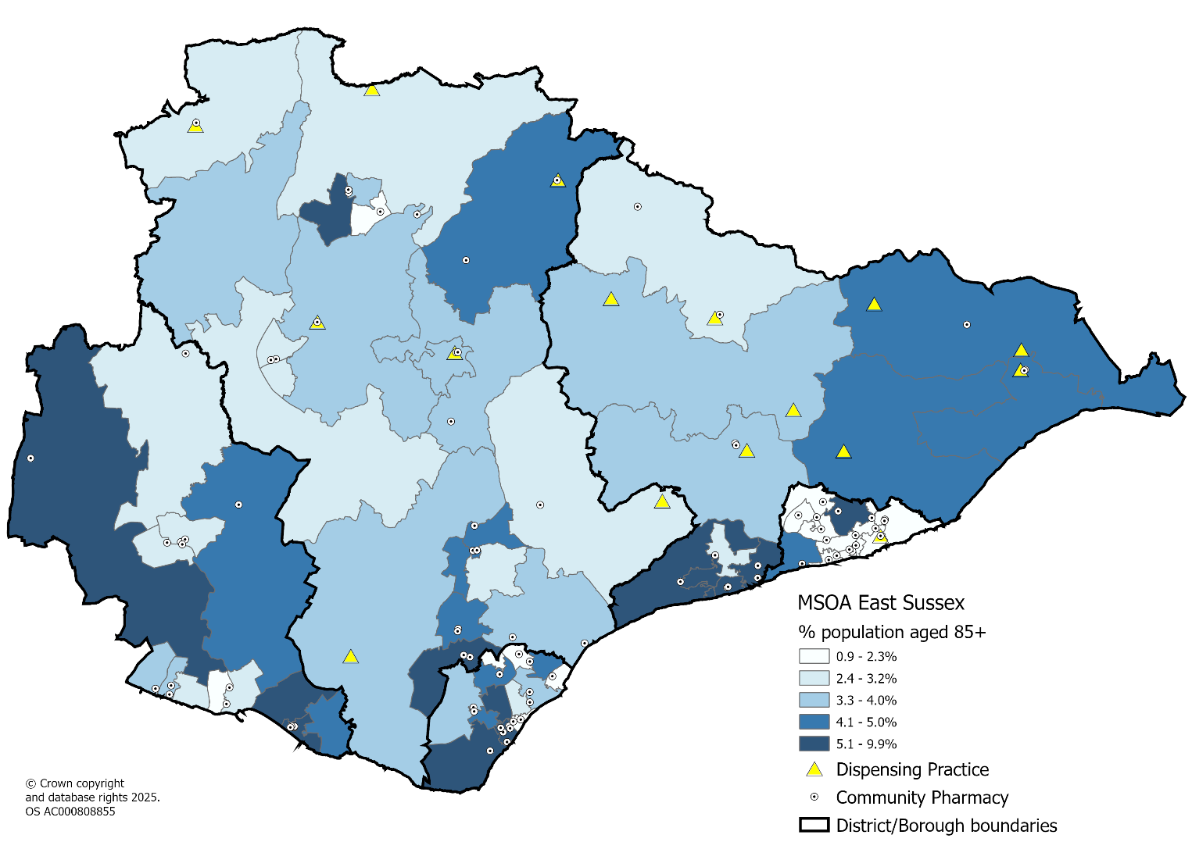
Source: Mid-2022 population estimates, Office for National Statistics

Births
There has been a general decline in birth rates in East Sussex over the past 5 years, similar to what has been observed in England.
East Sussex and most of its districts and boroughs have had lower birth rates (all ages) than England, however Hastings has higher birth rates than England

Chart: Live birth rate (per 1,000 women aged 15-44 years), 2014-2020
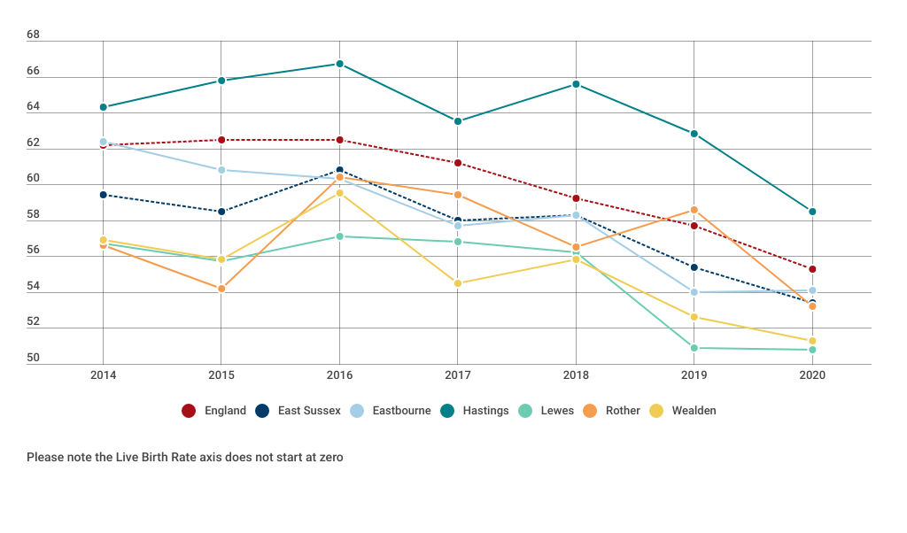
Source: Office for National Statistics
The table below shows that for women aged 35+ birth rates were lower than England for all districts and boroughs apart from Lewes and Rother. All districts and boroughs had a higher birth rate compared to England in women aged 20-34 years apart from Lewes.
The birth rates for women under 20 years, and 40 years and over, are based on the female population aged 15 to 19 years and 40 to 44 years, respectively. Birth rates for under 20s were higher than England in Eastbourne and Hastings Boroughs in 2020.
Table: Live Birth rate (per 1,000 women in the age group), 2020
Location | Under 20 | 20-24 | 25-29 | 30-34 | 35-39 | 40 & Over | all ages
England | 10 | 45 | 85 | 103 | 60 | 16 | 55
East Sussex | 10 | 50 | 92 | 104 | 56 | 13 | 53
Eastbourne | 15 | 54 | 101 | 107 | 47 | 12 | 54
Hastings | 17 | 68 | 94 | 99 | 50 | 15 | 59
Lewes | 7 | 39 | 88 | 102 | 63 | 13 | 51
Rother | 7 | 52 | 90 | 96 | 63 | 15 | 53
Wealden | 6 | 39 | 90 | 110 | 57 | 13 | 51
Source: Office for National Statistics

4.2 Ethnicity
Key Findings from East Sussex 2021 Census Briefing: Ethnicity, Language and Religion
Around 512,440 residents (93.9%) of East Sussex identified their ethnic group as white in the 2021 Census, the second highest proportion in the South East after the Isle of Wight. The second most common high-level ethnic group was “Mixed or Multiple ethnic groups”, comprising 2.3% of the population (12,310 people).
The number of residents identifying through the “White: Other White” category increased from 3.4% (17,870 people) in 2011 to 4.5% (24,580) in 2021, the largest percentage increase across all 19 ethnic groups.
Only 5.5% of the overall population (29,880 people) identified with a non-UK national identity; the largest increase within this group was in the “Romanian only” group, which increased from 0.06% of all residents (290 people) in 2011 to 0.4% (2,010) in 2021. Overall, this is the 3rd most common non-UK national identity after “Polish only” (0.4%, 2,390) and “Irish only” (0.4%, 2,250).
96.3% of residents aged three and over (511,760 out of 531,370) cited English as their main language, and a further 3.2% (16,770) said they spoke English either "well" or "very well” but did not speak it as their main language.
Table: Percentage of the population by ethnic group, 2021
Ethnic group | Eastbourne | Hastings | Lewes | Rother | Wealden | East Sussex | England
All Asian or Asian British | 3.5% | 2.8% | 1.9% | 1.5% | 1.4% | 2.1% | 9.6%
All Black, Black British, Caribbean or African | 1.3% | 1.4% | 0.7% | 0.6% | 0.4% | 0.8% | 4.2%
All Mixed or Multiple ethnic groups | 2.8% | 2.9% | 2.5% | 1.8% | 1.7% | 2.3% | 3.0%
All White ethnic group | 90.8% | 91.4% | 94.2% | 95.6% | 96.0% | 93.9% | 81.0%
- White: English, Welsh, Scottish, Northern Irish or British | 82.1% | 85.1% | 88.9% | 91.7% | 91.8% | 88.3% | 73.5%
- White: Other | 8.7% | 6.4% | 5.3% | 3.9% | 4.3% | 5.6% | 7.5%
All Other ethnic group | 1.7% | 1.5% | 0.7% | 0.5% | 0.5% | 0.9% | 2.2%
Source: 2021 Census, Office for National Statistics

Chart: Ethnic groups other than White British or Northern Irish in East Sussex, 2021
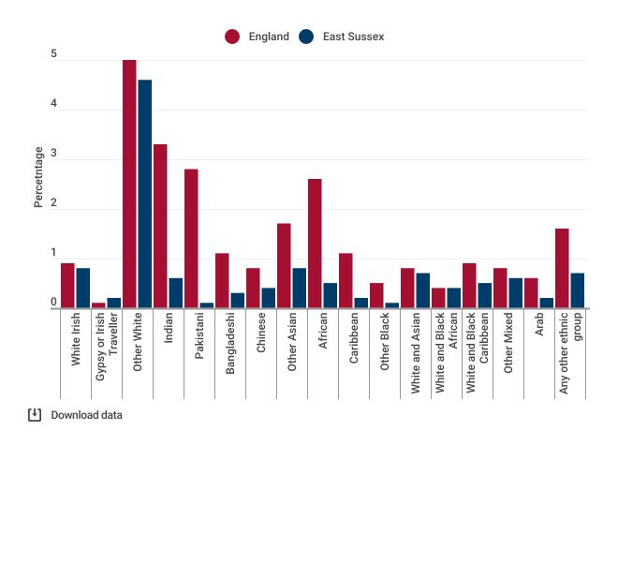
Source: 2021 Census, Office for National Statistics
The more ethnically diverse populations in East Sussex are located in Eastbourne, Hastings & St Leonards, the Havens, Lewes town and Forest Row.

Map: Ethnically diverse populations* by MSOA, 2021
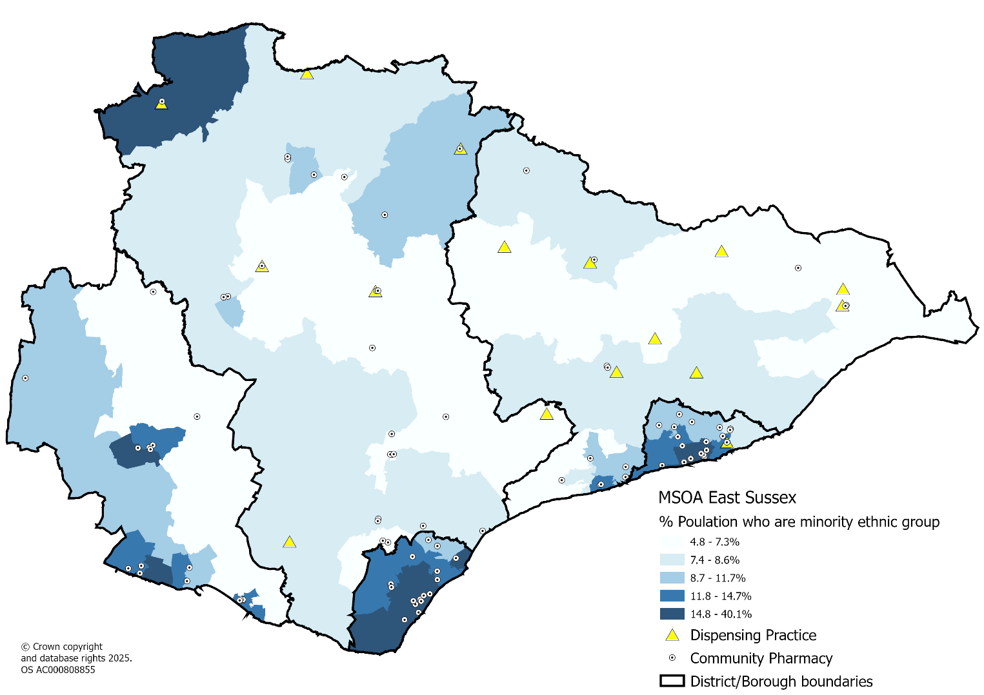
*Note: Percent of the population from an ethnic group other than White: English, Welsh, Scottish, Northern Irish or British
Source: 2021 census, Office for National Statistics

4.3 Population change 2025-2028
Between 2025 and 2028 there is estimated to be an extra 13,180 residents that will be living in East Sussex which represents a 2.4% increase over the three-year period. The greatest percentage increases will occur in the older age groups.
Table: Population projections between 2025 and 2028 in East Sussex
Age group | 2025 | 2028 | Change | % change
0-15 | 89,960 | 88,620 | -1,340 | -1.5%
16-64 | 316,740 | 319,240 | 2,500 | 0.8%
65-84 | 130,420 | 139,760 | 9,340 | 7.2%
85+ | 22,880 | 25,560 | 2,680 | 11.7%
Total | 560,000 | 573,180 | 13,180 | 2.4%
Source: Population projections (2023 based dwelling led), East Sussex County Council, March 2025
Wealden is estimated to see the largest percentage increase in population at 4.6%. Lewes (2.2%) and Rother (2.2%) are projected to experience similar increases to the East Sussex average (2.4%). Hastings (1.3%) is estimated to see a smaller increase, whilst Eastbourne is estimated to see a slight decrease (-0.1%).
Table: Population projections between 2025 and 2028 in Eastbourne borough
Age group | 2025 | 2028 | Change | % change
0-15 | 16,620 | 15,660 | -960 | -5.8%
16-64 | 60,320 | 59,180 | -1,140 | -1.9%
65-84 | 22,380 | 23,930 | 1,550 | 6.9%
85+ | 4,380 | 4,800 | 420 | 9.6%
Total | 103,700 | 103,570 | -130 | -0.1%
Source: Population projections (2023 based dwelling led), East Sussex County Council, March 2025
Table: Population projections between 2025 and 2028 in Hastings borough
Age group | 2025 | 2028 | Change | % change
0-15 | 15,730 | 15,290 | -440 | -2.8%
16-64 | 55,910 | 55,940 | 30 | 0.1%
65-84 | 17,200 | 18,480 | 1,280 | 7.4%
85+ | 2,560 | 2,880 | 320 | 12.5%
Total | 91,400 | 92,590 | 1,190 | 1.3%
Source: Population projections (2023 based dwelling led), East Sussex County Council, March 2025
Table: Population projections between 2025 and 2028 in Lewes district
Age group | 2025 | 2028 | Change | % change
0-15 | 16,490 | 16,120 | -370 | -2.2%
16-64 | 57,580 | 58,290 | 710 | 1.2%
65-84 | 23,810 | 25,280 | 1,470 | 6.2%
85+ | 4,530 | 4,960 | 430 | 9.5%
Total | 102,410 | 104,650 | 2,240 | 2.2%
Source: Population projections (2023 based dwelling led), East Sussex County Council, March 2025

Table: Population projections between 2025 and 2028 in Rother district
Age group | 2025 | 2028 | Change | % change
0-15 | 13,610 | 13,380 | -230 | -1.7%
16-64 | 49,420 | 49,410 | -10 | 0.0%
65-84 | 27,080 | 28,900 | 1,820 | 6.7%
85+ | 4,850 | 5,390 | 540 | 11.1%
Total | 94,960 | 97,080 | 2,120 | 2.2%
Source: Population projections (2023 based dwelling led), East Sussex County Council, March 2025
Table: Population projections between 2025 and 2028 in Wealden district
Age group | 2025 | 2028 | Change | % change
0-15 | 27,510 | 28,170 | 660 | 2.4%
16-64 | 93,510 | 96,430 | 2,920 | 3.1%
65-84 | 39,960 | 43,180 | 3,220 | 8.1%
85+ | 6,560 | 7,530 | 970 | 14.8%
Total | 167,540 | 175,310 | 7,770 | 4.6%
Source: Population projections (2023 based dwelling led), East Sussex County Council, March 2025

4.4 Housing development plans 2025/26 to 2027/28
This section details the latest available planned housing completions within each of the district and borough council areas in East Sussex for the period 2025/26 to 2027/28.
The figures gathered are the current estimates of completions planned over the period of the PNA. Some plans are currently being reviewed and updated and may change during the lifetime of the PNA. Also, it is possible that houses may not be completed by the date originally intended in the plans.
Around 9,000 new completions are currently planned for the period of the PNA. 46% of new completions are currently planned for Wealden, with 19% in Rother, 16% in Lewes, 11% in Hastings and 8% in Eastbourne.
No single ward/parish has close to a further 2,000 planned developments and therefore there is no need for additional pharmacy locations.
Table: Planned housing completions, 2025/26 to 2027/28
District/borough | 2025/26 | 2026/27 | 2027/28 | Total | %
Eastbourne | 229 | 234 | 238 | 701 | 8%
Hastings | 382 | 395 | 218 | 995 | 11%
Lewes | 408 | 565 | 506 | 1,479 | 16%
Rother | 386 | 624 | 727 | 1,737 | 19%
Wealden | 1,001 | 1,548 | 1,552 | 4,101 | 46%
East Sussex | 2,406 | 3,366 | 3,241 | 9,013 | 100%
Source: Local planning teams in East Sussex

Eastbourne borough
Table: Planned housing completions in Eastbourne, 2025/26 to 2027/28
Eastbourne ward | 2025/26 | 2026/27 | 2027/28 | Total
Devonshire | 58 | 41 | 81 | 180
Hampden Park | 5 | 10 | 0 | 15
Langney | 7 | 4 | 1 | 12
Meads | 75 | 65 | 11 | 151
Old Town | 12 | 8 | 2 | 22
Ratton | 1 | 2 | 11 | 14
Sovereign | 0 | 46 | 35 | 81
St. Anthony's | 5 | 3 | 36 | 44
Upperton | 66 | 55 | 61 | 182
Total | 229 | 234 | 238 | 701
Map: Wards in Eastbourne
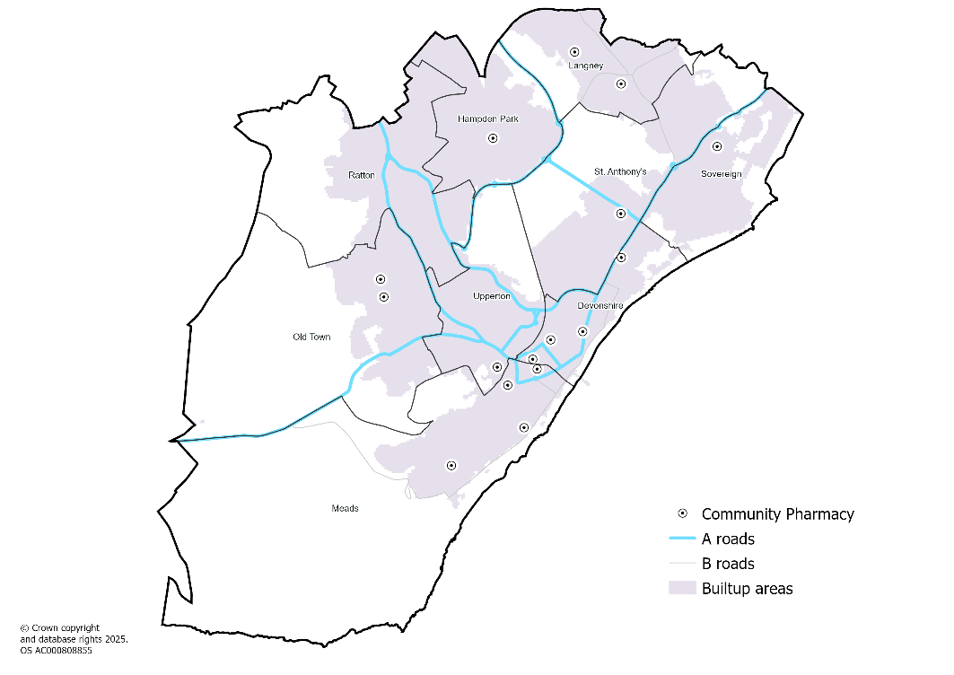

Hastings borough
Table: Planned housing completions in Hastings, 2025/26 to 2027/28
Hastings ward | 2025/26 | 2026/27 | 2027/28 | Total
Ashdown | 82 | 63 | 63 | 208
Baird | 24 | 3 | 3 | 30
Braybrooke | 2 | 12 | 3 | 17
Castle | 56 | 120 | 3 | 179
Central St Leonards | 8 | 18 | 3 | 29
Conquest | 33 | 33 | 33 | 99
Gensing | 13 | 2 | 22 | 37
Hollington | 3 | 3 | 33 | 39
Maze Hill | 13 | 38 | 11 | 62
Old Hastings | 3 | 3 | 3 | 9
Ore | 3 | 17 | 29 | 49
Silverhill | 21 | 3 | 2 | 26
St Helens | 3 | 3 | 2 | 8
Tressell | 33 | 23 | 2 | 58
West St Leonards | 69 | 52 | 3 | 124
Wishing Tree | 16 | 2 | 3 | 21
Total | 382 | 395 | 218 | 995

Map: Wards in Hastings
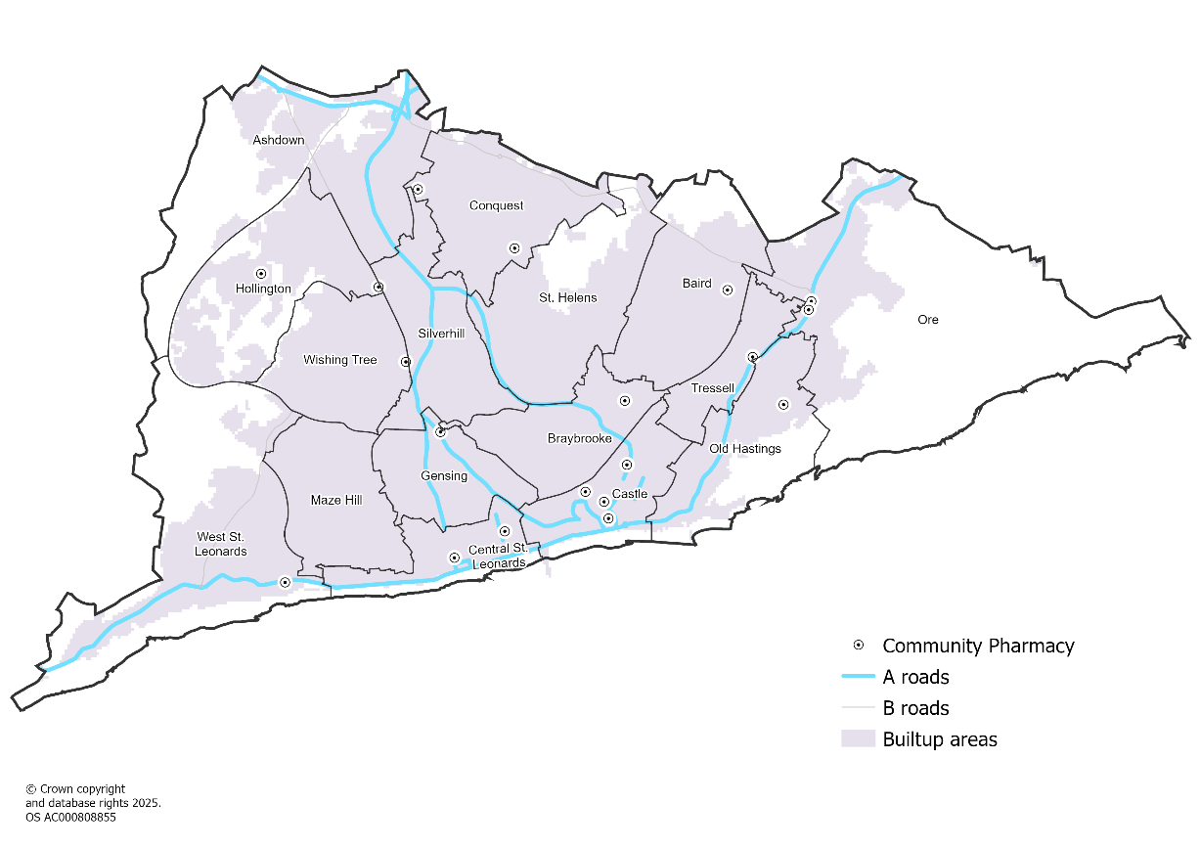

Lewes district
Table: Planned housing completions in Lewes, 2025/26 to 2027/28
Lewes parish | 2025/26 | 2026/27 | 2027/28 | Total
Barcombe | 13 | 12 | 10 | 35
Beddingham | 0 | 0 | 0 | 0
Chailey | 19 | 23 | 17 | 59
Ditchling | 3 | 0 | 0 | 3
East Chiltington | 2 | 0 | 0 | 2
Falmer | 0 | 0 | 0 | 0
Firle | 0 | 0 | 0 | 0
Glynde | 0 | 0 | 0 | 0
Hamsey | 10 | 7 | 7 | 24
Iford | 0 | 0 | 0 | 0
Kingston | 2 | 0 | 1 | 3
Lewes | 94 | 74 | 76 | 244
Newhaven | 71 | 142 | 134 | 347
Newick | 29 | 25 | 6 | 60
Peacehaven | 20 | 18 | 12 | 50
Piddinghoe | 1 | 0 | 0 | 1
Plumpton | 23 | 31 | 22 | 76
Ringmer | 42 | 94 | 120 | 256
Rodmell | 1 | 0 | 0 | 1
Seaford | 44 | 59 | 47 | 150
Southease | 0 | 0 | 0 | 0
South Heighton | 0 | 11 | 0 | 11
St Ann Without | 0 | 0 | 0 | 0
St John Without | 0 | 0 | 0 | 0
Streat | 1 | 0 | 0 | 1
Tarring Neville | 1 | 0 | 0 | 1
Telscombe | 10 | 8 | 0 | 18
Westmeston | 1 | 0 | 0 | 1
Wivelsfield | 21 | 61 | 54 | 136
Total | 408 | 565 | 506 | 1,479
Map: Parishes in Lewes
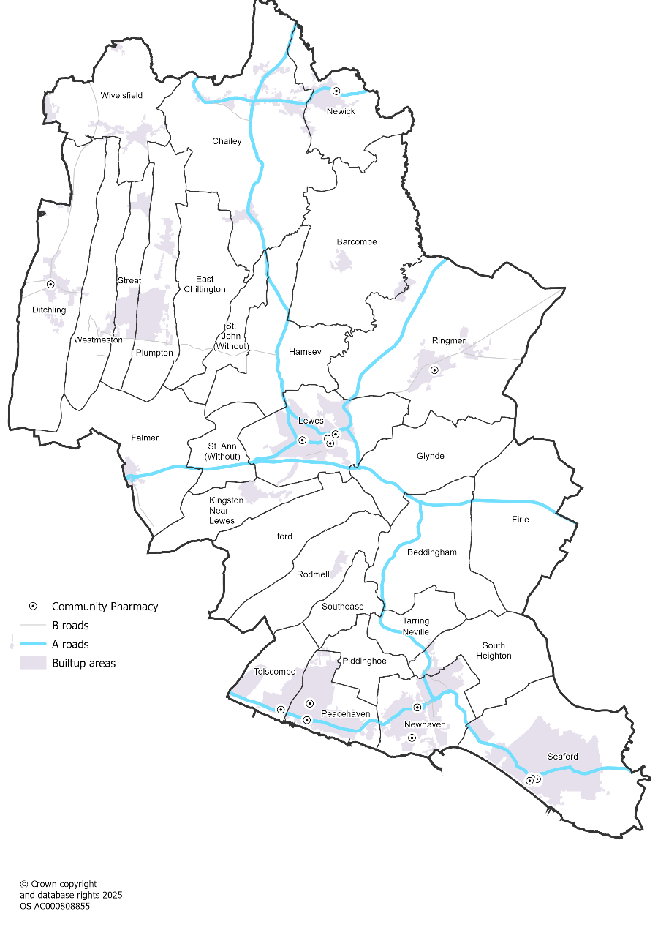

Rother district
Table: Planned housing completions in Rother, 2025/26 to 2027/28
Rother parish | 2025/26 | 2026/27 | 2027/28 | Total
Ashburnham | 0 | 0 | 0 | 0
Battle | 25 | 110 | 120 | 255
Beckley | 2 | 2 | 1 | 5
Bexhill | 248 | 393 | 437 | 1,078
Bodiam | 0 | 0 | 0 | 0
Brede | 1 | 1 | 1 | 3
Brightling | 0 | 0 | 0 | 0
Burwash | 28 | 16 | 2 | 46
Camber | 2 | 11 | 1 | 14
Catsfield | 1 | 1 | 1 | 3
Crowhurst | 2 | 2 | 2 | 6
Dallington | 0 | 0 | 0 | 0
East Guldeford | 0 | 0 | 0 | 0
Etchingham | 0 | 0 | 0 | 0
Ewhurst | 1 | 1 | 0 | 2
Fairlight | 1 | 0 | 0 | 1
Guestling | 2 | 2 | 2 | 6
Hurst Green | 15 | 15 | 26 | 56
Icklesham | 2 | 1 | 1 | 4
Iden | 0 | 0 | 12 | 12
Mountfield | 2 | 2 | 2 | 6
Northiam | 2 | 2 | 2 | 6
Peasmarsh | 1 | 21 | 26 | 48
Penhurst | 0 | 0 | 0 | 0
Pett | 0 | 0 | 0 | 0
Playden | 0 | 0 | 0 | 0
Rye | 5 | 5 | 34 | 44
Rye Foreign | 1 | 0 | 0 | 1
Salehurst and Robertsbridge | 17 | 17 | 29 | 63
Sedlescombe | 19 | 12 | 1 | 32
Ticehurst | 5 | 6 | 4 | 15
Udimore | 0 | 0 | 0 | 0
Westfield | 3 | 3 | 23 | 29
Whatlington | 1 | 1 | 0 | 2
Total | 386 | 624 | 727 | 1,737

Map: Parishes in Rother
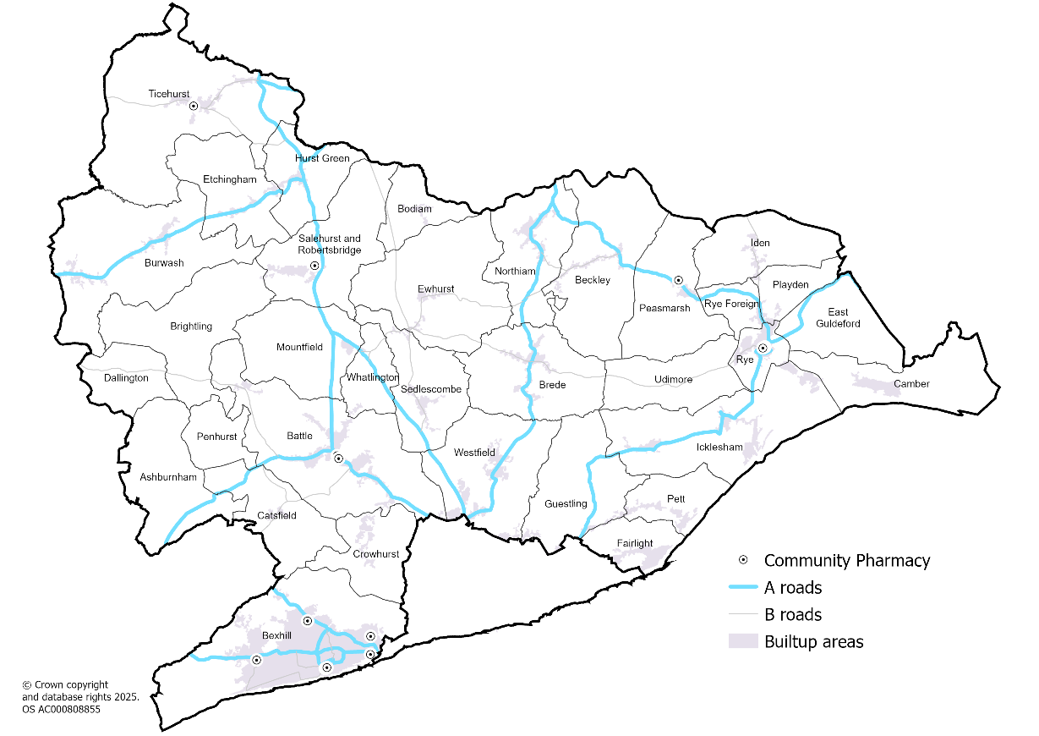

Wealden district
Table: Planned housing completions in Wealden, 2025/26 to 2027/28
Wealden parish | 2025/26 | 2026/27 | 2027/28 | Total
Alciston | 0 | 0 | 0 | 0
Alfriston | 0 | 0 | 0 | 0
Arlington | 10 | 5 | 3 | 18
Berwick | 2 | 0 | 10 | 12
Buxted | 29 | 32 | 35 | 96
Chalvington with Ripe | 32 | 41 | 40 | 113
Chiddingly | 13 | 6 | 0 | 19
Crowborough | 141 | 103 | 50 | 294
Cuckmere Valley | 0 | 0 | 0 | 0
Danehill | 2 | 1 | 0 | 3
East Dean & Friston | 4 | 2 | 0 | 6
East Hoathly with Halland | 50 | 60 | 70 | 180
Fletching | 3 | 0 | 0 | 3
Forest Row | 11 | 9 | 0 | 20
Framfield | 47 | 81 | 80 | 208
Frant | 2 | 22 | 52 | 76
Hadlow Down | 0 | 0 | 0 | 0
Hailsham | 212 | 349 | 377 | 938
Hartfield | 3 | 2 | 0 | 5
Heathfield and Waldron | 8 | 7 | 9 | 24
Hellingly | 73 | 201 | 148 | 422
Herstmonceux | 15 | 62 | 50 | 127
Hooe | 0 | 0 | 0 | 0
Horam | 2 | 59 | 64 | 125
Isfield | 1 | 0 | 0 | 1
Laughton | 4 | 0 | 3 | 7
Little Horsted | 0 | 0 | 0 | 0
Long Man | 0 | 0 | 0 | 0
Maresfield | 9 | 11 | 14 | 34
Mayfield and Five Ashes | 1 | 2 | 3 | 6
Ninfield | 11 | 35 | 35 | 81
Pevensey | 2 | 1 | 1 | 4
Polegate | 29 | 52 | 80 | 161
Rotherfield | 2 | 4 | 8 | 14
Selmeston | 0 | 0 | 0 | 0
Uckfield | 84 | 80 | 79 | 243
Wadhurst | 4 | 3 | 3 | 10
Warbleton | 1 | 0 | 0 | 1
Wartling | 2 | 1 | 1 | 4
Westham | 135 | 239 | 209 | 583
Willingdon and Jevington | 51 | 75 | 125 | 251
Withyham | 6 | 3 | 3 | 12
Total | 1,001 | 1,548 | 1,552 | 4,101

Map: Parishes in Wealden
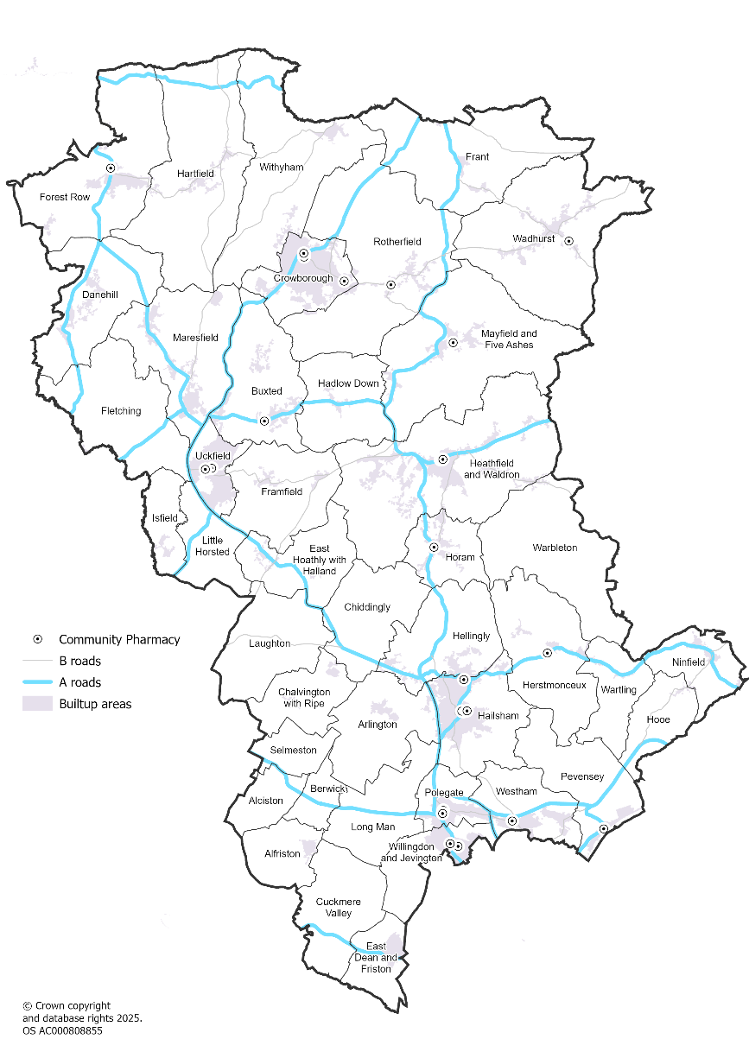

4.5 Rural and urban areas
East Sussex has a mixture of urban and rural areas, with the concentration or urban areas located on the coast, in the central corridor north from Eastbourne up to Heathfield, and the market towns of Lewes, Uckfield and Crowborough in the West and North.
Map: Rural urban areas across East Sussex, 2021
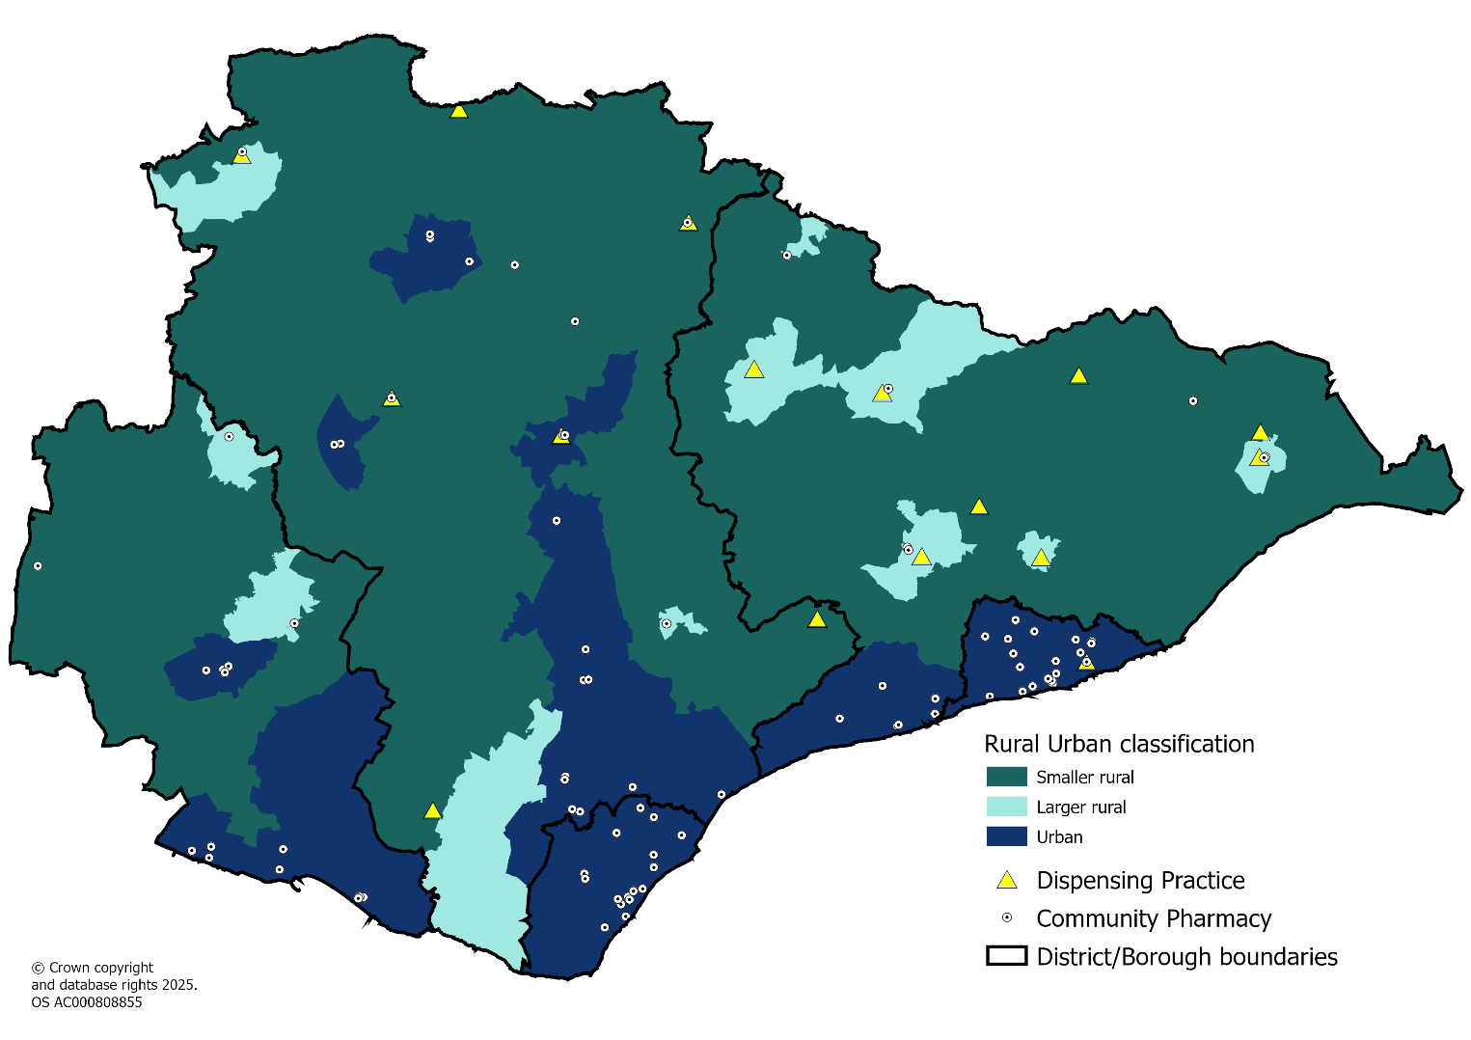
Source: 2021 Rural Urban Classification - Office for National Statistics
When it comes to density of population, the majority of the land in East Sussex is sparsely populated in the rural areas. The areas of high population density in East Sussex are areas with community pharmacies close by.

Map: Population density across East Sussex, 2021
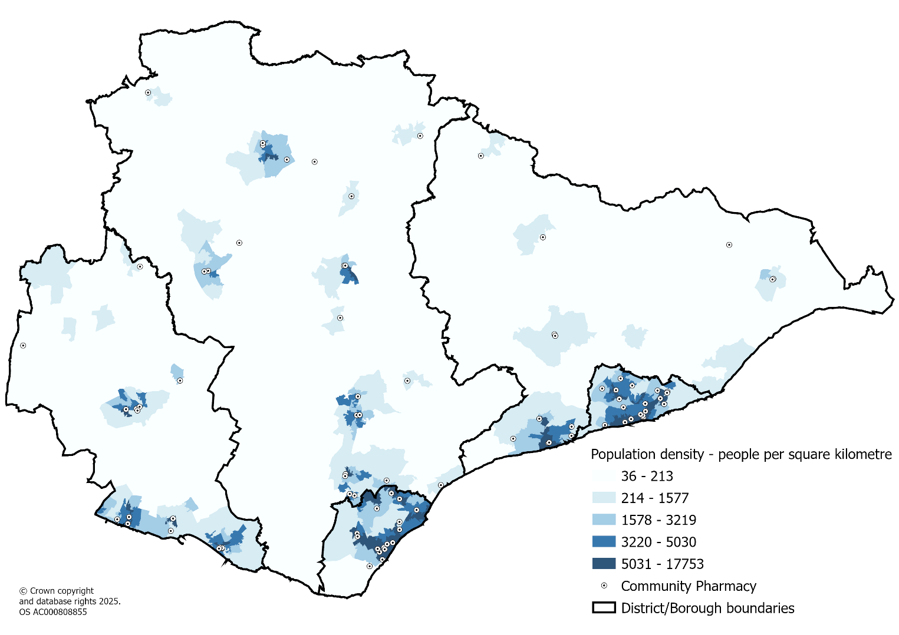
Source: 2021 Census, Office for National Statistics

4.6 Access to a car / van
The areas with low percentages of households with access to a car/van are all in the more densely populated urban areas of East Sussex.
Table: Access to car/van across East Sussex, 2021
District | 1 or more cars or vans in household | No cars or vans in household | Total households | % of households with no access to a car or van
Eastbourne | 33,512 | 12,096 | 45,608 | 26.5
Hastings | 28,658 | 11,801 | 40,459 | 29.2
Lewes | 35,478 | 8,212 | 43,690 | 18.8
Rother | 35,360 | 6,742 | 42,102 | 16.0
Wealden | 61,044 | 7,222 | 68,266 | 10.6
East Sussex | 194,052 | 46,073 | 240,125 | 19.2
Source: 2021 Census, Office for National Statistics

Map: Access to car/van across East Sussex, 2021
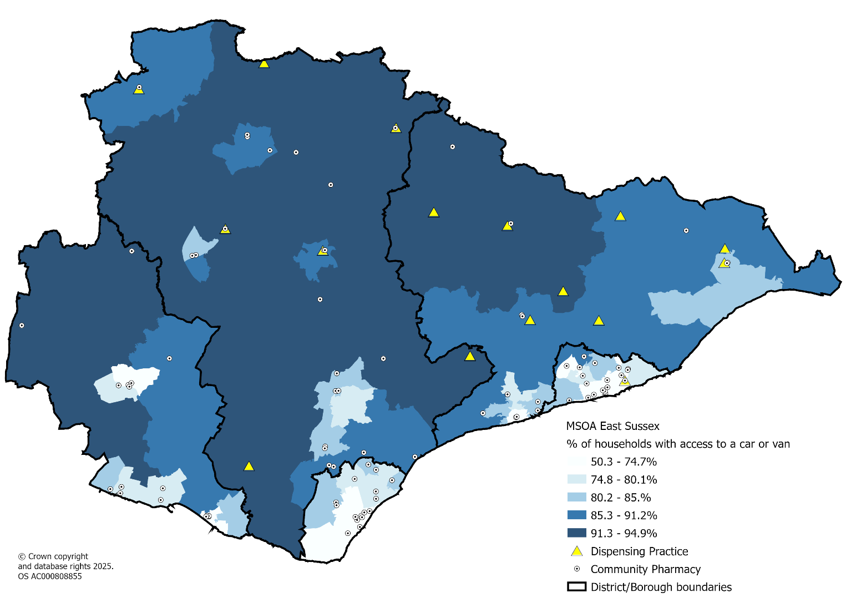
Source: 2021 Census, Office for National Statistics

4.7 Deprivation (IMD 2019)
The Index of Multiple Deprivation 2019 (IMD 2019) describes relative deprivation nationally at Lower Super Output Area (LSOA) level. The table below shows that 43% of LSOAs in Hastings are amongst the most deprived 20% of areas in England. This makes Hastings the most deprived local authority in the South East and amongst the most deprived nationally.
Table: Percentage of East Sussex LSOAs in each national deprivation quintile, IMD 2019
National deprivation quintile | Eastbourne | Hastings | Lewes | Rother | Wealden | East Sussex
1 = most deprived 20% of areas | 20% | 43% | 3% | 10% | 4% | 14%
2 | 30% | 30% | 19% | 21% | 3% | 19%
3 | 26% | 15% | 24% | 34% | 26% | 26%
4 | 13% | 11% | 37% | 26% | 35% | 26%
5 = least deprived 20% of areas | 11% | 0% | 16% | 9% | 32% | 16%
Source: Ministry of Housing, Communities & Local Government, 2019
The map below shows levels of deprivation for Lower Super Output areas (LSOAs) in East Sussex. They are presented as national quintiles so that quintile 1 represents areas that are amongst the most deprived 20% of LSOAs in England. The most deprived areas are mainly in urban coastal areas. This is also the case for Income Deprivation affecting both children and older people.

Map: Areas of deprivation in East Sussex showing the LSOAs ranking according to their national deprivation quintile, 2019
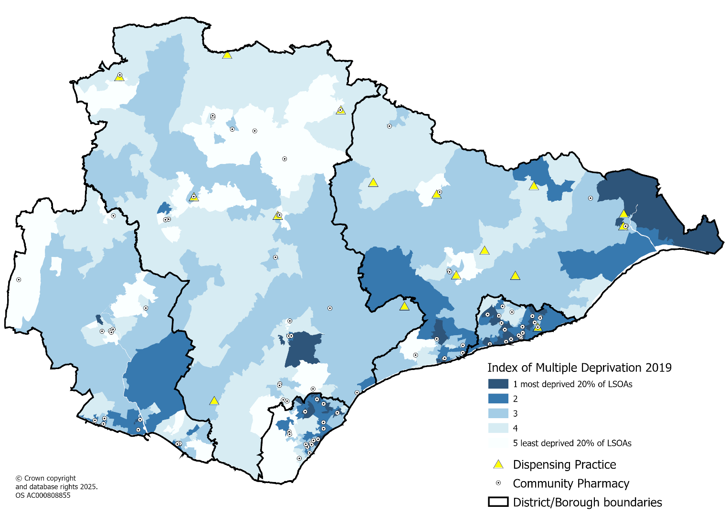
Source: Ministry of Housing, Communities & Local Government, 2019

Map: Income Deprivation Affecting Children Index (IDACI), 2019
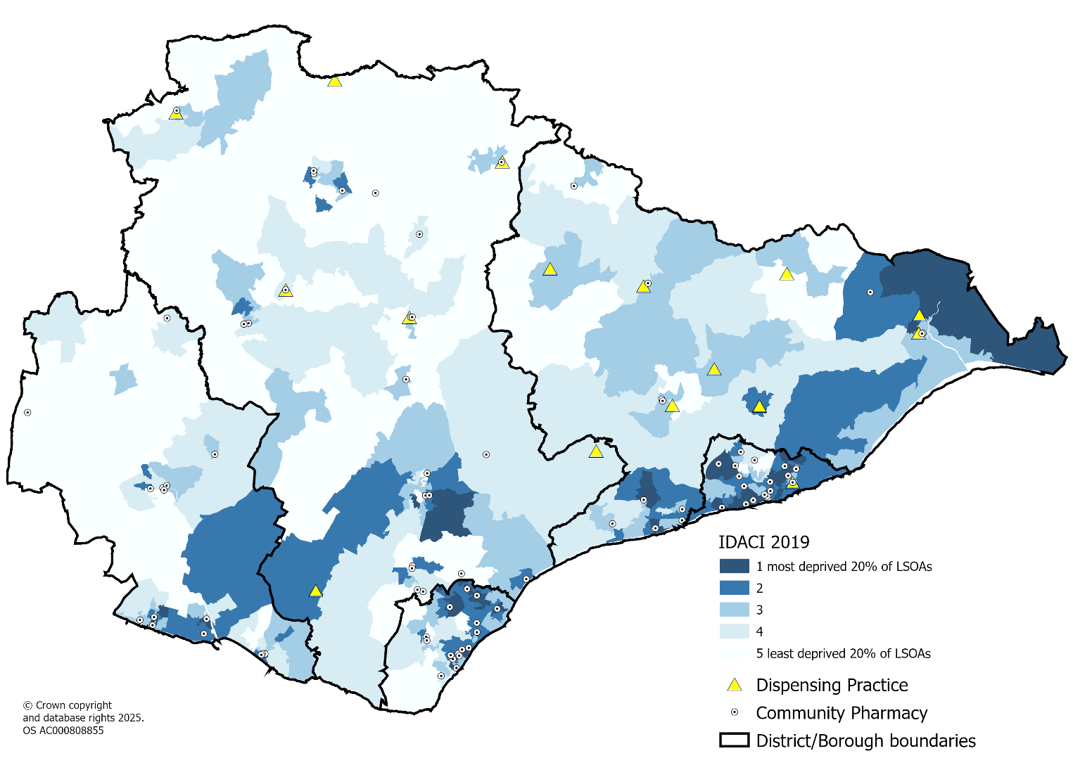
Source: Ministry of Housing, Communities & Local Government, 2019

Map: Income Deprivation Affecting Older people Index (IDAOPI), 2019
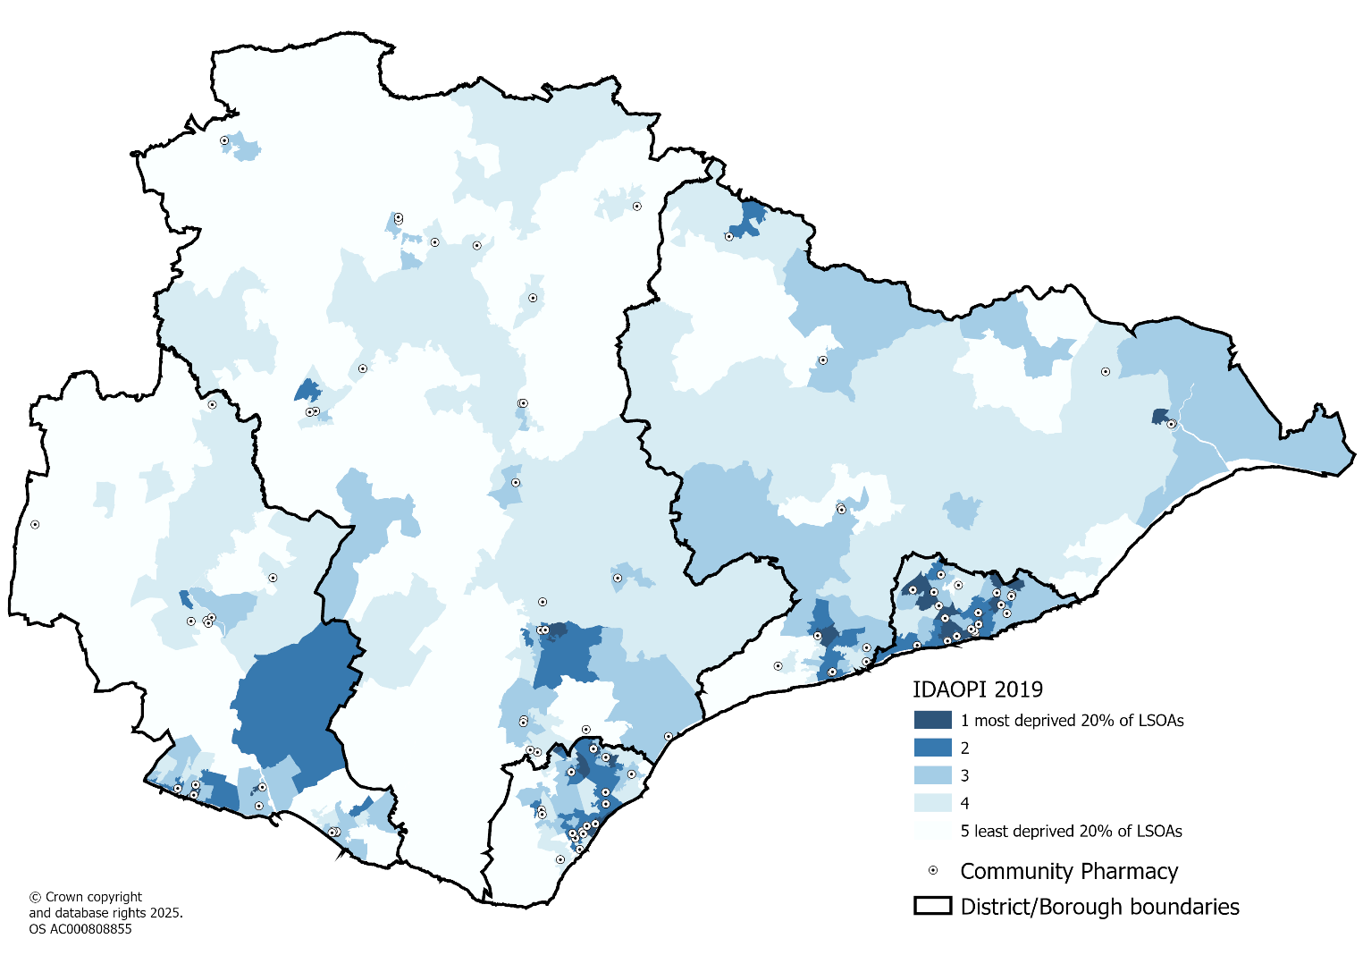 Source: Ministry of Housing, Communities & Local Government, 2019

5. Health and care needs

5.1 Life expectancy
Life Expectancy (LE) at birth is higher at an East Sussex level compared to England for both males and females. LE was increasing in East Sussex up to around 2012-2014 when it began to plateau. It then dropped slightly during the years affected by the COVID-19 pandemic. Recent data (2021-2023) estimates that life expectancy in East Sussex for males is 79.1 years and for females is 83.1 years.
At a district and borough level, male LE for 2021-2023 ranges from 76.7 years in Hastings to 81.9 years in Wealden. For females LE ranges from 80.9 in Hastings to 84.5 in Wealden.
For both males and females, LE is lower than England in Hastings and Eastbourne, and higher in Wealden, Lewes and Rother.
At a small area level (MSOA, latest data 2016-2020) Crowborough North East has the highest LE for males (86.2 years) and Frant and Groombridge for females (88.7 years). For males it is lowest in Pier in Eastbourne (73.4 years) and for females it is lowest in Central St Leonards (78.5 years). At an MSOA level that means that the gap is 12.7 years for males and 10.1 for females.
Table: Life expectancy at birth by district and borough in East Sussex, 2021-2023
Area | Males | Females
Eastbourne | 78.8 | 82.6
Hastings | 76.7 | 80.9
Lewes | 80.4 | 84.9
Rother | 80.3 | 83.2
Wealden | 81.9 | 84.5
East Sussex | 79.9 | 83.4
England | 79.1 | 83.1
Source: Public Health Outcomes Framework | Fingertips | Department of Health and Social Care

Map: Life expectancy at birth for males by Middle Layer Super Output Area (MSOA) in East Sussex, 2016-2020
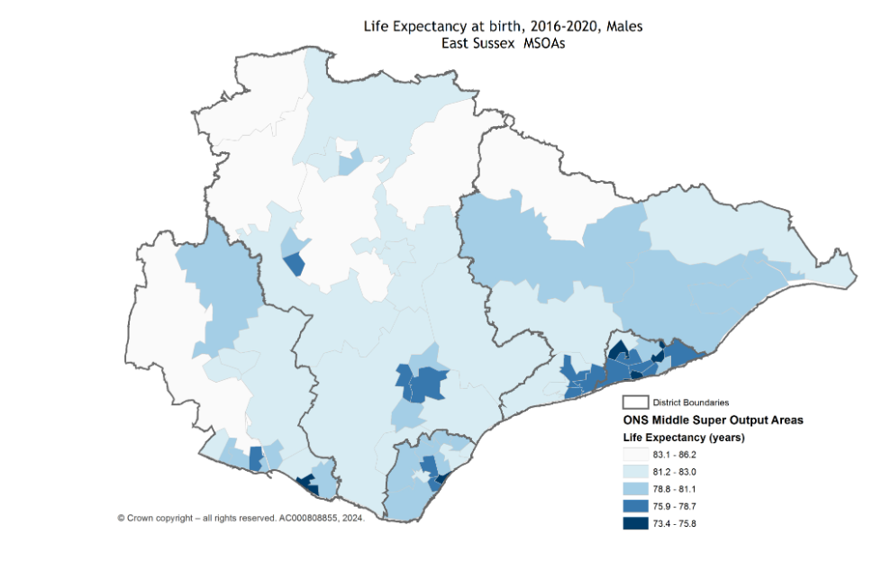
Source: Local health, public health data for small geographic areas | Fingertips | Department of Health and Social Care

Map: Life expectancy at birth for females by Middle Layer Super Output Area (MSOA) in East Sussex, 2016-2020
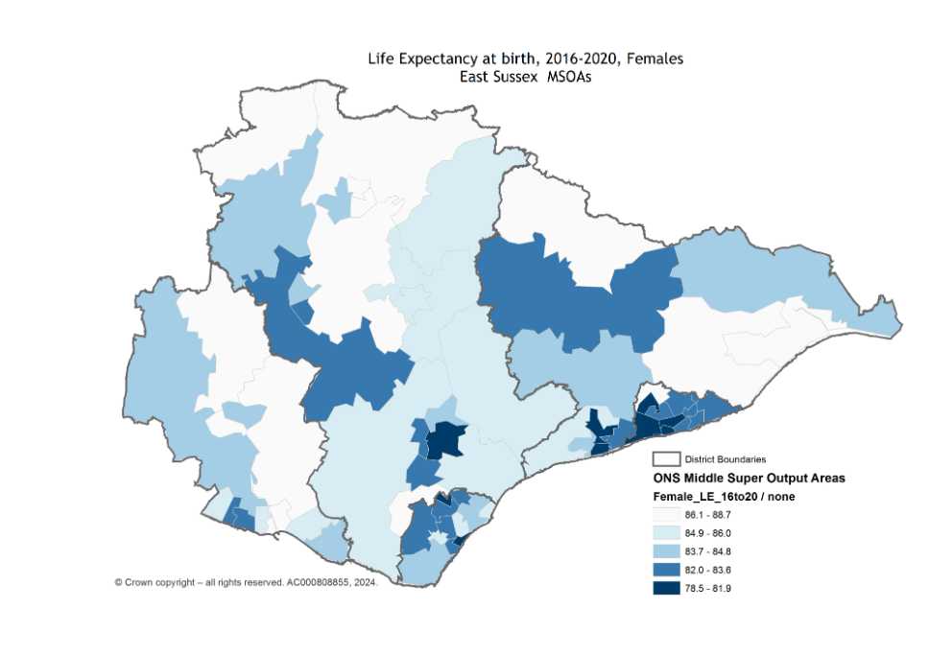
Source: Local health, public health data for small geographic areas | Fingertips | Department of Health and Social Care

5.2 Disease and poor health

Bad health
The 2021 Census asked residents “How is your health in general?”. 31,149 residents in East Sussex responded that their health was bad or very bad, which represents 5.7% of the population. This was higher than for England (5.2%). Higher percentages were seen in Hastings (7.3%), Eastbourne (6.3%) and Rother (6.0%).
Table: Self-reported health status, 2021
 | Bad or very bad health |  | Fair health |  | Very good or good health |  | Total
Area | Number | % | Number | % | Number | % | Number
Eastbourne | 6,383 | 6.3% | 15,503 | 15% | 79,800 | 78% | 101,686
Hastings | 6,613 | 7.3% | 14,122 | 16% | 70,260 | 77% | 90,995
Lewes | 5,484 | 5.5% | 14,156 | 14% | 80,265 | 80% | 99,905
Rother | 5,580 | 6.0% | 14,561 | 16% | 72,969 | 78% | 93,110
Wealden | 7,089 | 4.4% | 20,209 | 13% | 132,853 | 83% | 160,151
East Sussex | 31,149 | 5.7% | 78,551 | 14% | 436,147 | 80% | 545,847
England |  | 5.2% |  | 13% |  | 82%
Source: 2021 Census, office for National Statistics

Disability
The 2021 Census included a two-part question on disability. Firstly, respondents were asked if they had any long-term physical or mental health conditions or illnesses lasting or expected to last 12 months or more. Those who answered "Yes" were then asked if these conditions limited their ability to carry out day-to-day activities. People whose activities were limited "a little" or "a lot" were considered disabled.
In East Sussex there were 110,553 residents who self-reported to be disabled, representing 20.3% of the population. This was higher than for England (17.3%). Higher percentages were seen in Hastings (22.6%), Eastbourne (21.6%) and Rother (21.6%).
Table: Population who are disabled, 2021
Area | Number | %
Eastbourne | 21,919 | 21.6%
Hastings | 20,525 | 22.6%
Lewes | 20,342 | 20.4%
Rother | 20,138 | 21.6%
Wealden | 27,629 | 17.3%
East Sussex | 110,553 | 20.3%
England |  | 17.3%
Source: 2021 Census, Office for National Statistics
Looking at a more local level, the higher percentages of disabled people are in the coastal areas of East Sussex and also Hailsham.

Map: Population who are disabled, 2021
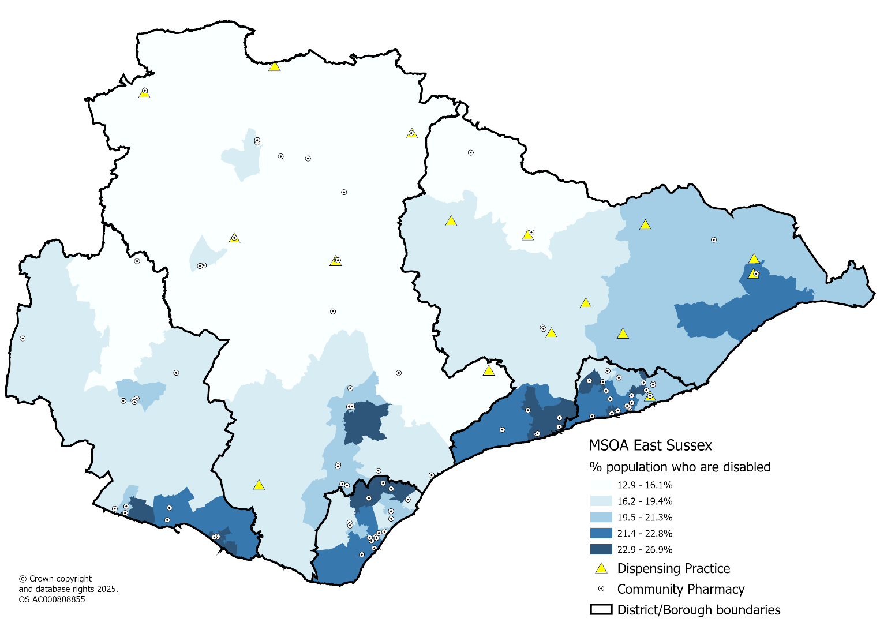
Source: 2021 Census, Office for National Statistics

Chronic disease
Data are published on the number of patients on specific chronic disease registers in GP practices as part of the Quality Outcomes Framework (QOF). This data has been summarised by district and borough area in the figure below.
Prevalences are higher in East Sussex compared to England. This may be due to the older age profile in East Sussex and the fact that many chronic conditions are age-related.
Rother has the highest prevalence rates with the exception of depression, where Hastings is highest.
Figure: Chronic disease prevalence, 2023/24
Quintiles
Compared to England
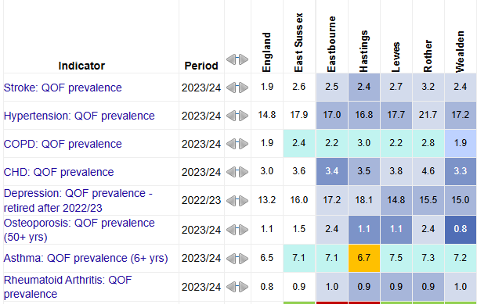
Source: Fingertips | Department of Health and Social Care

6. Current pharmaceutical services provision

6.1 Pharmacy provision in East Sussex
As at April 2025, there were 92 community pharmacies included in the pharmaceutical list for East Sussex and three distance selling pharmacies. There are 16 GP Dispensaries in East Sussex, and no Dispensing Appliance Contractors providing services within East Sussex.

Location of community pharmacies in East Sussex
Map: Location of community pharmacies and dispensing practices in East Sussex
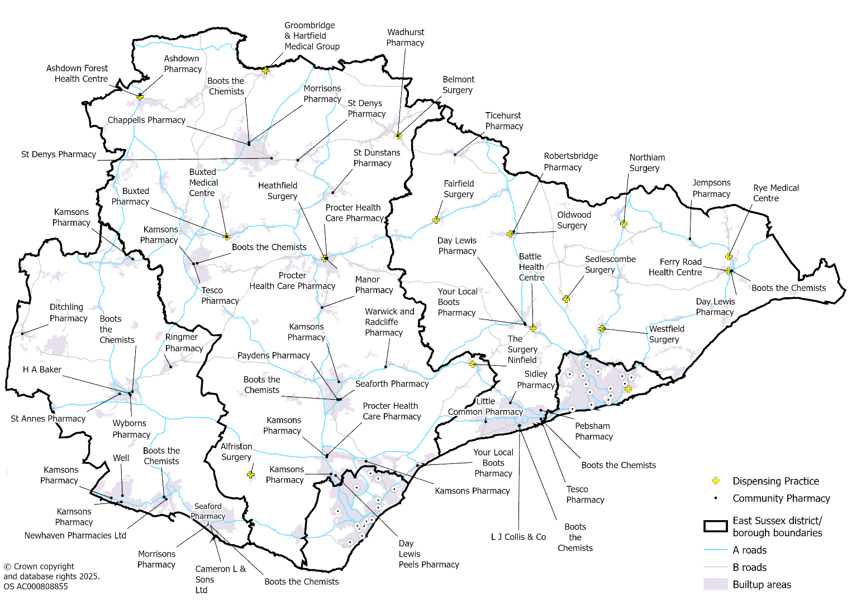

Map: Location of community pharmacies and dispensing practices in Eastbourne
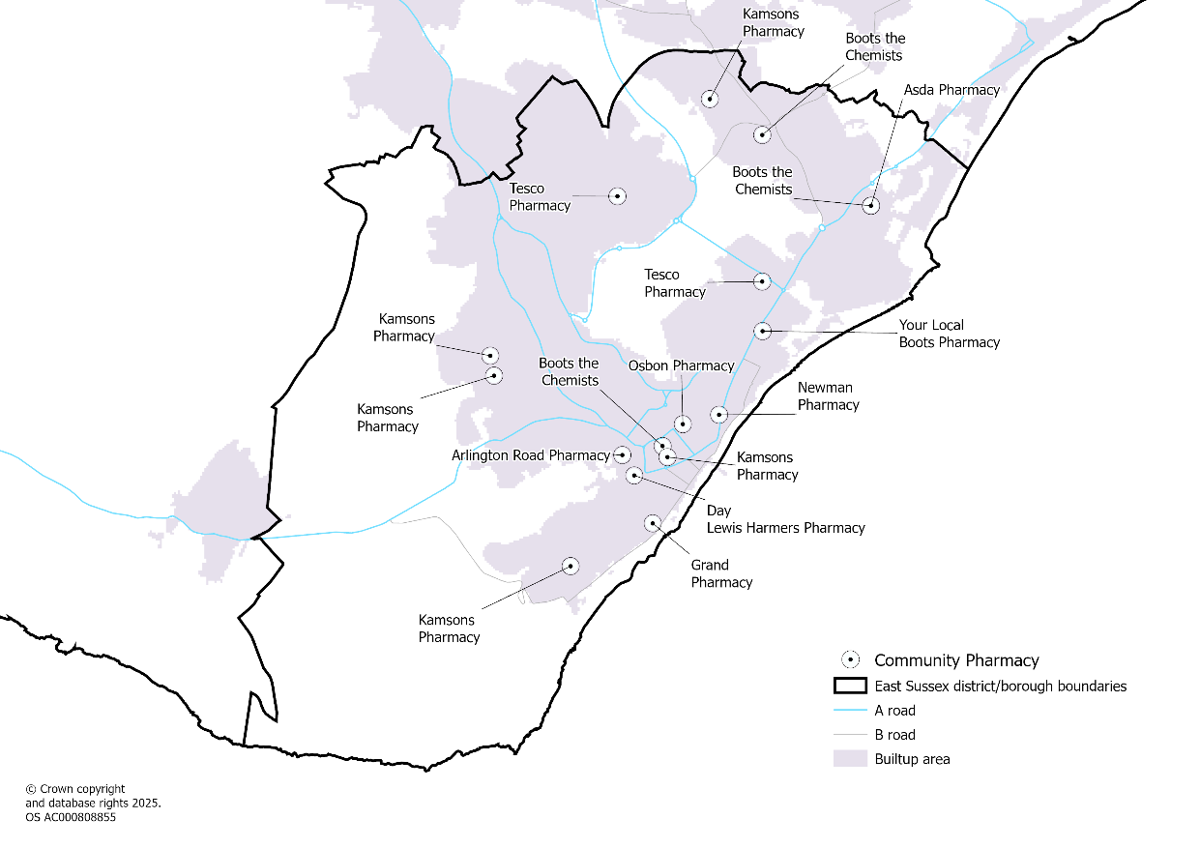
Map: Location of community pharmacies and dispensing practices in Hastings
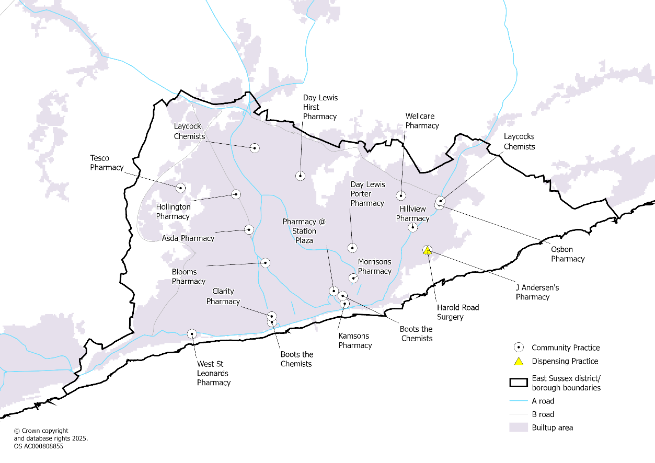

Pharmacy changes since the last PNA
There has been a gradual reduction in provision of pharmacies at a local, regional and national level. Since the last PNA in 2022 there are seven fewer community pharmacies, which is a 6% reduction, whilst the number of distance selling pharmacies and dispensing practices have remained the same. The greatest decrease has been in Eastbourne where there are 3 fewer pharmacies.
Table: Pharmacy service changes since the last PNA
Area | Provision type | Jan 2022 | April 2025 | Net change
Eastbourne | Community pharmacy | 20 | 17 | -3
 | Distance selling pharmacy | 0 | 0 | 0
 | Dispensing practice | 0 | 0 | 0
 | Total | 20 | 17 | -3
Hastings | Community pharmacy | 20 | 19 | -1
 | Distance selling pharmacy | 0 | 0 | 0
 | Dispensing practice | 1 | 1 | 0
 | Total | 21 | 20 | -1
Lewes | Community pharmacy | 17 | 16 | -1
 | Distance selling pharmacy | 1 | 1 | 0
 | Dispensing practice | 0 | 0 | 0
 | Total | 18 | 17 | -1
Rother | Community pharmacy | 15 | 14 | -1
 | Distance selling pharmacy | 1 | 1 | 0
 | Dispensing practice | 8 | 8 | 0
 | Total | 24 | 23 | -1
Wealden | Community pharmacy | 27 | 26 | -1
 | Distance selling pharmacy | 1 | 1 | 0
 | Dispensing practice | 7 | 7 | 0
 | Total | 35 | 35 | 0
East Sussex Total | Community pharmacy | 99 | 92 | -7
 | Distance selling pharmacy | 3 | 3 | 0
 | Dispensing practice | 16 | 16 | 0
 | Total | 118 | 111 | -7

Provision compared to neighbouring areas
There are no recommended rates for provision of community pharmacy services.
The rate of pharmacies in East Sussex is 17.1 per 100,000 population which is lower than the England rate of 18.1. Looking at neighbouring areas to East Sussex both Brighton and Hove (18.2) and Medway (17.8), which are both more urban densely populated areas, have higher rates than East Sussex. However, compared to similar neighbouring counties, East Sussex has the highest rate of provision. It’s not possible to add GP dispensaries to the analysis which would increase the rates in areas more rural in nature.
Table: Community pharmacy comparisons, Quarter 2 2024/25
Local Authority | Community Pharmacies 2024/25 Q2 | Population (Mid-2023) | Rate per 100,000 | Rank (out of 153, 1 =highest rate)
East Sussex | 95 | 555,484 | 17.1 | 99
Brighton & Hove | 51 | 279,637 | 18.2 | 82
Kent | 254 | 1,610,251 | 15.8 | 120
Medway | 51 | 286,800 | 17.8 | 95
Surrey | 181 | 1,228,671 | 14.7 | 136
West Sussex | 146 | 900,862 | 16.2 | 114
England | 10,439 | 57,690,323 | 18.1
Note: Distance selling Pharmacies are included in above table as unable to remove them from the national data easily. GP dispensaries are not included.
Source: NHS Business Services Authority and Population data from ONS

Provision across East Sussex boroughs and districts
Looking at pharmacy provision across the districts and boroughs in East Sussex we can include the dispensing practices. This shows highest provision per 100,000 population in Rother (24.2), which has the oldest population profile, followed by Hastings (22.0) which has the most population living in areas of deprivation. The lowest rates are in Eastbourne (16.4) and Lewes (16.8).
Table: Community pharmacy provision in East Sussex, Quarter 2 2024/25
Area | Community Pharmacies | Distance selling pharmacies | Dispensing practices | Total | Population (Mid-2023) | Rate per 100,000
Eastbourne | 17 |  |  | 17 | 103,796 | 16.4
Hastings | 19 |  | 1 | 20 | 90,817 | 22.0
Lewes | 16 | 1 |  | 17 | 101,356 | 16.8
Rother | 14 | 1 | 8 | 23 | 94,862 | 24.2
Wealden | 26 | 1 | 7 | 35 | 164,653 | 20.6
East Sussex | 92 | 3 | 16 | 112 | 555,484 | 20.0
Source: NHS Business Services Authority and Population data from ONS

Pharmacy Access Scheme (PhAS)
The aim of the Pharmacy Access Scheme (PhAS) is a national scheme to support patient access to NHS community pharmaceutical services in England. Qualifying pharmacies will receive an additional payment.
The PhAS has been designed to capture isolated and eligible pharmacies to support patient access.
Eligibility for PhAS is based on both the dispensing volume of the pharmacy, and distance from the next nearest pharmacy. Pharmacy Access Scheme (PhAS) - Community Pharmacy England
17 community pharmacies in East Sussex receive payments as part of the PhAS.
Map: Community Pharmacies who receive PhAS payments
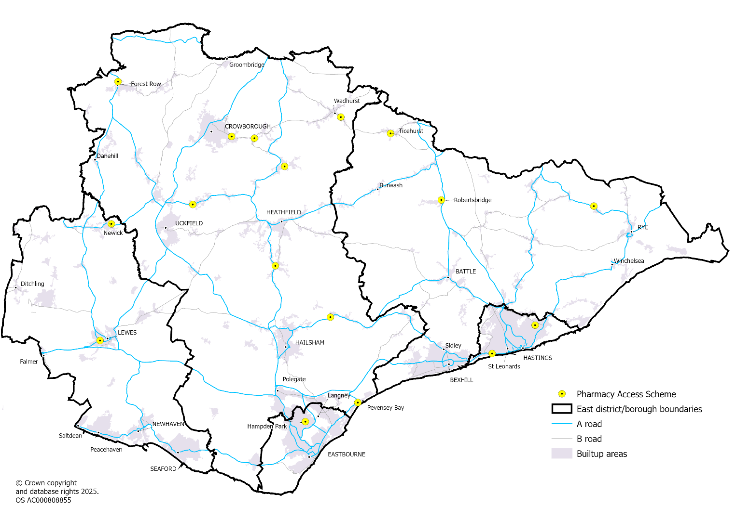
Source: NHS Sussex ICB

6.2 Opening Hours
Core hours: Those hours a pharmacy is formally contracted to provide NHS pharmaceutical services. Core hours are usually 40 hours but there are some contracted for 100 hours. See details in next section.
Supplementary hours: Additional hours a pharmacy opens beyond their core hours. Decreases in hours can be modified with five weeks’ notice to NHS Sussex ICB, and no notice period is required to increase them.

100-hour contract changes
100-hour pharmacies became a new provision under amendments to The National Health Service (Pharmaceutical Services) Regulations 1992, which came into force on 1 April 2005.
In an attempt to increase pharmacy provision and competition, the legislation introduced four exemptions to earlier NHS regulations that prohibited new contractors from entering the pharmaceutical list unless it was “necessary or expedient” to securing the adequate provision of pharmaceutical services locally.
These exemptions included pharmacies where the applicant committed to providing pharmaceutical services for at least 100 hours each week, as well as those located in large shopping centres, and those that would provide pharmacy services online.
However, the exemption was removed in a 2012 update to the NHS regulations, after a government white paper found in 2008 that Primary Care Trusts (commissioners at the time) were not able to control where 100-hour pharmacies opened, which meant there was “no match between the better access that a 100 hours per week pharmacy delivers and the need for such an improvement locally”. Additionally, the government found that there was a “clustering of 100 hours per week pharmacies close to each other”.
The updated regulations meant that no new 100-hour pharmacies could open but stated that existing 100-hour pharmacies must maintain their opening hours. However, in May 2023, further amendments were made to the National Health Service (Pharmaceutical and Local Pharmaceutical Services) Regulations 2013; one of which allowed existing 100-hour pharmacies to reduce their minimum opening hours to 72 hours per week.
Under the amended regulations, pharmacies that held 100-hour contracts would have to remain open between 17:00 and 21:00 from Monday to Saturday, and between 11:00 and 16:00 on Sundays, if previously open these hours, to maintain out-of-hours pharmacy provision.

Contracted hours in East Sussex
Of the 92 community pharmacies in East Sussex, four are on 100 hours (amended) contracts. This is a reduction of four from the eight that were in place at the last PNA. Pharmacies with 40-hour contracts can choose to open for longer under supplementary hours arrangements.
Table: Community pharmacies in East Sussex by contract type
Area | 40 hours | 100 Hours (Amended) | Grand Total
Eastbourne | 15 | 2 | 17
Hastings | 17 | 2 | 19
Lewes | 16 |  | 16
Rother | 14 |  | 14
Wealden | 26 |  | 26
East Sussex | 88 | 4 | 92
Source: NHS Sussex Integrated Care Board

Opening times
All 92 community pharmacies and 16 dispensing practices are open weekdays.
Map: Pharmacies and dispensing practices open weekdays i.e. all locations
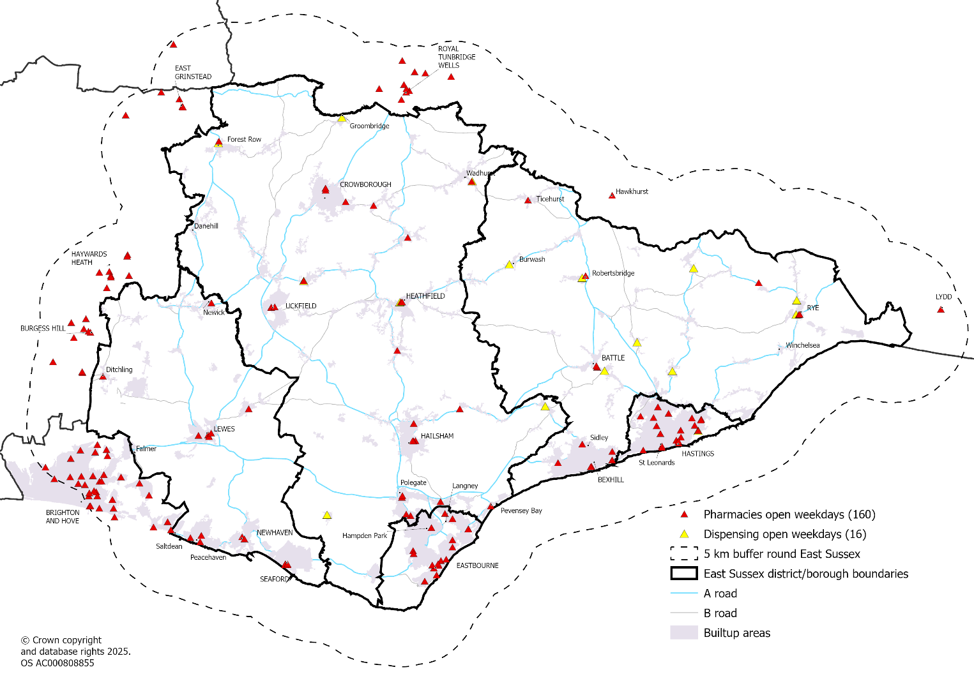
For this PNA, and as agreed by the Steering Group, we have defined evening opening hours as being open for at least one day beyond 6pm Monday to Friday. Weekend opening is defined as being open for any period of time on Saturday/Sunday.
Across East Sussex 39% of pharmacies and GP dispensaries are open evenings and this ranges from 48% in Wealden to 31% in Lewes.
77% of pharmacies and GP dispensaries are open on a Saturday and this ranges from 88% in Eastbourne to 64% in Rother.
15% of pharmacies and GP dispensaries are open on a Sunday and this ranges from 35% in Eastbourne to 3% in Wealden.
The maps in this section also display pharmacy services within 5km of the East Sussex border that are open at specific times. As well as the city of Brighton and Hove, the towns of Burgess-Hill, Haywards Heath, East Grinstead and Royal Tunbridge Wells all boost access to pharmacies for East Sussex residents, including in the evenings and weekends.
Table: Community Pharmacies and Dispensing practices open evenings and weekends
 |  | Open | evenings | Open | Saturdays | Open | Sundays
Area | Total | Number | % | Number | % | Number | %
Eastbourne | 17 | 6 | 35% | 15 | 88% | 6 | 35%
Hastings | 20 | 7 | 35% | 17 | 85% | 6 | 30%
Lewes | 16 | 5 | 31% | 13 | 81% | 1 | 6%
Rother | 22 | 8 | 36% | 14 | 64% | 2 | 9%
Wealden | 33 | 16 | 48% | 24 | 73% | 1 | 3%
East Sussex | 108 | 42 | 39% | 83 | 77% | 16 | 15%
Source: NHS Sussex Integrated Care Board

Map: Pharmacies and dispensing practices open on a weekday evening
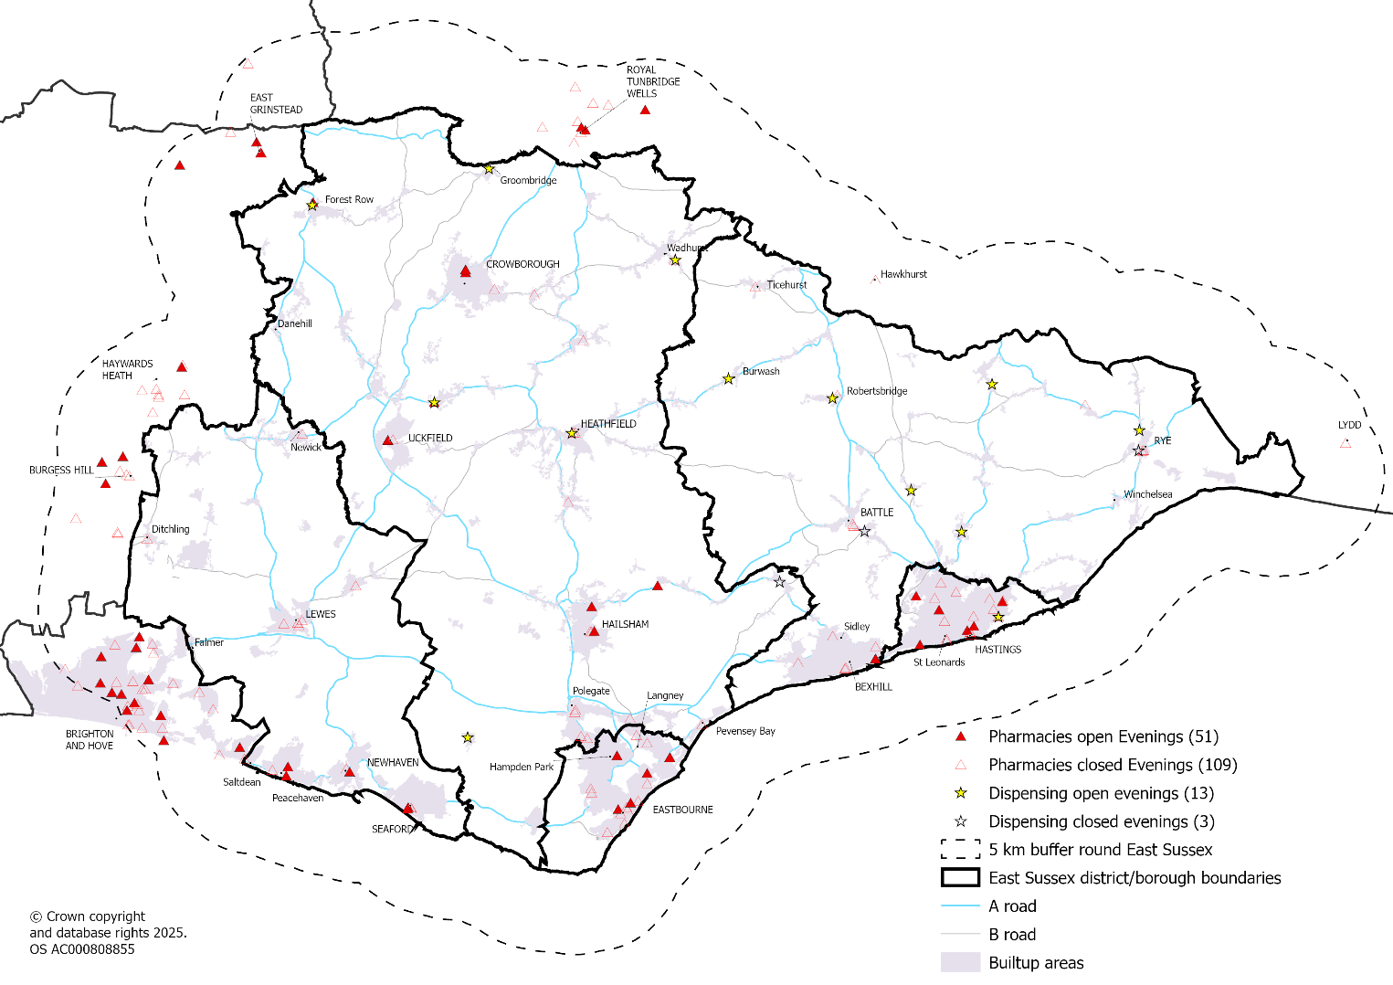

Map: Pharmacies open on a Saturday
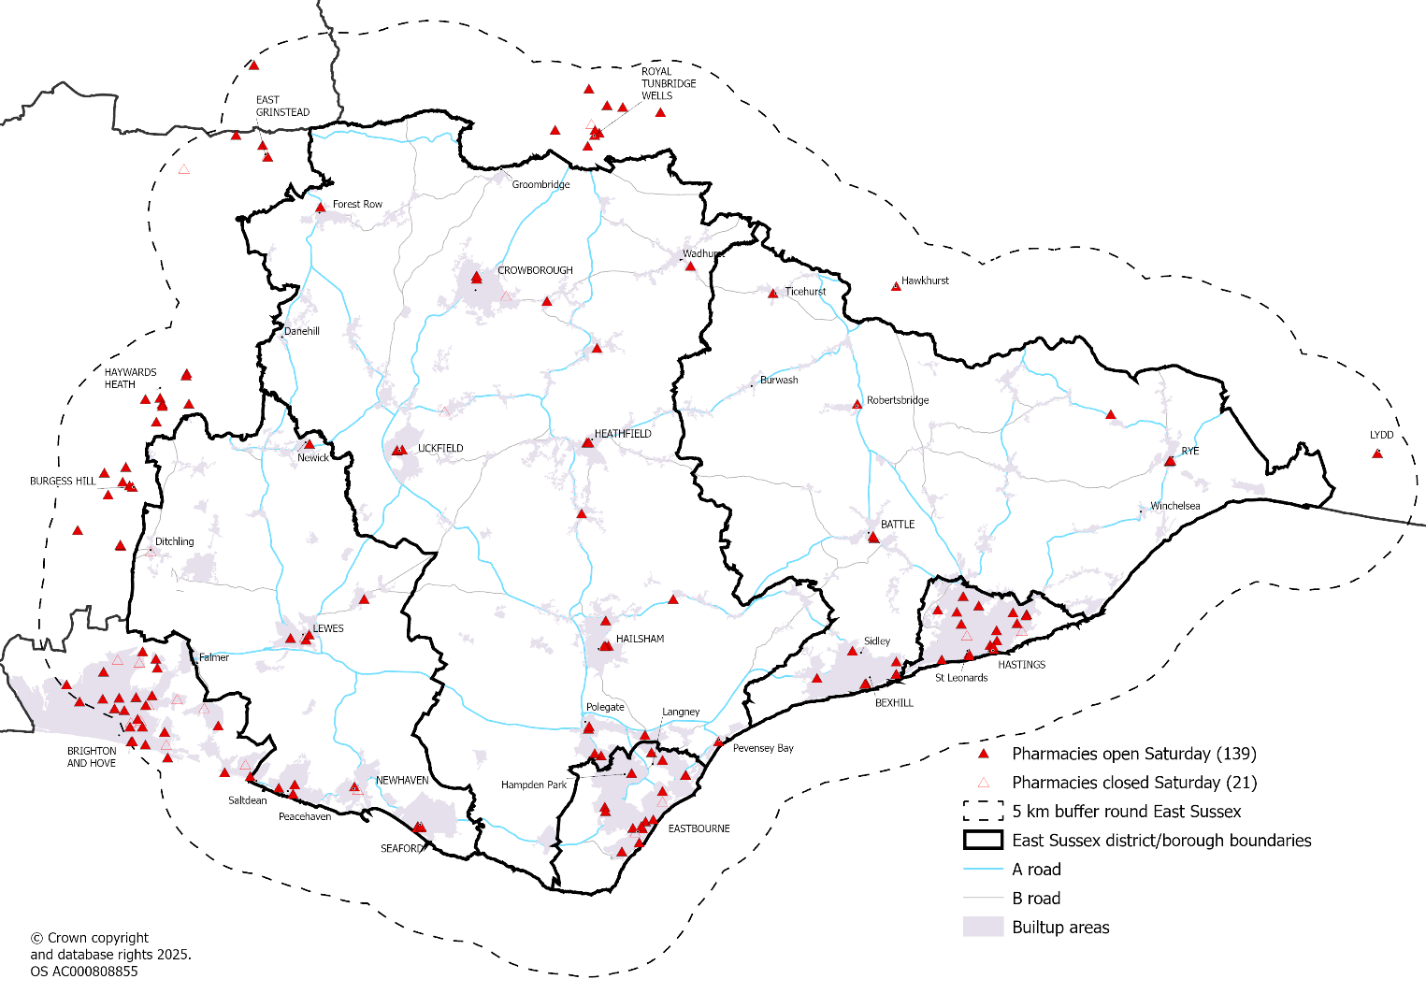

Map: Pharmacies open on a Sunday
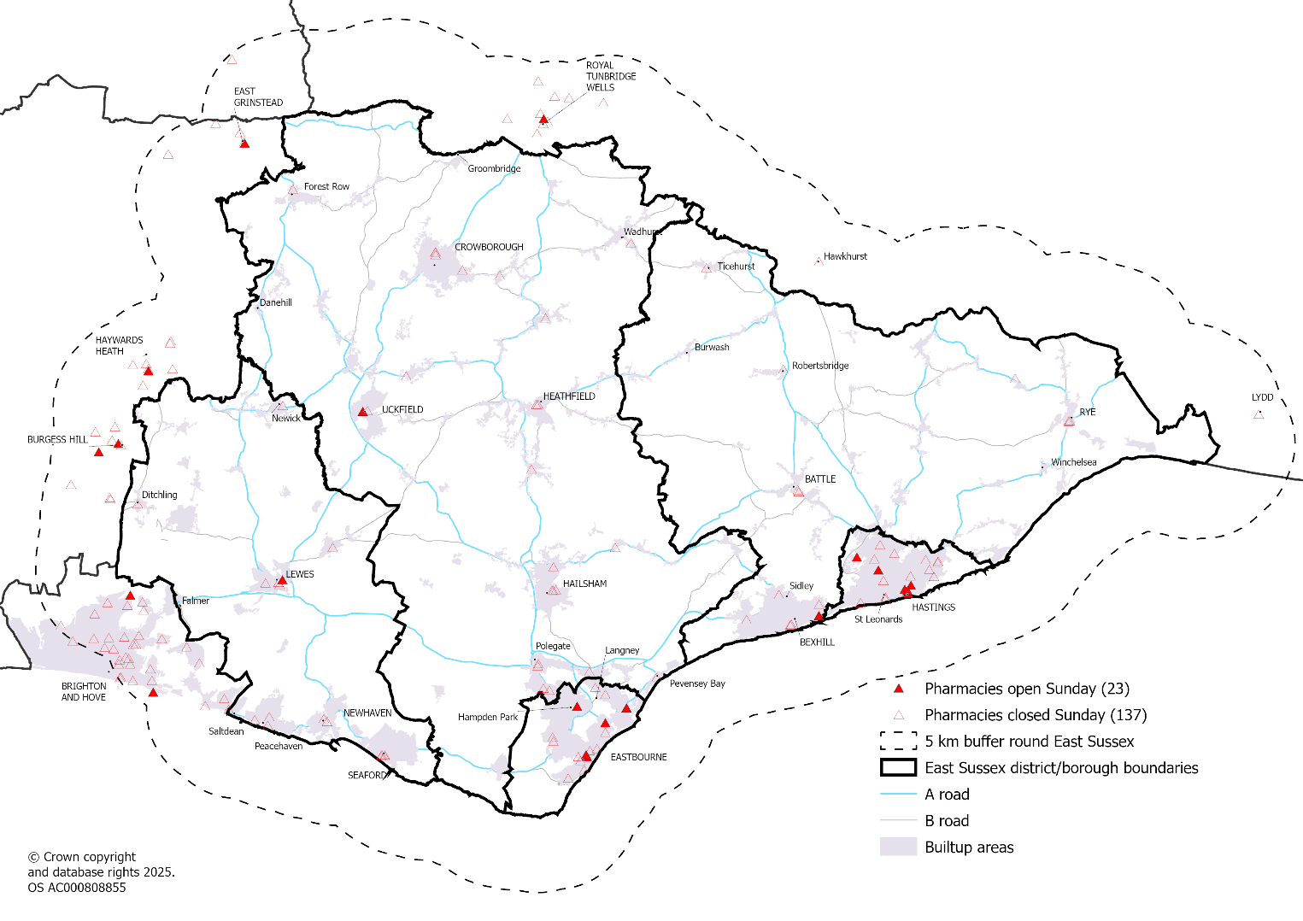

6.3 Travel times to access pharmacies

Method
This analysis utilised the SHAPE tool which is an online, interactive, data mapping, analysis and insight tool that supports service planning and estates strategy development. Its supported by the Department of Health and Social Care and allows users to plot pharmacies and then calculate travel times. Travel methods used were car by time and public transport by time. The travel catchment areas come from a third party provider called Targomo Location-Based Analytics for Decision Makers - Targomo. Based on the pharmacy/dispensing practice locations selected in SHAPE, that location data is sent to Targomo based on the selected travel time and type and will return an area which is accessible. Once this information is returned, SHAPE use that to calculate the population within that area. This population is called “Included population” in the analysis here.
The steering group agreed to use the 30 minutes travel time for a one-way journey for the analysis, which was the same as for the previous PNA.
A buffer zone of 5 kilometres was used to include community pharmacies within reasonable distance from East Sussex to take account of residents who’s nearest pharmacy may be outside of the county.
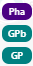
Each blue marker on the maps represents a community pharmacy and where there are pharmacies in close proximity the number on the marker displays how many are close by. The green markers represent dispensing practices. A GPb marker is a branch surgery that hosts the dispensary.
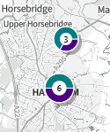
Where there are two or more locations close together on the map, they are replaced with an icon that shows how many locations are plotted in that area.

The yellow area mapped shows areas within 30 minutes of an open pharmacy/Dispensing practice.

Weekday access
There are no populated areas of East Sussex that are not within a 30 minute drive by car, both within and outside rush hour.

Map: Car travel access weekdays (outside rush hour)
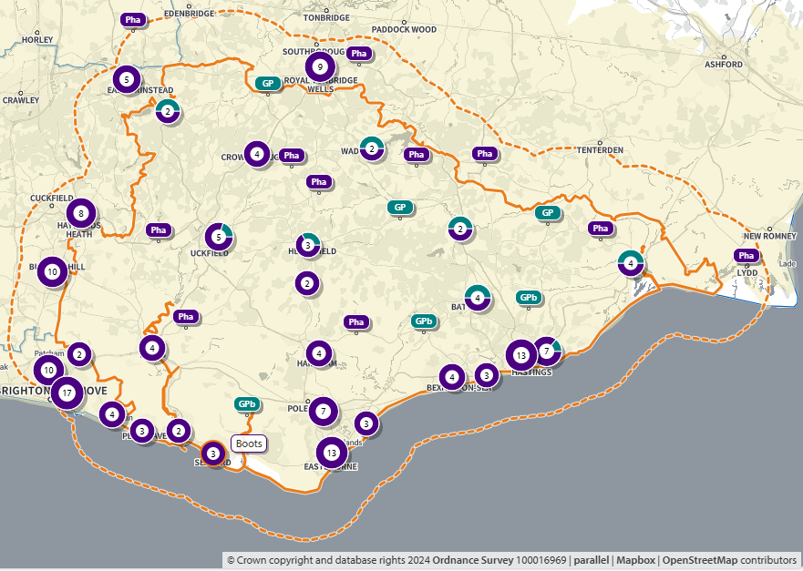
Source: SHAPE Place • Car: by time • 0 locations • 5 to 30 minutes • 30 minutes visible

Map: Car travel access weekdays (during rush hour)
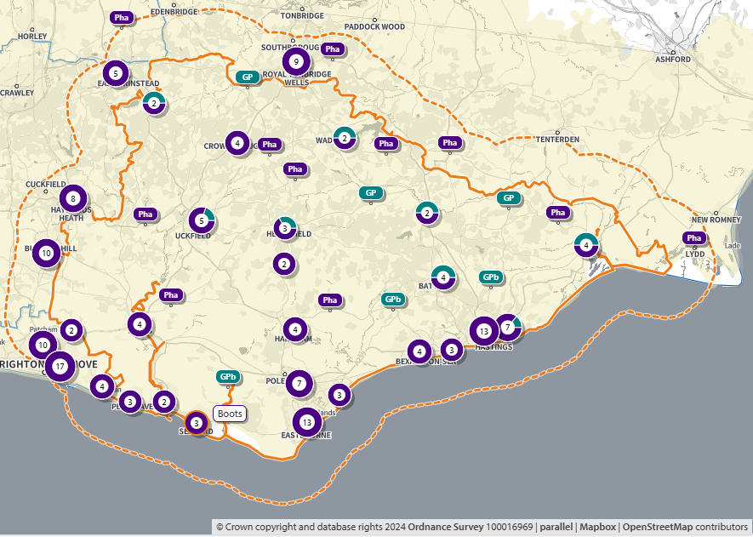
Source: SHAPE Place • Car: by time • 0 locations • Rush hour • 5 to 30 minutes • 30 minutes visible
When looking at access via public transport on weekdays the analysis showed that 10,738 (1.9%) residents did not have access within 30 minutes.

Map: Public transport access weekdays
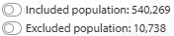
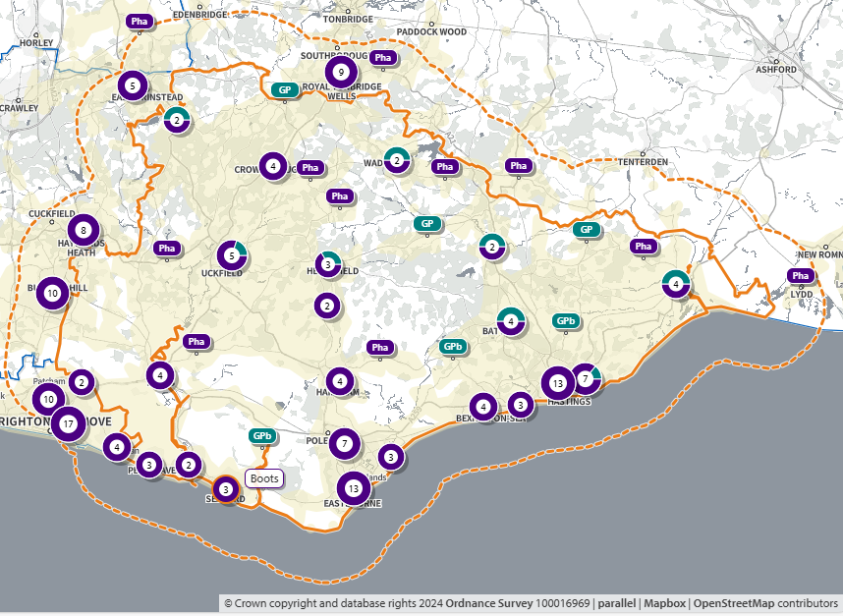
Source: SHAPE Place • Public transport • 169 locations • 5 to 30 minutes • 30 minutes visible

Evening access
The definition used for the PNA is for a location to be open for at least one day beyond 6pm Monday to Friday
There are no populated areas of East Sussex that are not within a 30 minute drive by car of a community pharmacy or dispensing practice after 6pm.
Whilst there are no services open in the evening in Lewes town, the analysis showed that travel times by car and public transport are sufficient to nearby towns such as Uckfield and Brighton.
Whilst rural areas are boosted by dispensing practices, not all are open every evening for long beyond 6pm. This particularly affects areas in rural Rother
When looking at access via public transport on weekday evenings the analysis showed that 32,324 (5.9%) residents did not have access within 30 minutes.
Map: Car travel access weekday evenings
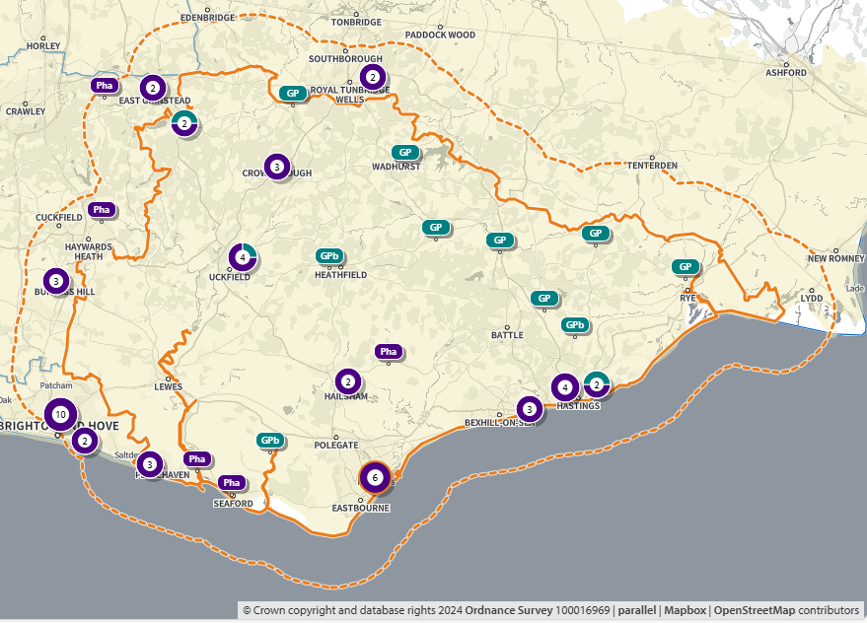
Source: SHAPE Place • Car: by time • 0 locations • 5 to 30 minutes • 30 minutes visible

Map: Public transport access weekday evenings
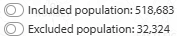
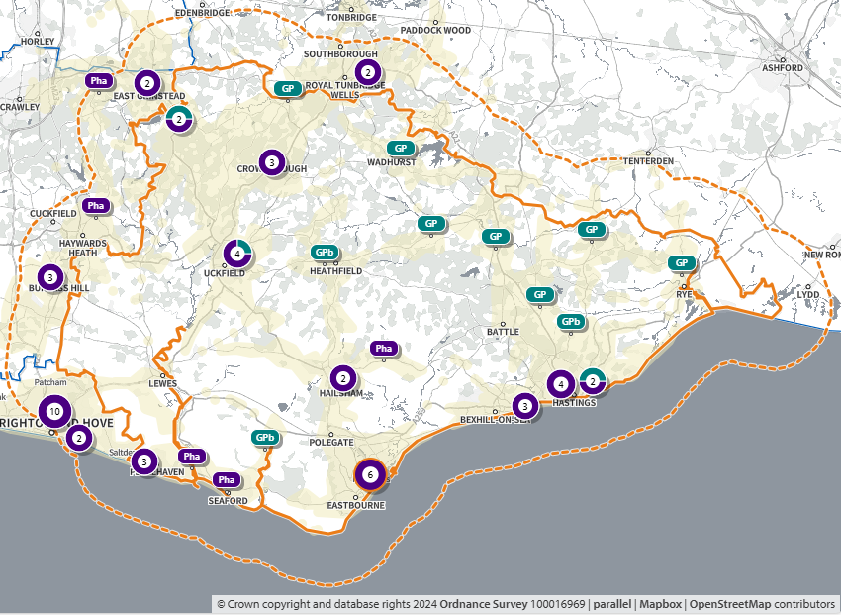
Source: SHAPE Place • Public transport • 60 locations • 5 to 30 minutes • 30 minutes visible

Weekend access
There are no populated areas of East Sussex that are not within 30 minute drive by car of a community pharmacy or dispensing practice on either a Saturday or Sunday.
When looking at access via public transport on Saturdays the analysis showed that 69,747 (12.7%) of residents did not have access within 30 minutes. This increased to 218,288 (39.6%) on a Sunday.

Map: Saturday access by car
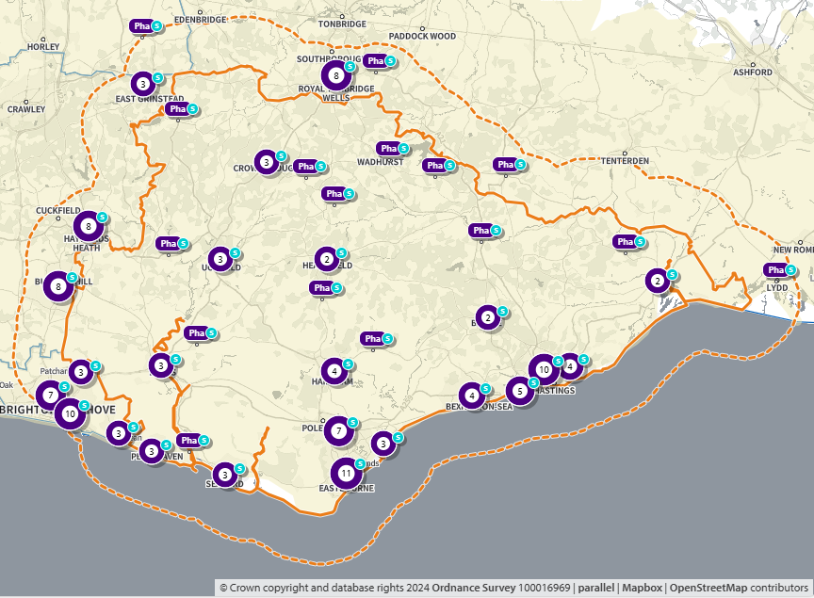
Source: SHAPE Place • Car: by time • 0 locations • 5 to 30 minutes • 30 minutes visible

Map: Saturday access by public transport
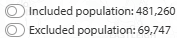
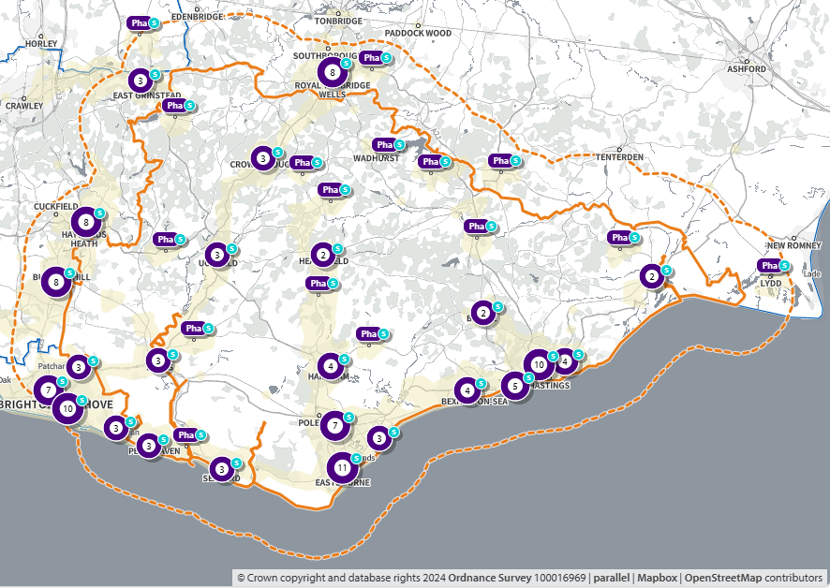
Source: SHAPE Place • Public transport • 133 locations • 5 to 30 minutes • 30 minutes visible

Map: Sunday access by car
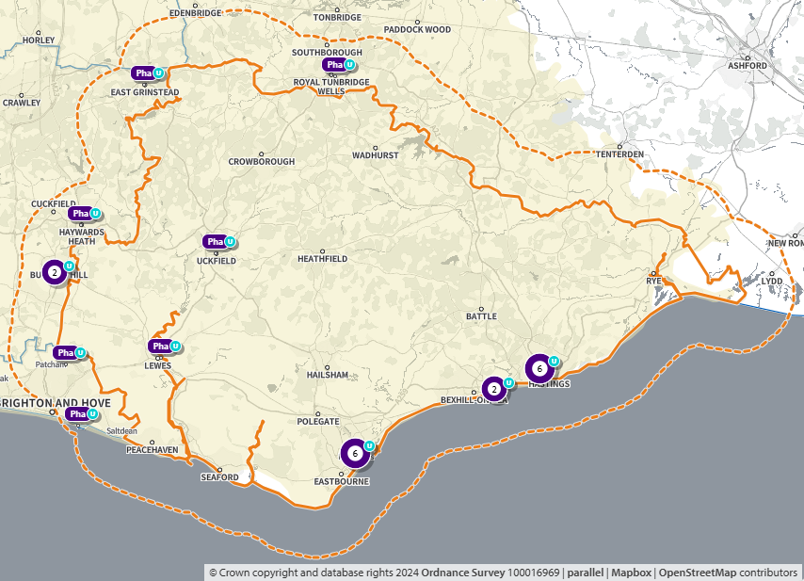
Source: SHAPE Place • Car: by time • 0 locations • 5 to 30 minutes • 30 minutes visible

Map: Sunday access by public transport
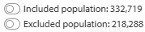
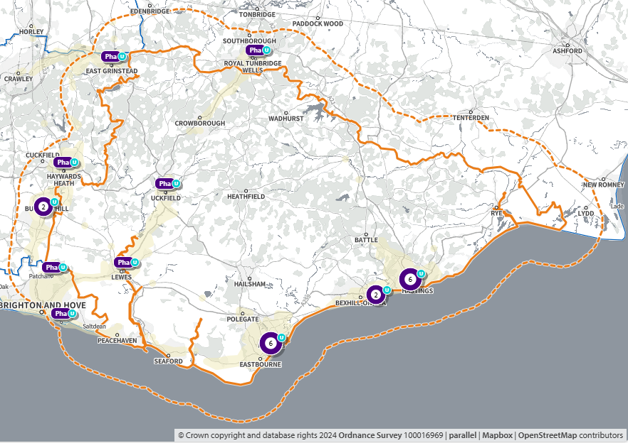
Source: SHAPE Place • Public transport • 0 locations • 5 to 30 minutes • 30 minutes visible

6.4 Necessary Services
Necessary services for this PNA are described in section 2.5. Not all activity is available for every element of the services, so a summary of what is available is provided below.

Dispensing activity
There were 10.3 million items dispensed by pharmacies in East Sussex during 2024. Pharmacies in Eastbourne dispensed the greatest number of items per pharmacy (9,857 per month per pharmacy) and Rother the fewest (7,734). On average there were 18.5 items dispensed per head of population per year in East Sussex during 2024. This was highest in Hastings (24.1) and Eastbourne (20.5) and lowest in Rother (14.7) and Lewes (16.1).
It should be noted that activity data is a measure of pharmaceutical demand on a service and not pharmaceutical need.
Table: Dispensing activity by community pharmacies in East Sussex, 2024 calendar year
 | Number of pharmacies | Total items dispensed | Average items per month | Number of items per month per pharmacy | Population | Number of items per head of population per year
Eastbourne | 18 | 2,129,171 | 177,431 | 9,857 | 103,796 | 20.5
Hastings | 19 | 2,184,907 | 182,076 | 9,583 | 90,817 | 24.1
Lewes | 16 | 1,629,789 | 135,816 | 8,488 | 101,356 | 16.1
Rother | 15 | 1,392,099 | 116,008 | 7,734 | 94,862 | 14.7
Wealden | 27 | 2,946,853 | 245,571 | 9,095 | 164,653 | 17.9
East Sussex | 95 | 10,282,819 | 856,902 | 9,020 | 555,484 | 18.5
Note: Analysis includes pharmacies open at any point during the calendar year
Source: Dispensing contractors' data | NHSBSA

Discharge Medicines Service (DMS)
Since 15th February 2021, NHS Hospital Trusts have been able to refer patients who would benefit from extra guidance around prescribed medicines for provision of the DMS at their community pharmacy. The service has been identified by NHS England’s Medicines Safety Improvement Programme to be a significant contributor to the safety of patients at transitions of care, by reducing readmissions to hospital.
Activity is varied across East Sussex and is reliant on the referral from hospital providers. Rates are highest in Eastbourne (2.3 per 1,000 population) and lowest in both Hastings (0.5) and Rother (0.5). This suggests that referrals are greater from the Eastbourne District General Hospital, compared to the Conquest Hospital in Hastings. NHS Sussex ICB is already working locally to encourage and support hospital services in utilising this service.
Table: Discharge Medicines Service activity in East Sussex, 2024 calendar year
Activity | Eastbourne | Hastings | Lewes | Rother | Wealden | East Sussex
Complete Discharge Medicines Services | 91 | 22 | 137 | 14 | 124 | 388
Part complete Discharge Medicines Services | 147 | 23 | 22 | 35 | 100 | 327
Total Discharge Medicines Services | 238 | 45 | 159 | 49 | 224 | 715
Rate per 1,000 population | 2.3 | 0.5 | 1.6 | 0.5 | 1.4 | 1.3
Source: Dispensing contractors' data | NHSBSA

Pharmacy First service (Advanced service)
The new Pharmacy First service, launched 31 January 2024, replacing the previous Community Pharmacist Consultation Service. It enables community pharmacies to complete episodes of care for seven common conditions following defined clinical pathways and also incorporates the elements of the former Community Pharmacist Consultation Service, i.e. minor illness consultations with a pharmacist and the supply of urgent medicines (and appliances). An electronic patient referral for the service is sent from NHS 111, general practices (urgent supply referrals are not allowed from general practices) and other authorised healthcare providers to the community pharmacy. For the seven common conditions patients can also self-refer directly to the pharmacy.
Pharmacy First services are available across all community pharmacies in East Sussex, although some pharmacies experience more activity than others. Urgent medicine supply consultations saw the greatest activity in terms of numbers, followed by the Minor illness referral consultations. Of the seven common condition clinical pathways acute sore throat and uncomplicated UTI both saw the greatest activity.

Table: Pharmacy First activity, numbers in 2024 calendar year
Pharmacy First Service | Eastbourne | Hastings | Lewes | Rother | Wealden | East Sussex
Urgent Medicine Supply Consultations | 2,341 | 3,634 | 1,165 | 1,815 | 2,076 | 11,031
Minor Illness Referral Consultations | 2,672 | 1,521 | 1,156 | 1,409 | 2,923 | 9,681
Consultations - Acute Sore Throat | 1,033 | 925 | 624 | 706 | 1,176 | 4,464
Consultations - Uncomplicated UTI | 992 | 755 | 627 | 551 | 1,176 | 4,101
Consultations - Sinusitis | 424 | 333 | 330 | 396 | 504 | 1,987
Consultations - Acute Otitis Media | 394 | 294 | 227 | 375 | 609 | 1,899
Consultations - Infected Insect Bites | 301 | 334 | 286 | 347 | 410 | 1,678
Consultations - Impetigo | 116 | 165 | 119 | 127 | 213 | 740
Consultations - Shingles | 136 | 124 | 79 | 133 | 219 | 691
Source: Dispensing contractors' data | NHSBSA
Looking at the activity as rates per 1,000 resident population, Hastings has double the rate (40.0) for urgent medicine supply consultations compared to the East Sussex average (19.9). Lewes saw the lowest rate (11.5) which was half the East Sussex average (19.9). For the minor illness referral consultations, Eastbourne (25.7) had the highest rate with Lewes having the lowest (11.4).

Table: Pharmacy First activity, rate per 1,000 population in 2024 calendar year
Pharmacy First Service | Eastbourne | Hastings | Lewes | Rother | Wealden | East Sussex
Urgent Medicine Supply Consultations | 22.6 | 40.0 | 11.5 | 19.1 | 12.6 | 19.9
Minor Illness Referral Consultations | 25.7 | 16.7 | 11.4 | 14.9 | 17.8 | 17.4
Consultations - Acute Sore Throat | 10.0 | 10.2 | 6.2 | 7.4 | 7.1 | 8.0
Consultations - Uncomplicated UTI | 9.6 | 8.3 | 6.2 | 5.8 | 7.1 | 7.4
Consultations - Sinusitis | 4.1 | 3.7 | 3.3 | 4.2 | 3.1 | 3.6
Consultations - Acute Otitis Media | 3.8 | 3.2 | 2.2 | 4.0 | 3.7 | 3.4
Consultations - Infected Insect Bites | 2.9 | 3.7 | 2.8 | 3.7 | 2.5 | 3.0
Consultations - Impetigo | 1.1 | 1.8 | 1.2 | 1.3 | 1.3 | 1.3
Consultations - Shingles | 1.3 | 1.4 | 0.8 | 1.4 | 1.3 | 1.2
Source: Dispensing contractors' data | NHSBSA

6.5 Enhanced services

Bank holiday provision
There is one local enhanced service commissioned by NHS Sussex ICB in East Sussex which is for selected pharmacies for bank holidays. The pharmacies that open change for each bank holiday and so there is no single list of pharmacies that are signed up to this.
As an example, for Good Friday (18th April 2025) there were 15 community pharmacies open across the county. These were in Eastbourne (4), Hailsham (1), Seaford (1), Bexhill-on-Sea (1), Hastings (2), St Leonards (2), Peasmarsh [near Rye] (1), Crowborough (1), Lewes (1) and Uckfield (1).

COVID-19 Vaccination Service
This is a national enhanced service commissioned by NHS England, and on 30th May 2024, NHS England opened a new Expression of Interest (EOI) process for pharmacy owners that wished to take part in future COVID-19 vaccination service campaigns between September 2024 and March 2026. COVID-19 Vaccination Service - Community Pharmacy England
The current phase of the vaccination programme is the Spring 2025 campaign and 48 out of 92 community pharmacies are currently commissioned to deliver this service in East Sussex.
Table: Pharmacies commissioned to deliver the COVID-19 vaccination service for the Spring 2025 campaign
 | Eastbourne | Hastings | Lewes | Rother | Wealden | Total
Pharmacies commissioned | 7 | 13 | 10 | 9 | 9 | 48
Total pharmacies | 17 | 19 | 16 | 14 | 26 | 92
% | 41% | 68% | 63% | 64% | 35% | 52%
Source: NHS Sussex ICB

6.6 Advanced services
Advanced services relevant to community pharmacies in East Sussex are detailed below. Services undertake by dispensing appliance contractors (DAC) are not covered as there are currently none of these in the county, residents can access a DAC outside the county. There were no Stoma Customisation or Appliance Use Reviews claimed for during 2024 by any community pharmacies in East Sussex.

New Medicine Service (NMS)
The NMS, which commenced on 1st October 2011, provides support for people with long-term conditions newly prescribed a medicine to help improve medicines adherence. It is focused on specific patient groups and conditions.
The current conditions eligible for the service are:
- asthma and COPD
- diabetes (Type 2)
- hypertension
- hypercholesterolaemia
- osteoporosis
- gout
- glaucoma
- epilepsy
- Parkinson’s disease
- urinary incontinence/retention
- heart failure
- acute coronary syndromes
- atrial fibrillation
- long term risks of venous thromboembolism/embolism
- stroke / transient ischemic attack
- coronary heart disease
All community pharmacies across East Sussex are providing this service with all of them claiming payments during 2024. There is a variation in activity rates across the county with highest activity per 1,000 population in Hastings (110.6) and lowest in Rother (74.1).

Table: New Medicines Service activity, 2024 calendar year
Activity | Eastbourne | Hastings | Lewes | Rother | Wealden | East Sussex
NMS interventions declared | 9,301 | 10,047 | 8,298 | 7,025 | 15,045 | 49,716
Rate per 1,000 population | 89.6 | 110.6 | 81.9 | 74.1 | 91.4 | 89.5
Source: Dispensing contractors' data | NHSBSA

Flu vaccination
All but five community pharmacies claimed payments for flu vaccinations during 2024. Four (out of 26 in Wealden) of these were in Wealden (Heathfield x 2, Polegate and Horam) and one (out of 17 in Hastings) was in Hastings (St Leonards). There is a variation in activity rates across the county with highest activity per 1,000 population in Hastings (151.2) and lowest in Wealden (54.5).
Table: Flu vaccination activity, 2024 calendar year
Activity | Eastbourne | Hastings | Lewes | Rother | Wealden | East Sussex
Influenza Administered Fees | 10,419 | 13,729 | 9,975 | 10,115 | 8,978 | 53,216
Rate per 1,000 population | 100.4 | 151.2 | 98.4 | 106.6 | 54.5 | 95.8
Source: Dispensing contractors' data | NHSBSA

Hypertension Case-Finding service
The Hypertension Case-Finding Service was commissioned as an Advanced service from 1st October 2021. In public-facing communications, the service is described as the NHS Blood Pressure Check Service.
The service aims to:
- Identify people aged 40 years or older, or at the discretion of pharmacy staff, people under the age of 40, with high blood pressure (who have previously not had a confirmed diagnosis of hypertension), and to refer them to general practice to confirm diagnosis and for appropriate management.
- At the request of a general practice, undertake ad hoc clinic and ambulatory blood pressure measurements. These requests can be in relation to people either with or without a diagnosis of hypertension.
- Provide another opportunity to promote healthy behaviours to patients.
All but eight community pharmacies claimed payments for blood pressure checks during 2024. Six (out of 26 in Wealden) of these were in Wealden (Crowborough x 2, Heathfield x 2, Horam and Rotherfield). One (out of 17 in Hastings) was in Hastings (St Leonards) and another one was in Eastbourne (out of 17 in Eastbourne). There is a variation in activity rates across the county with highest activity per 1,000 population in Eastbourne (54.7) and lowest in Wealden (19.3).
Table: Hypertension case-finding activity, 2024 calendar year
Activity | Eastbourne | Hastings | Lewes | Rother | Wealden | East Sussex
Clinic Blood Pressure checks | 5,428 | 2,414 | 2,423 | 2,725 | 2,903 | 15,893
Ambulatory Blood Pressure Monitoring (ABPM) | 250 | 241 | 184 | 106 | 270 | 1,051
Total activity | 5,678 | 2,655 | 2,607 | 2,831 | 3,173 | 16,944
Rate per 1,000 population | 54.7 | 29.2 | 25.7 | 29.8 | 19.3 | 30.5
Source: Dispensing contractors' data | NHSBSA

Smoking Cessation Service (SCS)
The SCS was commissioned as an Advanced service from 10th March 2022. This service has been designed to enable NHS hospital trusts to undertake a transfer of care on patient discharge, referring patients (where they consent) to a community pharmacy of their choice to continue their smoking cessation treatment, including providing medication and support as required. The ambition is for referral from NHS trusts to community pharmacy to create additional capacity in the smoking cessation pathway.
There are only two pharmacies in East Sussex who have claimed activity on this service during 2024. One pharmacy in Eastbourne has claimed 29 consultations and one pharmacy in Hastings has claimed for 1.
The reason the activity was so low in East Sussex is because the in-patient tobacco dependency treatment service within East Sussex Healthcare NHS Trust was not fully live in 2024. The service will be up and running in 2025 which in turn will lead to increased referrals for this service to community pharmacies.

Pharmacy Contraception Service (PCS)
The PCS commenced on 24th April 2023, allowing the on-going supply of oral contraception (OC) from community pharmacies. From 1st December 2023, the service expanded to include both initiation and on-going supply of OC. From October 2025, subject to the introduction of IT updates to community pharmacy clinical services IT systems, the service will be expanded to include Emergency Hormonal Contraception (EHC).
All but 35 community pharmacies claimed payments for PCS during 2024. There is a variation in activity rates across the county with highest activity per 1,000 population in Hastings (3.6), Rother (3.4) and Eastbourne (3.3), and lowest in Lewes (1.4).
Table: Pharmacy contraception service activity, 2024 calendar year
Activity | Eastbourne | Hastings | Lewes | Rother | Wealden | East Sussex
Initiation consultations | 60 | 41 | 23 | 33 | 62 | 219
Ongoing consultations | 278 | 290 | 119 | 290 | 419 | 1,396
Total activity | 338 | 331 | 142 | 323 | 481 | 1,615
Rate per 1,000 population | 3.3 | 3.6 | 1.4 | 3.4 | 2.9 | 2.9
Source: Dispensing contractors' data | NHSBSA

Lateral Flow Device (LFD) tests supply service
The LFD tests supply service for patients potentially eligible for COVID-19 treatments was commissioned as an Advanced service from 6th November 2023. In March 2024 it was announced that the service would continue to be commissioned in 2024/25 and that additional patient groups became eligible to access the service. In late May 2024, the service specification was updated to make the eligibility criteria section clearer to understand, as well as emphasising that patients eligible for the service do not need to have symptoms of COVID-19 to obtain a free box of LFD test kits under the service.
All but 14 community pharmacies claimed payments for LFD service during 2024. There is a variation in activity rates across the county with highest activity per 1,000 population in Hastings (7.7) and lowest in Eastbourne (3.5).
Table: Pharmacy contraception service activity, 2024 calendar year
Activity | Eastbourne | Hastings | Lewes | Rother | Wealden | East Sussex
LFD Test Supply Service Fees | 360 | 702 | 467 | 580 | 696 | 2,805
Rate per 1,000 population | 3.5 | 7.7 | 4.6 | 6.1 | 4.2 | 5.0
Source: Dispensing contractors' data | NHSBSA

6.7 Locally commissioned services
There are two services locally commissioned by NHS Sussex ICB, three commissioned by East Sussex County Council (ESCC), and three commissioned via Change Grow Live (CGL) who provide substance misuse treatment services as commissioned by ESCC.

End of life care / palliative care drugs – NHS Sussex ICB
This service has been commissioned so that patients or their representatives can always have access to essential Palliative Care drugs. This is particularly important for staff working in the community to be aware of to be able to sign-post to. For pharmacies providing the service they will need to stock minimum quantities of a specific set of items.
25 out of 92 community pharmacies across East Sussex are commissioned to provide this LCS and they are shown in the map below and offer a good number of locations across the county.

Map: Pharmacies signed up to the End-of-Life Care / Palliative Care Drugs LCS
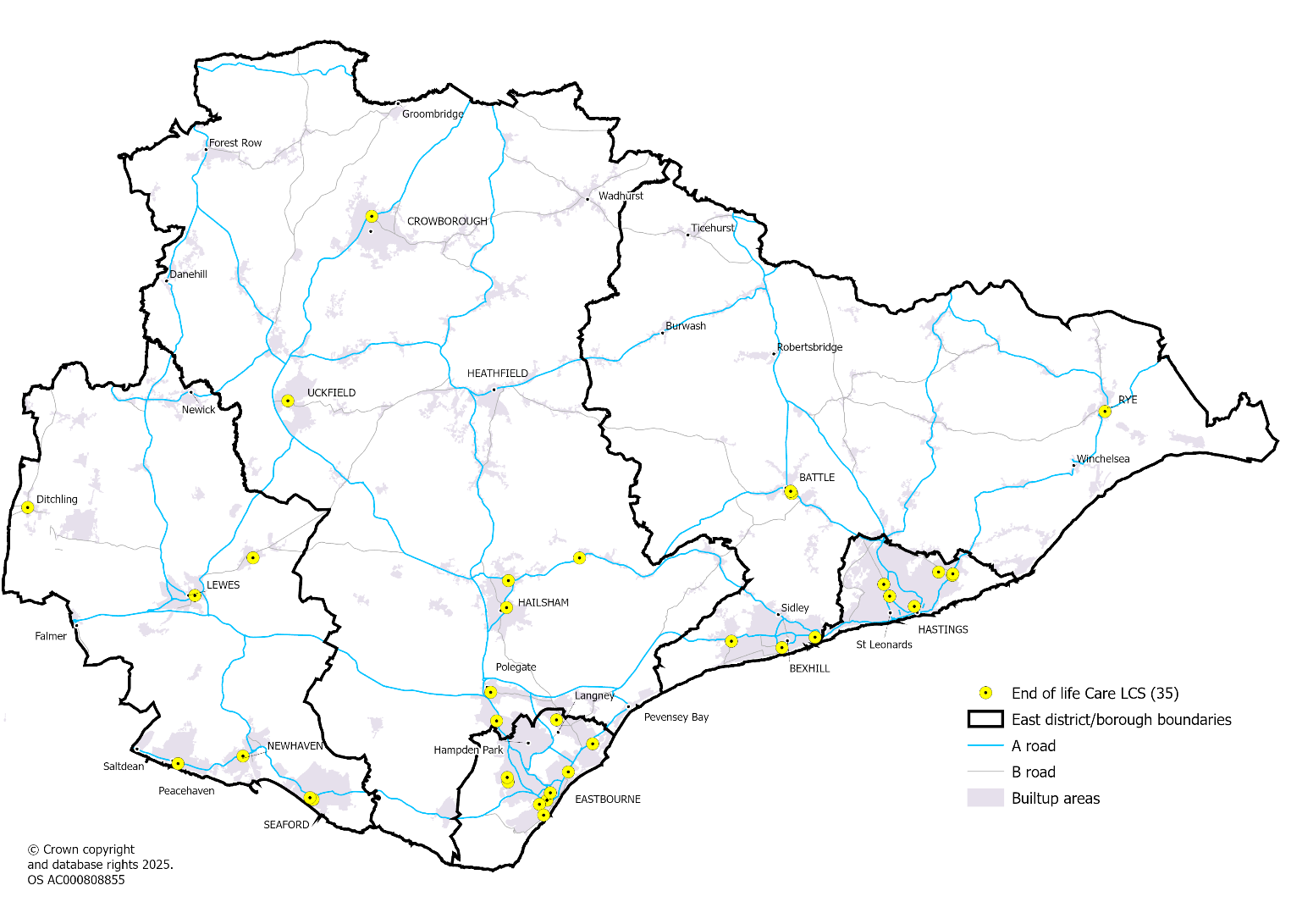

Supply of oral antiviral medication for the treatment of COVID-19 and management of Influenza – NHS Sussex ICB
There are four out of 92 pharmacies commissioned to provide this LCS, and they are shown in the map below. For both of these services a selected number of pharmacies are commissioned to provide geographical coverage and service provision is not open to all pharmacies.

Map: Pharmacies signed up to the Antiviral LCS
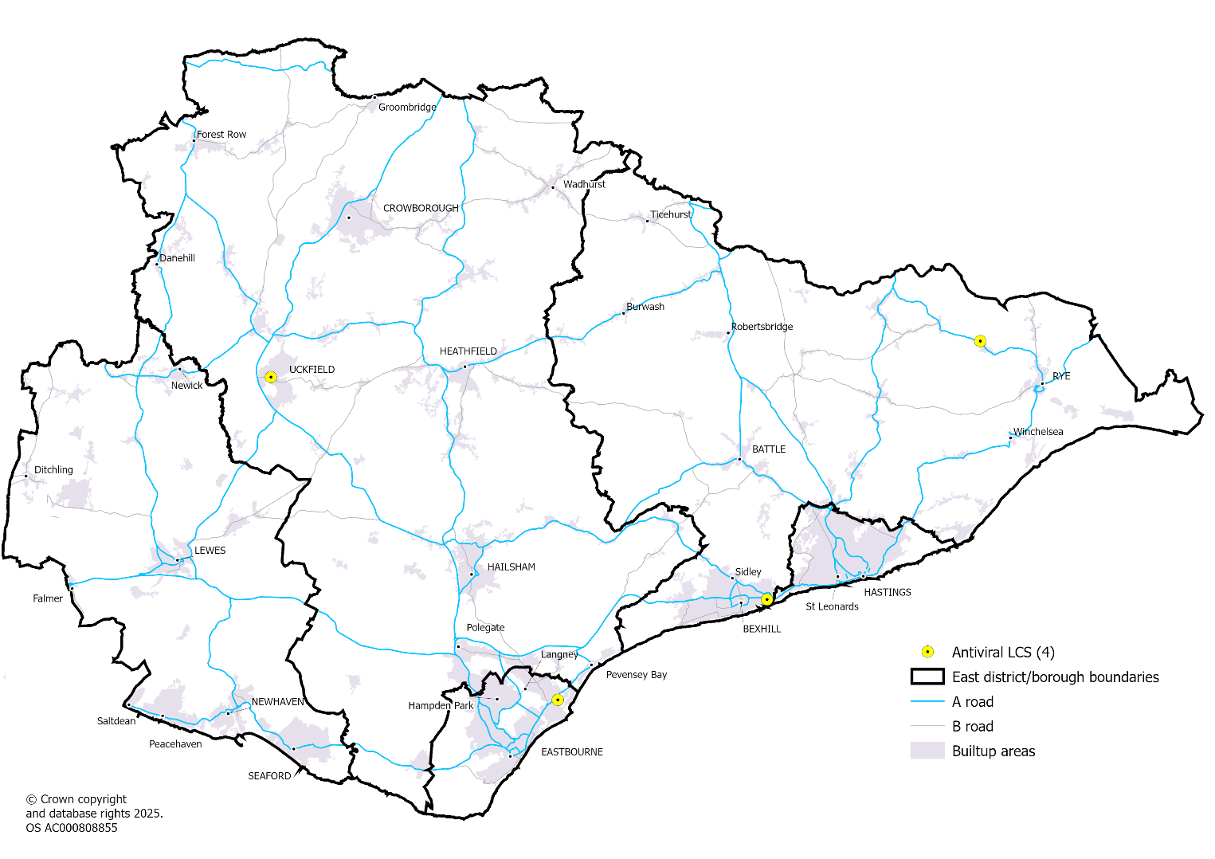

C-Card for under 25s – ESCC
This service is for the distribution of condoms only as part of The East Sussex C-Card Condom Distribution Scheme. The scheme is a free and confidential co-ordinated condom distribution network for young people aged 13–24 years old in East Sussex. It aims to provide quick and confidential access to condoms, supported by evidence based, accurate contraceptive and sexual health information, and signposting to comprehensive contraceptive and sexual health services.
Community Pharmacy PHLSA Services | East Sussex County Council
There are 28 out of 92 pharmacies signed up for this service across the county with at least four locations in each district/borough area.

Map: Pharmacies signed up to the C-card LCS
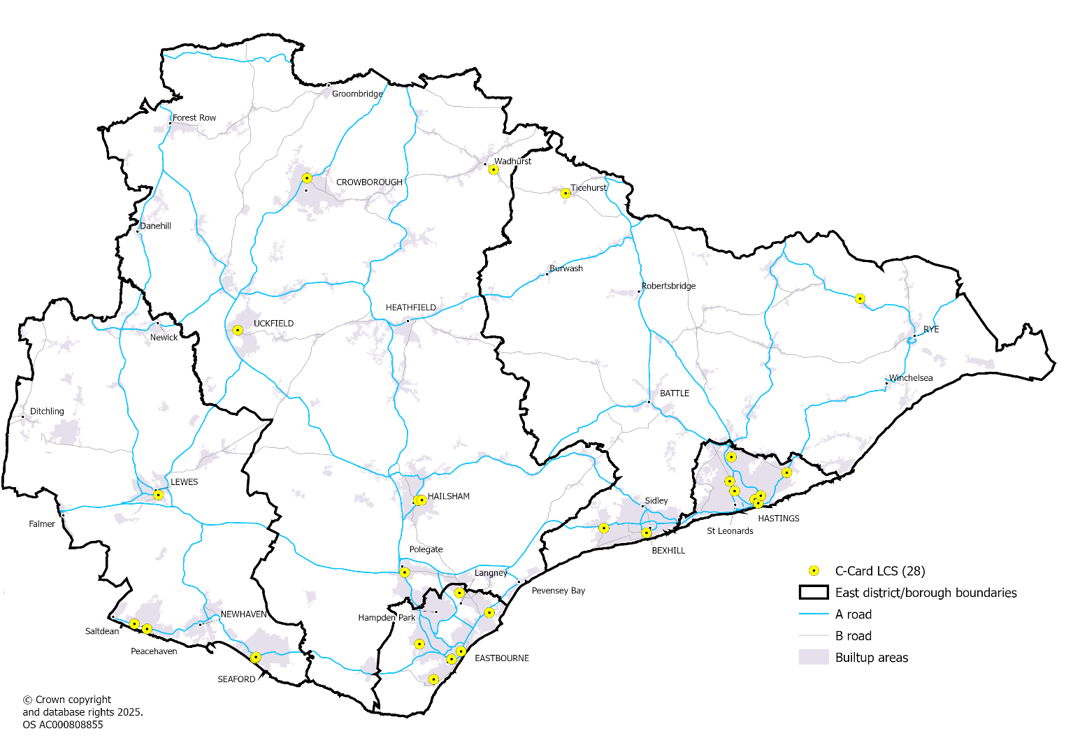

Emergency Hormonal Contraception (EHC) to under 25s - ESCC
This service is for the provision of free Emergency Hormonal Contraception (EHC). The contractor must be able to provide the EHC service for 90% of their opening times in order to maintain trust in the East Sussex sexual health website service finder www.eastsussexsexualhealth.co.uk
This service covers:
- Assessing and dispensing, under local Patient Group Direction (PGD), free emergency hormonal contraception to East Sussex residents aged 25 or under, and those aged over 25 who are unable to access the alternative free at point of delivery services such as GP practices, online (SH.UK) and specialist sexual health services.
- Provision of free pregnancy testing when appropriate to East Sussex residents aged 25 and under who are requesting EHC.
- Provision of free STI home sampling kits to all ages.
Community Pharmacy PHLSA Services | East Sussex County Council
There are 27 out of 92 pharmacies signed up for this service across East Sussex with four or more locations available in each district/borough.
Map: Pharmacies signed up to the ECH LCS
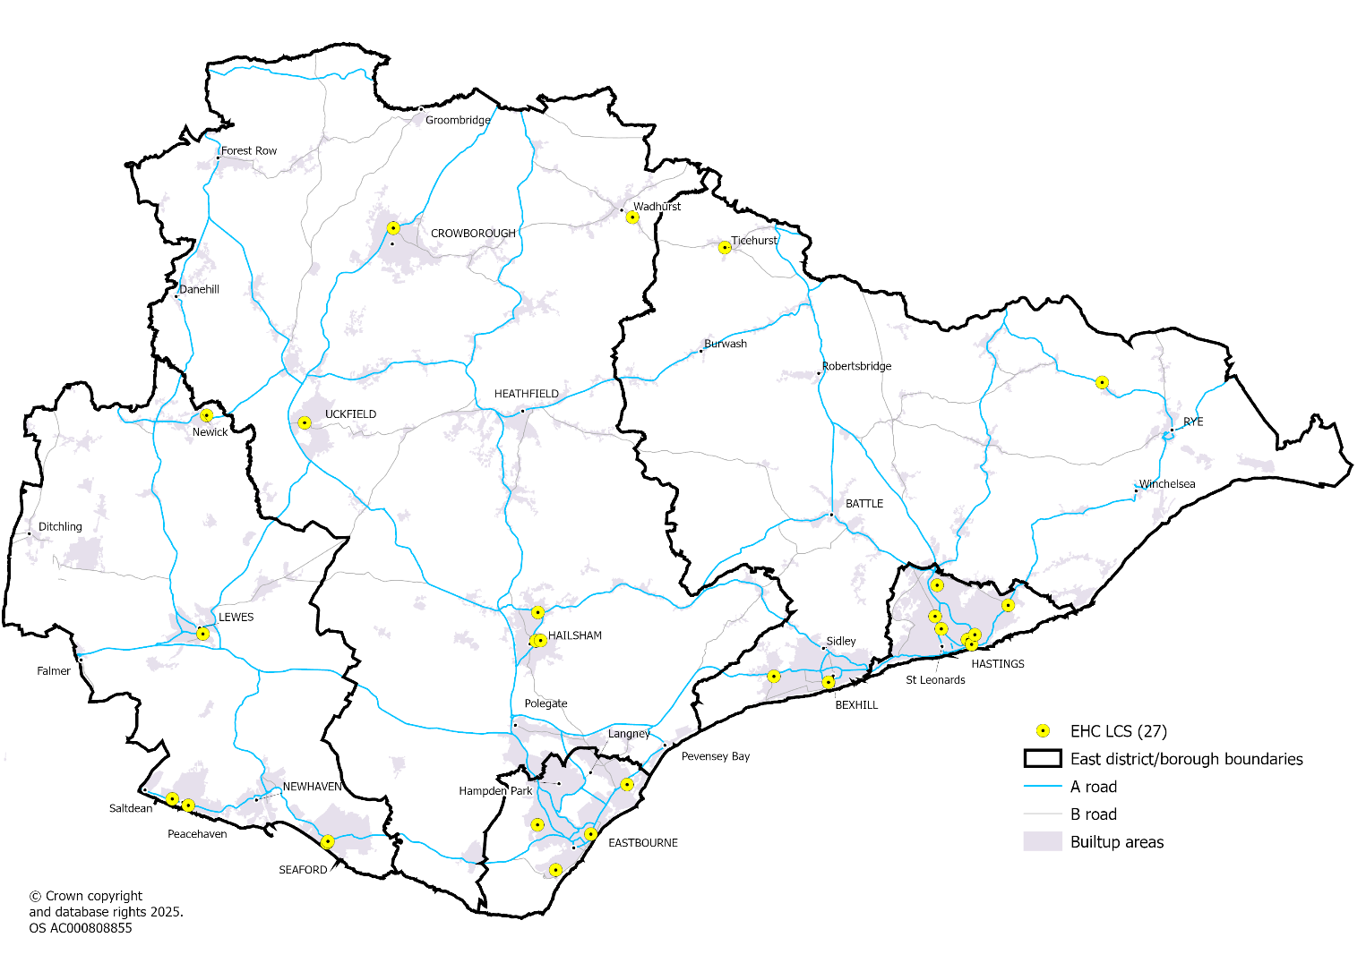

Smoking Cessation - ESCC
This service enables Community Pharmacies to provide Stop Smoking Services to their clients which:
- Offer choice of treatment options appropriate to clients
- Offer or support clients to use the most effective evidence-based treatments available
- Support people to successfully quit smoking
- Achieve high levels of client satisfaction
Community Pharmacy PHLSA Services | East Sussex County Council
There are 22 out of 92 pharmacies signed up for this service in East Sussex with three or more locations available in each district/borough.

Map: Pharmacies signed up to the smoking cessation LCS
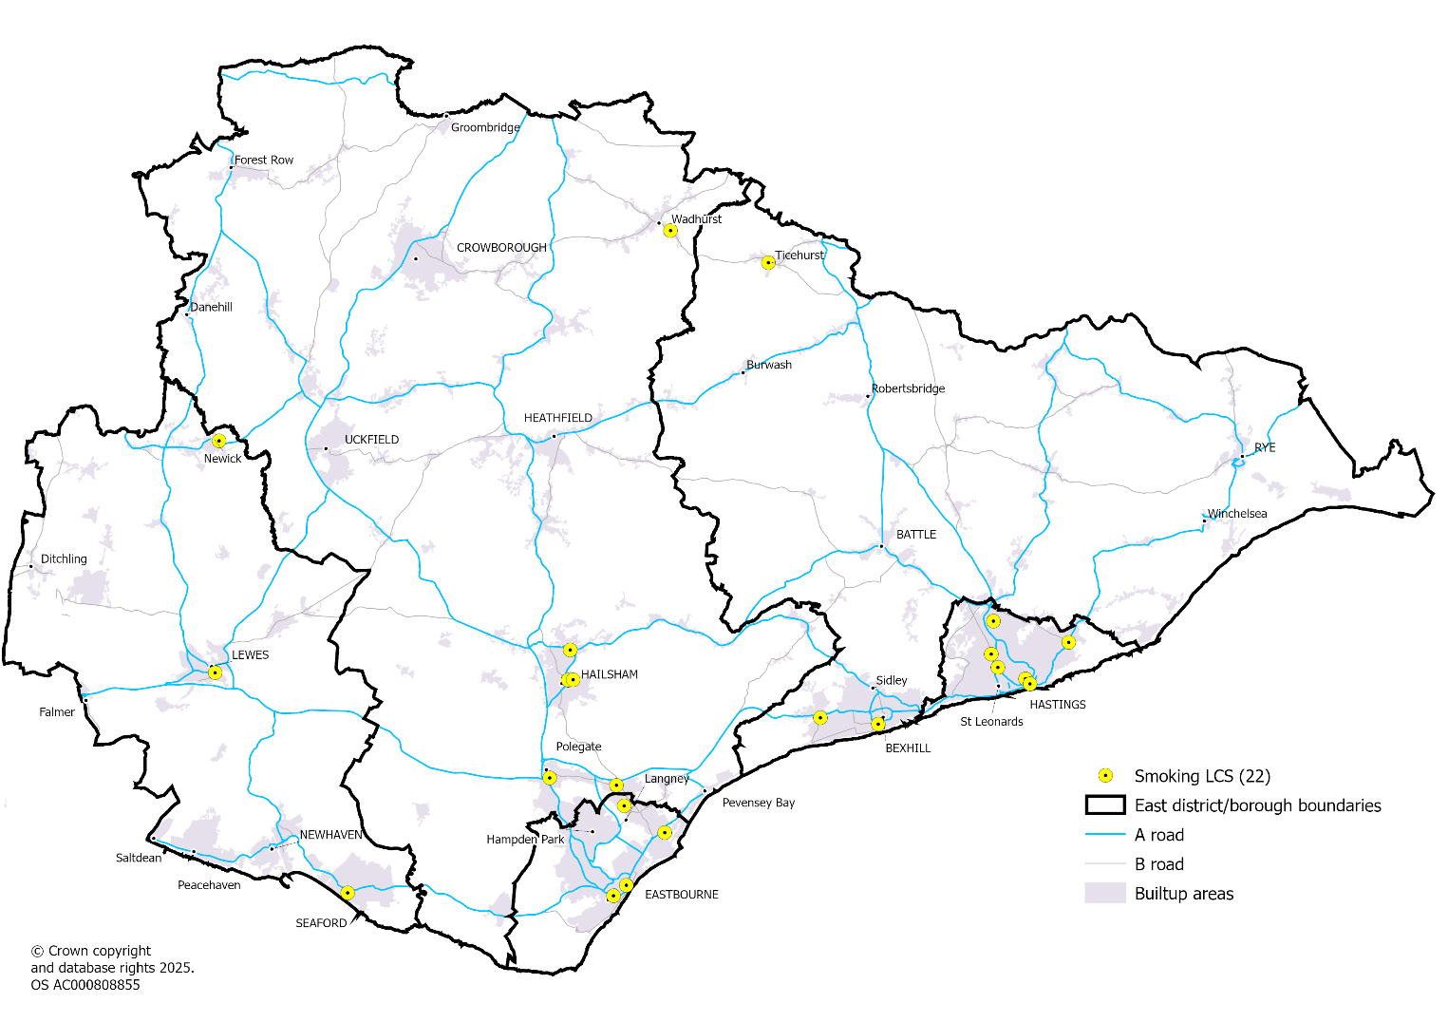

Opiate reversers (naloxone) - CGL
Naloxone is an emergency antidote for overdoses caused by opiates such as heroin,
methadone, morphine, codeine and fentanyl. Community pharmacies dispense naloxone to
anyone who is likely to provide support for an opiate overdose.
34 out of 92 community pharmacies are signed up to the service with good coverage across the main built-up areas.
Table: Naloxone activity, 1st April 2024 to 17th March 2025
Activity | Eastbourne | Hastings | Lewes | Rother | Wealden | East Sussex
Naloxone activity | 9 | 146 | 6 | 13 | 0 | 174
Rate per 1,000 population | 0.1 | 1.6 | 0.1 | 0.1 | 0.0 | 0.3
Source: CGL
Map: Pharmacies signed up to the Naloxone LCS
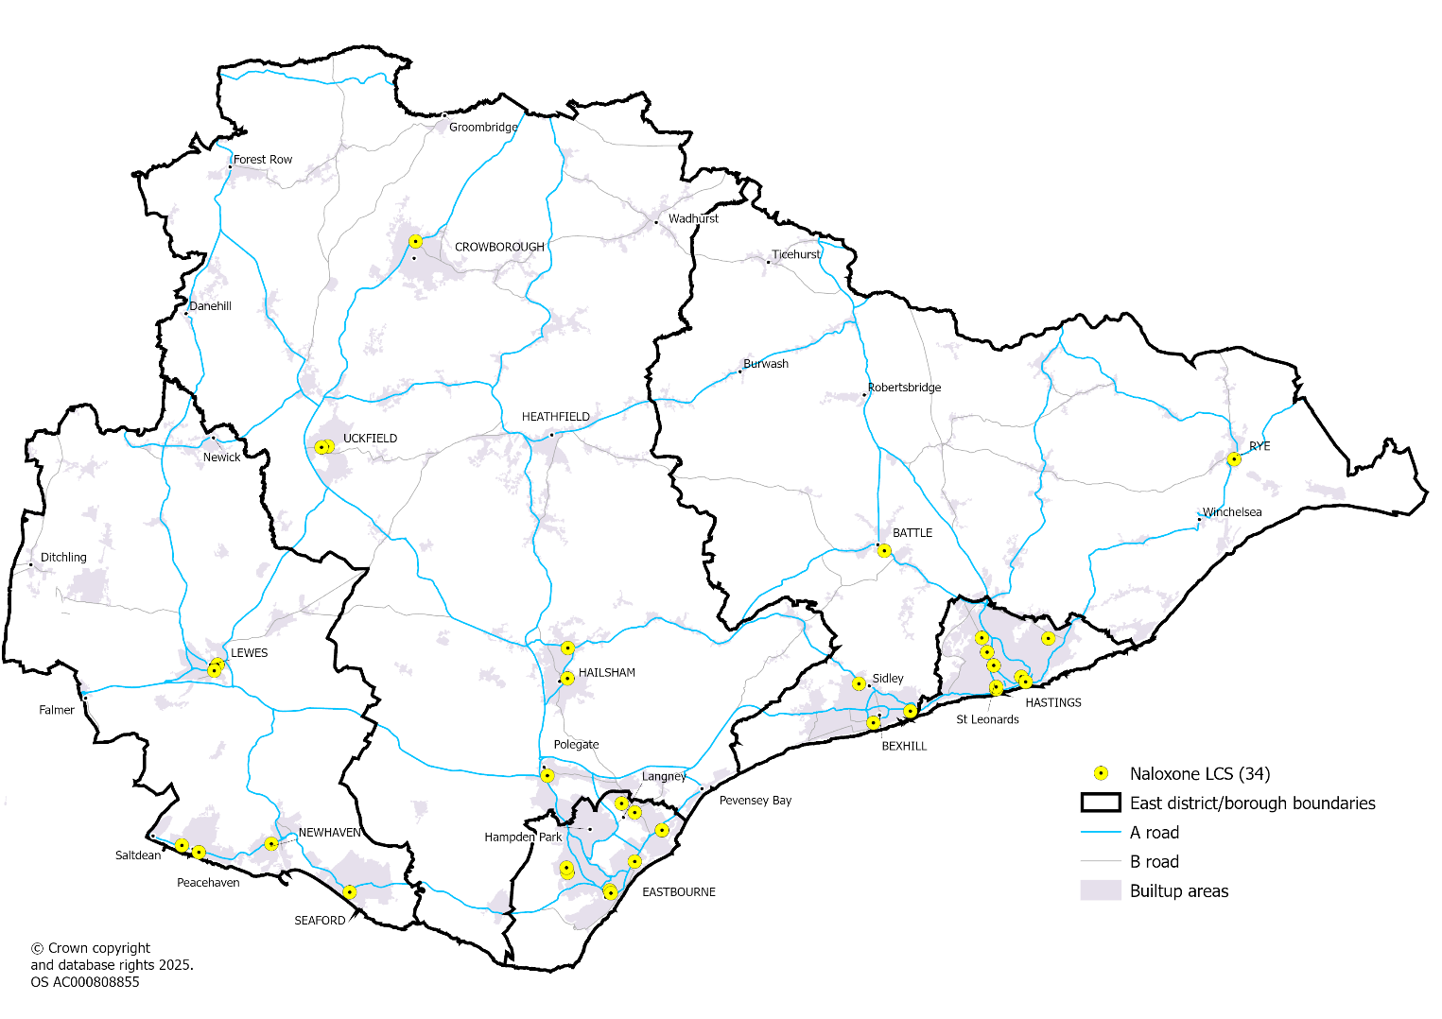

Needle and syringe exchange programme (NSP) - CGL
The aim of this service is to reduce the transmission of blood-borne viruses associated with injecting drug use by providing free, sterile injecting equipment and advice in line with NICE public health guideline PH52
22 out of 92 community pharmacies are signed up to the service, mainly concentrated in coastal areas plus Lewes town and Hailsham.
Table: Needle exchange activity, 1st April 2024 to 17th March 2025
Activity | Eastbourne | Hastings | Lewes | Rother | Wealden | East Sussex
Needle Exchange interactions | 1,382 | 4,905 | 755 | 25 | 239 | 7,306
Rate per 1,000 population | 13.3 | 54.0 | 7.4 | 0.3 | 1.5 | 13.2

Map: Pharmacies signed up to the Needle and syringe exchange LCS
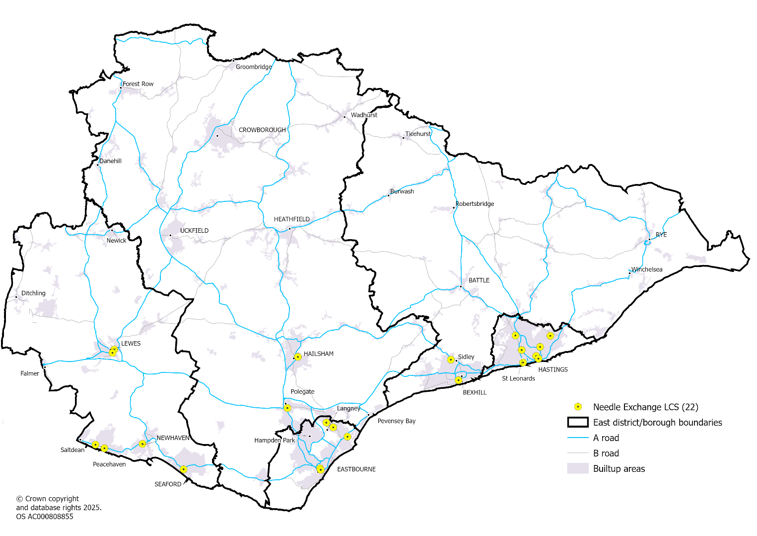

Distribution of oral substitution therapy and supervised consumption - CGL
The supervised consumption scheme through community pharmacy aims to reduce mortality and morbidity among high-risk opiate users by improving consistency and quality of care. This service supports individuals in complying with their prescribed regime therefore reducing incidents of accidental deaths through overdose, and pharmacists are able to keep to a minimum the misdirection of controlled drugs, which may help reduce drug related deaths in the community
80 out of 92 community pharmacies are signed up to the service with excellent coverage across the county.

Table: Supervised consumption activity, 1st April 2024 to 17th March 2025
Activity | Eastbourne | Hastings | Lewes | Rother | Wealden | East Sussex
Supervised consumption interactions | 2,678 | 3,140 | 525 | 522 | 317 | 7,182
Rate per 1,000 population | 25.8 | 34.6 | 5.2 | 5.5 | 1.9 | 12.9
Map: Pharmacies signed up to the supervised consumption LCS
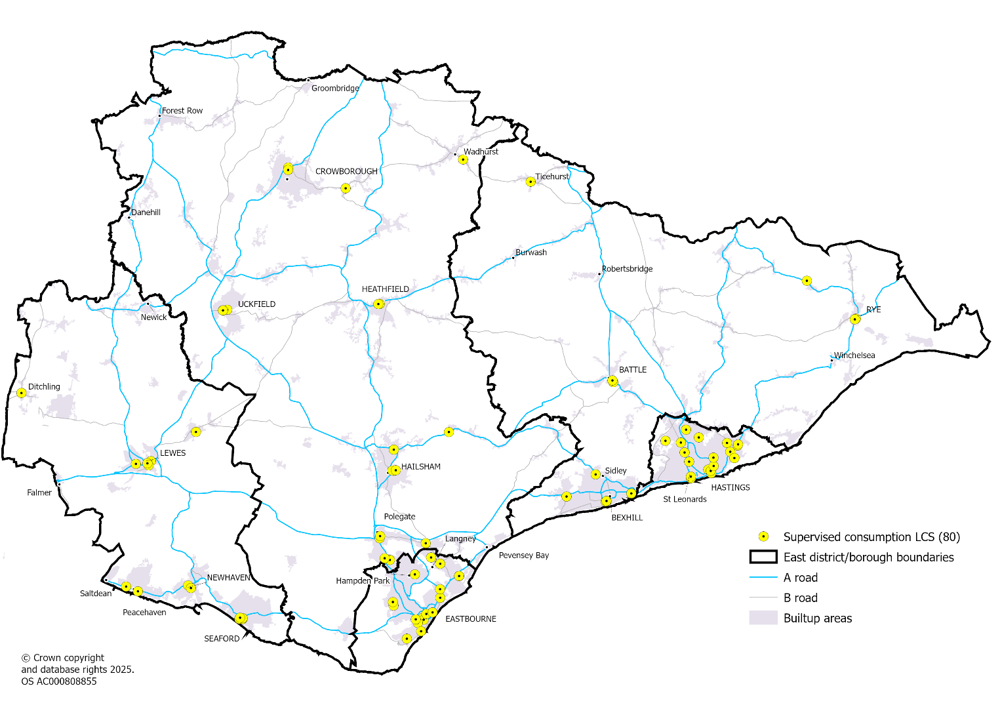

6.8 Other services affecting demand for and which supply pharmaceutical services

NHS Acute Trust Hospitals
East Sussex NHS Trust (ESHT) is the main trust providing both acute hospital and outpatient services to East Sussex residents in the East of the county. Acute hospital services are provided over two sites at Eastbourne District General Hospital, and The Conquest Hospital in Hastings. The hospital pharmacy service operates from both acute sites with a single Chief Pharmacist overseeing both.
Although based outside of East Sussex, University Hospitals Sussex (UHSx) (hospitals in Brighton and Haywards Heath) and Maidstone and Tunbridge Wells (MTW) (hospital in Pembury) also provide extensive acute inpatient and outpatient services to many East Sussex residents.
The table below shows that for emergency admissions to hospital, 70% of residents attended ESHT, 15% at UHSx and 10% at MTW. This distribution differs between districts and borough in East Sussex.
Table: Emergency admissions for East Sussex residents by hospital trust admitted to, 2022/23
NHS Trust | Eastbourne | Hastings | Lewes | Rother | Wealden | East Sussex
East Sussex Healthcare Trust (ESHT) | 93% | 94% | 26% | 87% | 52% | 70%
University Hospitals Sussex (UHSx) | 3% | 2% | 69% | 2% | 13% | 15%
Maidstone and Tunbridge Wells (MTW) | 0% | 1% | 0% | 7% | 29% | 10%
Elsewhere | 4% | 3% | 4% | 4% | 6% | 4%
Percent Total | 100% | 100% | 100% | 100% | 100% | 100%
Source: East Sussex Joint Strategic Needs Assessment |

NHS Community Hospitals
Sussex Community NHS Foundation Trust (SCFT) runs three community hospitals across the county in Crowborough, Lewes, and Uckfield. Rye and Bexhill Hospitals are run by ESHT. Community hospital services in East Sussex are summarised below, Table 26
Table: Community Hospital Services in East Sussex
Community Hospital | Services provided (Trust)
Crowborough War Memorial | Urgent care centre, minor injuries unit, intermediate care unit; community nursing; therapies; diagnostic imaging. (SCFT)  Crowborough birthing centre. (MTW)
Lewes Victoria | Urgent Treatment Centre (UTC); Intermediate care unit; community nursing; therapies; diagnostic imaging. (SCFT)
Uckfield Community | Minor injuries unit, intermediate care beds; community nursing; therapies; Diagnostic imaging. (SCFT)
Rye, Winchelsea and District Memorial | Intermediate care unit, Palliative and end of life of care, outpatient services. (ESHT)
Bexhill | Ophthalmic Day Surgery, Outpatient clinics, Physiotherapy, Radiology, Wet Age-related Macular Degeneration (AMD) follow-up; Diabetic Retinal Screening, intermediate care unit. (ESHT)
Source: SCFT; ESHT; MTW

Mental health services
Sussex Partnership NHS Foundation Trust provides mental health services across East Sussex. They provide services in a variety of different locations including hospitals, health centres, rehabilitation and recovery centres and smaller clinic spaces all over East Sussex.
Hospitals and locations :: Sussex Partnership NHS Foundation Trust

Residential and Nursing Care homes
In East Sussex there were 282 care homes. See map in section 3.2 There are three hospices (one in Hastings, Eastbourne and Chailey respectively) registered in East Sussex.
Apart from Lewes District, the District and Boroughs in East Sussex have more care home beds per 100 people aged 75 and over than the England average.
The number of nursing home beds per 100 people aged 75 and over is lower than the England average for Lewes and Rother and higher for Eastbourne, Hastings and Wealden.
Table: Rates of care home bed provision, 2021
 | Eastbourne | Hastings | Lewes | Rother | Wealden | East Sussex | England
Care home beds per 100 people 75 and over | 13.9 | 17.2 | 8.2 | 12.2 | 9.8 | 11.7 | 9.4
Nursing home beds per 100 people 75+ | 6.3 | 7.0 | 3.5 | 3.9 | 5.4 | 5.1 | 4.6
Source: Palliative and End of Life Care Profiles - Data | Fingertips | Department of Health and Social Care

Other services
Dentists
Dentists may issue NHS prescriptions which are dispensed as part of pharmaceutical services. However the level of activity is unknown.
Cross border NHS services
East Sussex is bounded to the west by Brighton & Hove and West Sussex, to the north and East by Kent. Patients who live toward the borders of the county may choose to access pharmaceutical services from pharmacies located in the major towns close to these borders, namely Brighton & Hove, Burgess Hill, Haywards Heath, East Grinstead and Royal Tunbridge Wells, all of which are found within five kilometres of the East Sussex border.
Private hospitals
There are three private healthcare sites within East Sussex: the Esperance (BMI Healthcare) in Eastbourne, the Horder Centre (Horder Healthcare) in Crowborough, and the Spire Hospital Sussex (Spire Healthcare) in Hastings. These provide several specialties, including surgical and non-surgical services. All have in-house pharmacy departments.

7. East Sussex Residents’ Survey 2025

Methodology
A key aspect of the PNA is capturing the views of people who use community pharmacy services in the county. To do this a resident survey was designed, building on previous surveys undertaken in previous PNAs. The steering group helped to ensure the survey was focussed on the key areas where we required evidence from the public. The survey was designed and tested by a member of the public unfamiliar with a PNA to ensure the questions were clear.
The survey was hosted on the East Sussex County Council’s Survey and consultation portal, Citizen Space. Have your say on pharmacy services in East Sussex - East Sussex - Citizen Space and ran during the 6 weeks between 6th February and 20th March 2025.
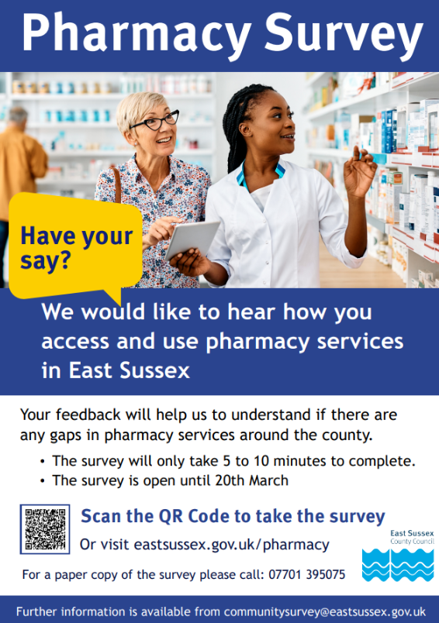
A poster was designed to promote the survey which was posted out to all community pharmacies, GP Practices (and branch surgeries), all 17 public libraries and all 11 family hubs with a letter asking if they would display the poster in their premises.
Hard copy surveys were also available in public libraries and sent out to anyone requesting one.
The survey was promoted through the GP Practice Patient Participation Group Network, who encouraged their members to complete the survey and promote within their practices. Partners, such as Healthwatch and NHS Sussex, promoted the survey through their newsletters.
Social media advertising was purchased to promote the survey on Facebook and Instagram, whilst there were also posts from ESCC accounts on Facebook, Instagram and X.

7.1 Findings

Area of residence
Of the 947 who responded to the survey, 943 provided the district/borough where they live. Comparing the distribution to the general population we can see that Rother and Wealden are slightly over represented and Eastbourne and Hastings slightly under-represented. However the sample size is big enough to provide useful results.
Where data are split by district/borough some numbers and percentages may be slightly different in tables and charts when comparing to East Sussex, as some people did not provide their district/borough of residence.
Chart: District/borough of residence
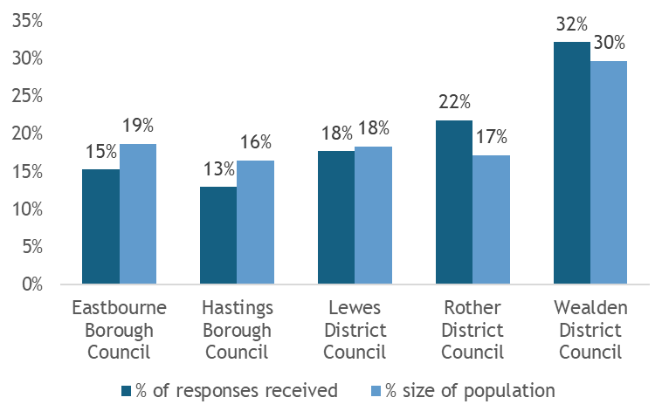
Table: Responses by area of residence
Area | Responses
Eastbourne | 144
Hastings | 122
Lewes | 167
Rother | 206
Wealden | 304
Don't know | 2
Not Answered | 2
Total | 947

Equalities questions
Age and sex
27% of responses were from men compared to 73% from women. The chart below compares the age and sex distribution of respondents to the survey (coloured bars) to the general resident population in East Sussex (outlines). This shows that a greater percentage of respondents were in the 65-84 age category compared to the general population. A lower proportion were in the 18-64 age group, although this was more pronounced for males. A similar percentage were aged 85+ compared to the population. This tells us that older females responded most to the survey. This will reflect population groups who are generally more likely to respond to a survey, plus the population who will be utilising pharmacy services the most.
Chart: Responses by age and sex
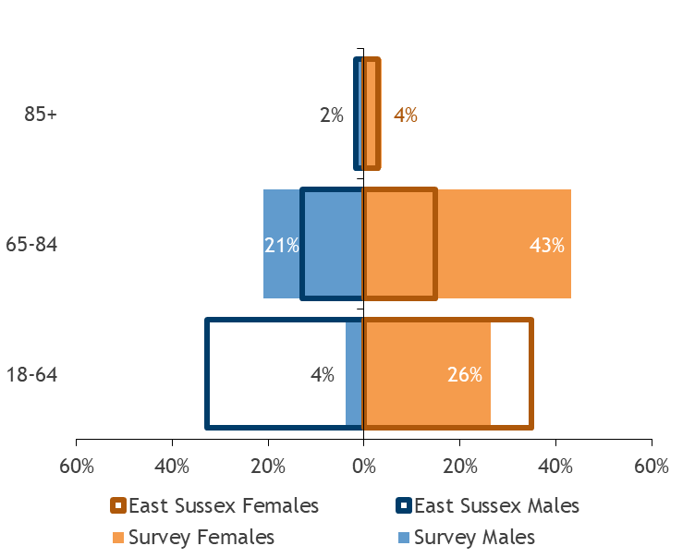
Ethnic group
83% of respondents were white ethnicity, with 1.5% other ethnic groups and 16% who did not answer or preferred not to say.

Chart: Responses by ethnic group
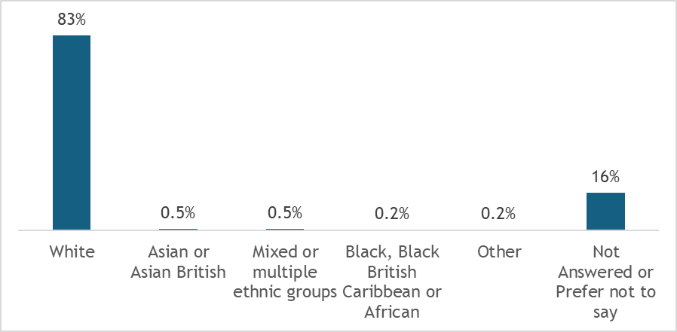
78% of respondents were straight/heterosexual, with 3.4% other orientations and 19% who did not answer or preferred not to say.
Chart: Responses by sexual orientation
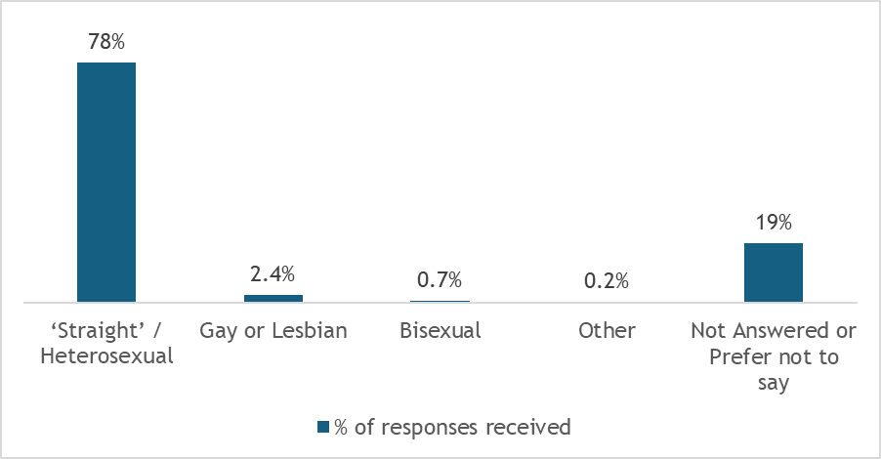
Religion or belief
48% of respondents were Christian, 30% had no religion and 2.3% were other religions/beliefs. 19% did not answer or preferred not to say.

Chart: Responses by religion or belief
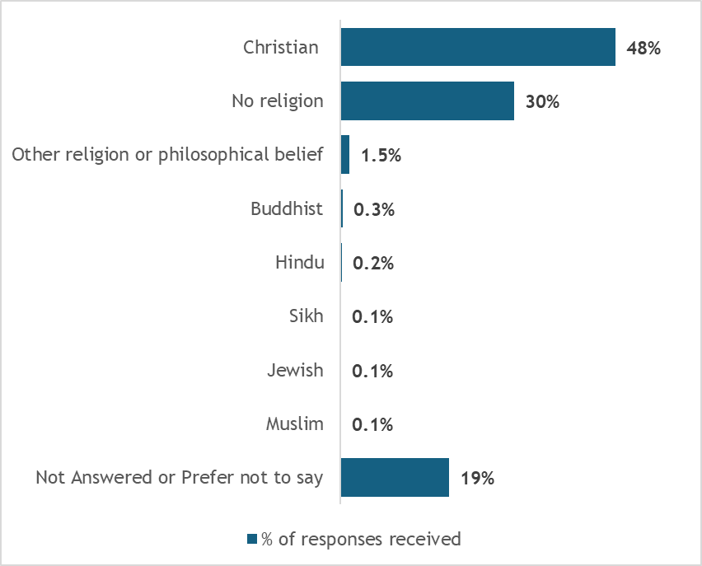
Long-term limiting illness
56% (531 people) responded that they did have a physical or mental health conditions or illnesses lasting or expected to last 12 months.
Chart: Do you have any physical or mental health conditions or illnesses lasting or expected to last 12 months or more?
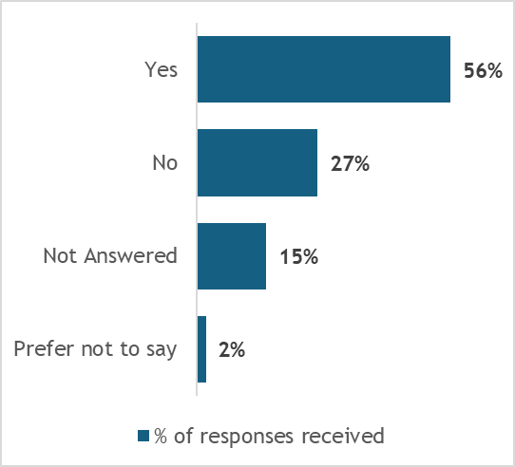
Of those 531 people 69% responded that their condition or illnesses reduced their ability to carry out day-to-day-activities.
Chart: Do any of your conditions or illnesses reduce your ability to carry out day-to-day activities?
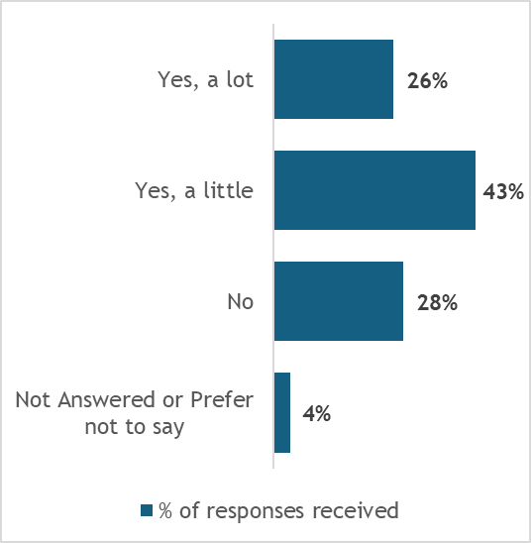

Where do you usually get your prescription from?
71% of respondents reported they got their prescription from a pharmacy/chemist shop, with 14% getting it directly from a GP Surgery. Of those who got their prescription from a GP, 57% lived in Rother and 37% lived in Wealden which reflects the availability of dispensing practices for more rural patients.
Chart: Where do you get your prescription from?
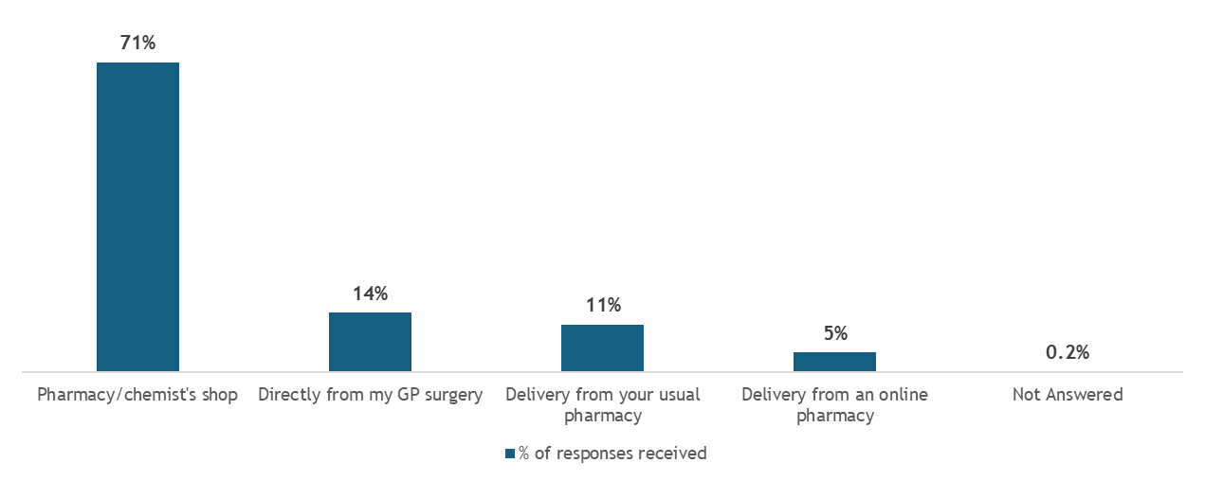

Chart: The percentage split for each district/borough showing where people usually get their prescriptions
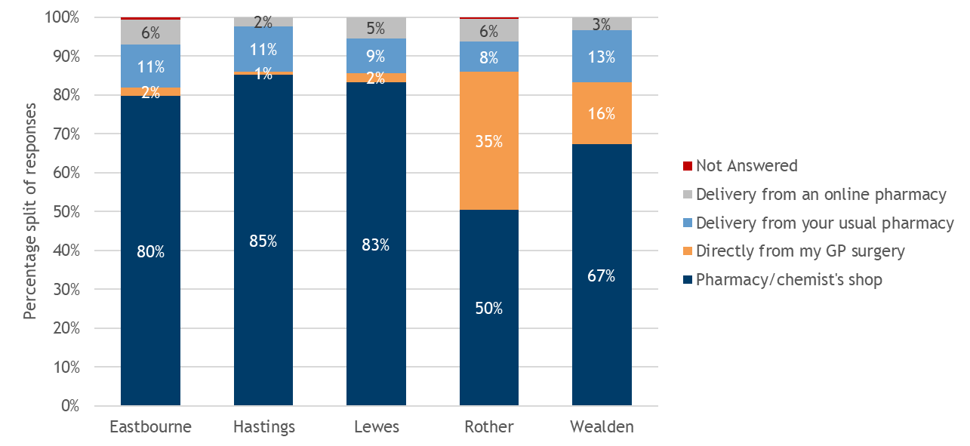

How often do you use a pharmacy for health reasons?
The vast majority of respondents visited their pharmacy monthly (65%), with 17% every few months, 10% weekly and 7% once a year or less.
Chart: How often do you use a pharmacy for health reasons?
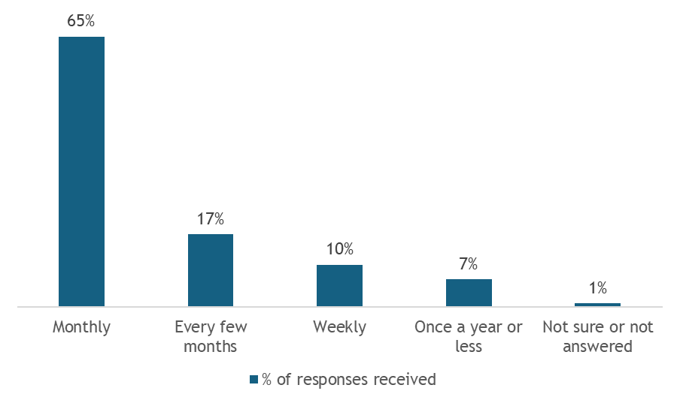

How do you usually travel to the pharmacy?
For those who visited a pharmacy in person, 53% travelled by car and 42% walked. Only 2% travelled by public transport. Use of public transport is highest in Eastbourne (6%) and lowest in Rother (2%) and Wealden (0%). This reflects the access to car statistics in section 4.6.
Chart: How do you usually travel to the pharmacy?
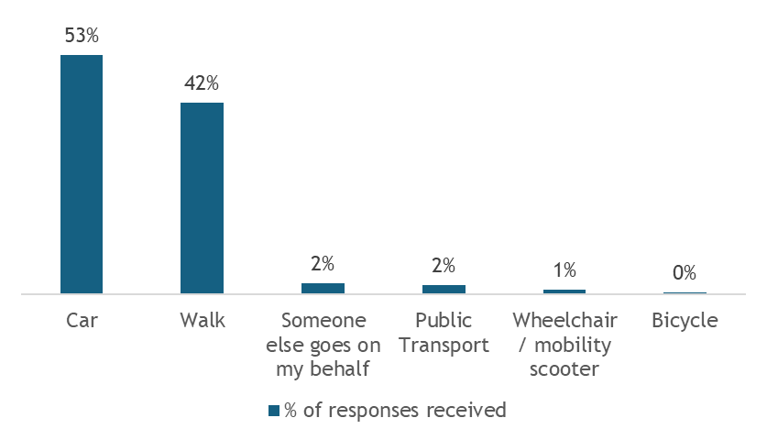
Table: How do you usually travel to the pharmacy?
Method of travel | Eastbourne | Hastings | Lewes | Rother | Wealden | East Sussex
Car | 49% | 43% | 42% | 60% | 59% | 52%
Walk | 42% | 50% | 52% | 35% | 38% | 42%
Someone else goes on my behalf | 2% | 4% | 3% | 2% | 2% | 2%
Public Transport | 6% | 3% | 3% | 2% | 0% | 2%
Wheelchair / mobility scooter | 0% | 1% | 1% | 2% | 1% | 1%
Bicycle | 1% | 0% | 0% | 0% | 0% | 0%

What time do you usually go to the pharmacy?
The vast majority of respondents (86%) go to their pharmacy on weekdays between 9am and 6pm. 3% usually go on a weekday evening and another 3% on the weekend (8% did not answer or were unsure).
Chart: What time do you usually go to the pharmacy?
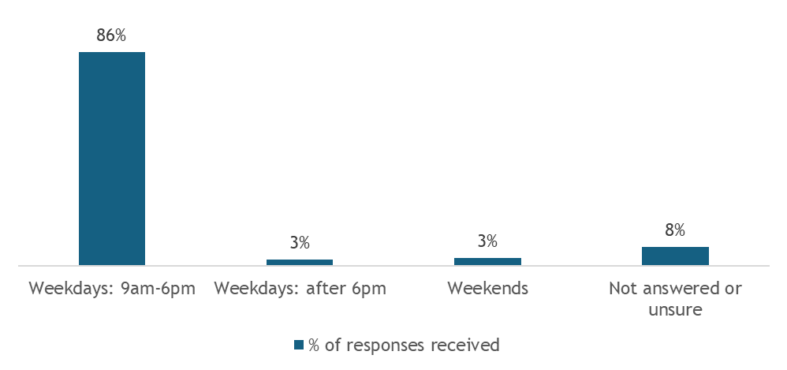

How easy was it to access a pharmacy at different times
Most respondents found it easier to access the pharmacy weekdays between 9am and 6pm (66% found it easy) and at weekends (49% found it easy), whilst only 29% found it easy weekdays after 6pm and 28% on bank holidays.
Looking at the responses by district/borough and which area scored poorest on access for each time option, Hastings respondents found it hardest to access weekdays, Lewes respondents found it hardest in the evenings and bank holidays, and Rother respondents found it hardest on the weekends.
Chart: How easy was it to access a pharmacy at these different times?
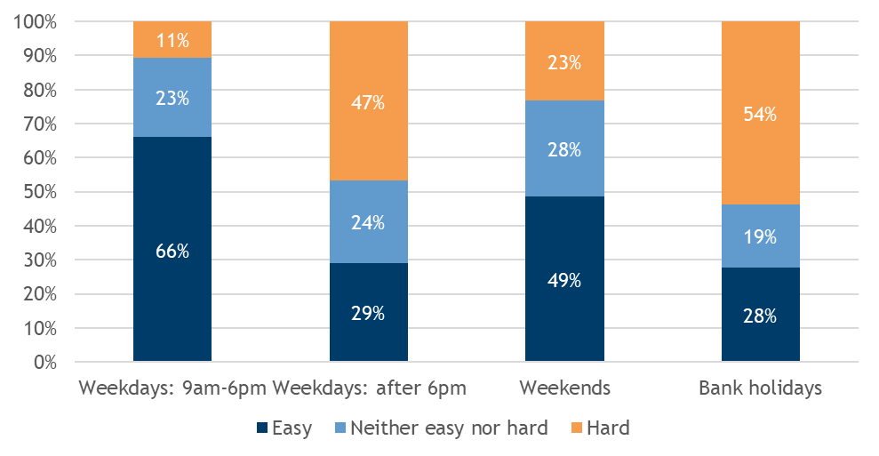

Chart: % of respondents from each district/borough who found it "hard" to access a pharmacy at these different times
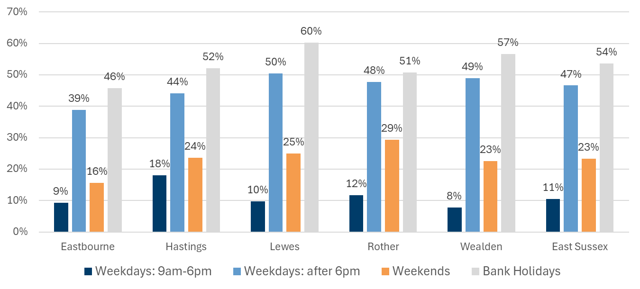

Access for people with physical disabilities
27% (259) of people responded to this question with 79% (204 people) of those reporting that the pharmacy always met their needs.
For those that said their needs were sometimes or never met, 35% stated difficulties accessing the building because of steps, 25% insufficient/no seating, 18% difficulty opening the door and 10% long queues.
Chart: If you have a physical disability, does your pharmacy meet your needs for you to access the building?
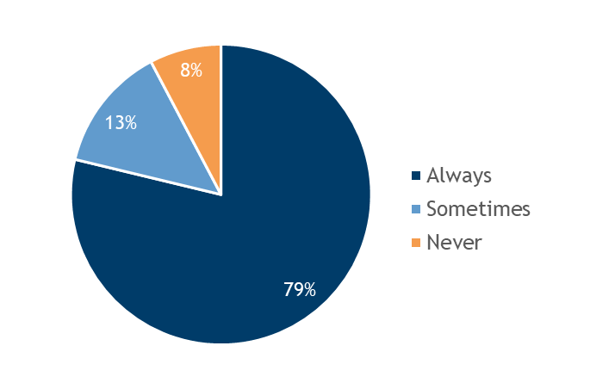
Chart: The reasons given by people with a physical disability need as to why the pharmacy only sometimes or never meets their needs
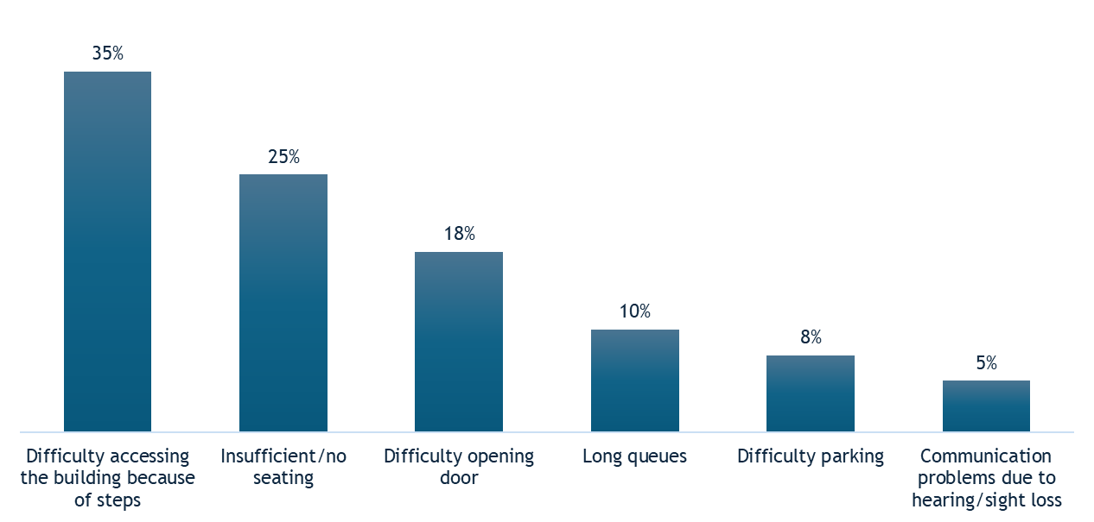

Experience for people with communication needs
Communication needs might include needing written information in another format e.g. large print, audio or in another language.
21% (194) of people responded to this question, and of those 79% (154 people) reported that the pharmacy always met their needs.
The most common reason for why the pharmacy did not meet their needs related to some form of telecommunication need not being met. This might include the pharmacy not calling/messaging to update/respond to customers, no longer being able to call the pharmacy, or the pharmacy being slow at responding to emails/calls.
Chart: If you have a communication need, does your pharmacy communicate information with you in the way you need?
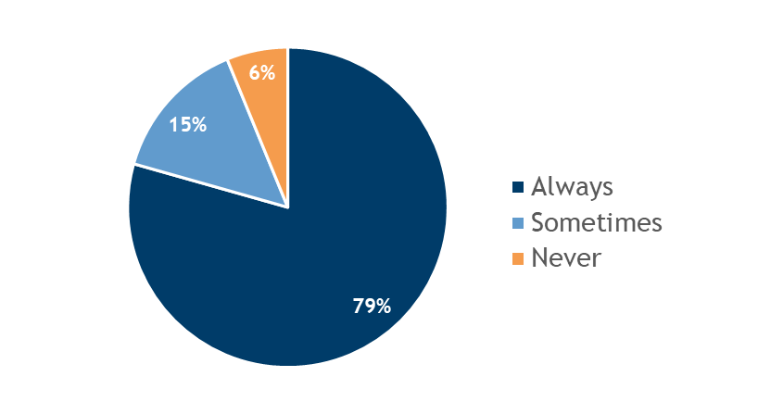
Chart: The reasons given by people (25 individuals) with a communication need as to why the pharmacy does not always meet their needs
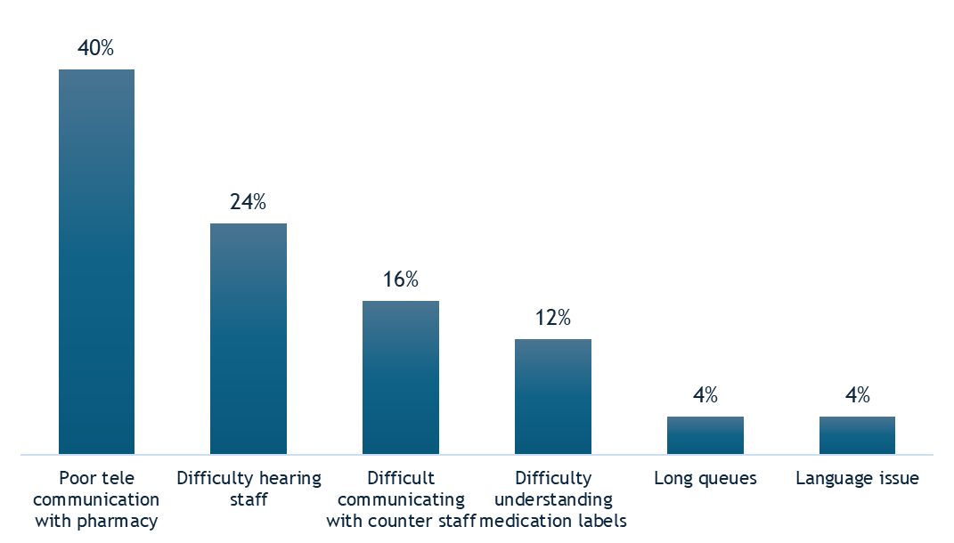

Helping others access pharmacies
33% (311) of people help someone to use pharmacy services, and of those 6% (18 people) reported they found it difficult to meet that person's needs.
When respondents were asked what makes it easy or difficult to collect on behalf of someone else, there were four times more positive responses to negative ones.
Chart: If you help someone else to use pharmacy services, does the pharmacy make it easy or difficult for you to meet that person's needs
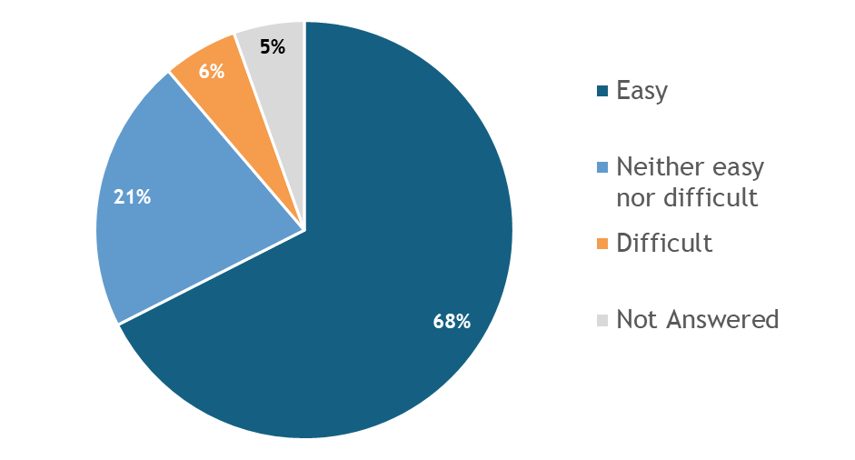

Chart: What makes it easy or difficult to collect on behalf of someone else?
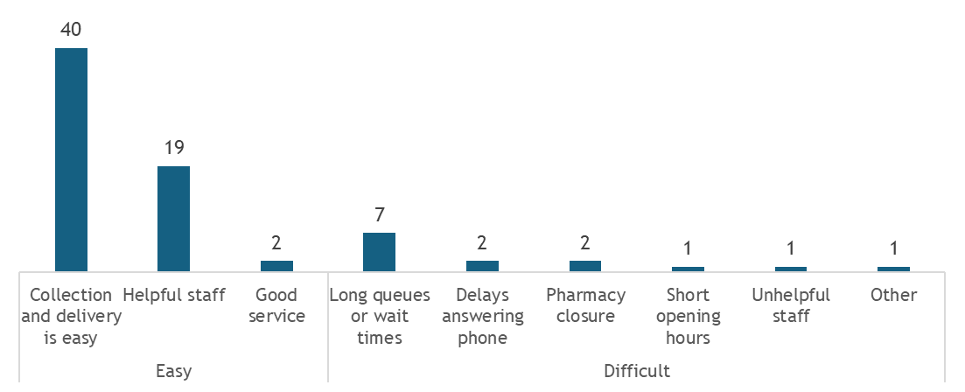

Any other comments about pharmacy services in East Sussex
The final question was an open question inviting any other comments to which we received 683 responses. We completed a qualitative analysis, and these were the numbers of responses against some key themes:
- Convenience and Accessibility: There were 49 responses mentioning the convenience of local pharmacies, with 15 responses highlighting issues with limited opening hours and closures.
- Service Quality: There were 38 responses praising the helpful and friendly staff, while 12 responses criticise long wait times and poor customer service.
- Delivery Services: Delivery services were mentioned in 27 responses, with 8 responses expressing concerns about unpredictability and delays. Note that delivery services are not an NHS funded service, or a pharmacy commissioned service.
- Pharmacy Closures: There were 22 responses expressing strong sentiment against the closure of local pharmacies.
- Role of Pharmacists: Pharmacists were valued in 31 responses for their advice and handling minor health issues, but 9 responses mention concerns about overburdened pharmacists and lack of continuity in care.
- Out-of-Hours Services: There were 18 responses indicating a need for the existing pharmacies to be open longer during evenings, weekends, and bank holidays.
- Integration with GP Services: Better integration between pharmacies and GP services was desired in 14 responses, with issues such as delays in prescription processing and lack of communication highlighted.
- Environmental Concerns: Environmental impact of pharmacy practices was mentioned in 5 responses. This was mainly related to plastic packaging.

10. Gap analysis
Guidance from the Department of Health and Social Care suggests there are three types of gaps in provision that can be articulated in the PNA:
- Geographical gaps in the location of premises.
- Geographical gaps in the provision of services.
- Gaps in the times at which, or days on which, services are provided.
This section summarises the analysis in East Sussex.

10.1 Geographical gaps in the location of pharmacies
Section 6.1 contains analysis of provision (pharmacies and dispensing practices) per 100,000 population across the districts and boroughs in East Sussex. This shows highest provision per 100,000 population in Rother (24.2), which has the oldest population profile, followed by Hastings (22.0) which has the most population living in areas of deprivation. The lowest rates are in Eastbourne (16.4) and Lewes district (16.8).
Section 4.5 shows a map of all pharmacy locations overlaid onto population density. This shows that all highly populated areas of the county have sufficient pharmacy locations nearby. Access in more rural areas, such as rural Rother and the northern areas of Wealden, is boosted with dispensing practices.
Access for residents is boosted by provision in towns outside East Sussex but within 5km of the county border (section 6.2).
Current planned housing developments will not create a gap during the lifetime of the PNA (section 4.4).
Conclusion: No gaps in the location of pharmacies.

10.2 Geographical gaps in the provision of services
- Section 6.4 has shown that there are no gaps in the provision of necessary services which included all essential services, and the Pharmacy First advanced service provided from the majority of premises to give good geographical coverage.
- In terms of advanced services (section 6.6) and locally commissioned services (section 6.7), existing pharmacies should be further supported by commissioners to enhance provision and uptake of services for residents in East Sussex.
Conclusion: No gaps in provision of necessary services and no identified needs for additional pharmaceutical services

10.3 Gaps in the times at which, or days on which, services are provided
- Section 7.1 shows that the vast majority of survey respondents (86%) go to their pharmacy on weekdays between 9am and 6pm. 3% usually go on a weekday evening and another 3% on the weekend (8% did not answer or were unsure).
- Section 6.2 shows opening times for pharmacies across East Sussex. Coverage is best on weekdays when the vast majority of residents access services.
Evenings (open after 6pm at least one weekday)
- Across East Sussex 39% of pharmacies and GP dispensaries are open evenings and this ranges from 48% in Wealden to 31% in Lewes. Access for residents is boosted by provision in towns outside East Sussex but within 5km of the county border (section 6.2).
- The travel analysis in section 6.3 showed no areas were more than 30 minute drive from an open location and only 5.9% of the population did not have access via public transport within 30 minutes.
- The resident survey analysis in section 7.1 showed that 47% found it hard to access a pharmacy in the evening. This ranged from 39% in Eastbourne to 50% in Lewes district.
Weekends
- 77% of pharmacies and GP dispensaries are open on a Saturday and this ranges from 88% in Eastbourne to 64% in Rother. 15% of pharmacies and GP dispensaries are open on a Sunday and this ranges from 35% in Eastbourne to 3% in Wealden (section 6.2).
- Access for residents is boosted by provision in towns outside East Sussex but within 5km of the county border. This is far better on a Saturday than a Sunday.
- The travel analysis in section 6.3 showed no areas were more than 30 minute drive from an open location on a Saturday or Sunday.
- When looking at access via public transport on Saturdays the analysis showed that 69,747 (12.7%) of residents did not have access within 30 minutes. This increased to 218,288 (39.6%) on a Sunday.
- The resident survey analysis in section 7.1 showed that 23% found it hard to access a pharmacy on the weekends. This ranged from 16% in Eastbourne to 29% in Rother.
Bank holidays
- There is an enhanced service commissioned by NHS Sussex ICB to ensure suitable access is available across East Sussex.
- The resident survey analysis in section 7.1 showed that 54% found it hard to access a pharmacy on a bank holiday. This ranged from 46% in Eastbourne to 60% in Lewes district.
Access to car/van
- Section 4.6 shows that the areas with low percentages households with access to a car/van are all in the more densely populated urban areas of East Sussex which have better access to pharmacies during the evenings and weekends.
Conclusion: No gaps in the times at which, or days on which, services are provided.

11. Stakeholders’ consultation
To be completed after the consultation closes

Appendices

Glossary
Advanced services: Services that pharmacies may choose to provide
CGL - Change Grow Live: Provide substance misuse treatment services in East Sussex for East Sussex County Council.
COVID-19 - Coronavirus Disease 2019: An infectious disease caused by the SARS-CoV-2 virus, leading to a global pandemic.
DAC - Dispensing Appliance Contractor: A healthcare provider that supplies and dispenses medical appliances.
Distance selling pharmacy: A pharmacy that provides prescription medications and healthcare services remotely, often through online platforms or mail-order systems, delivering directly to the patient's home or specified location.
EHC - Emergency Hormonal Contraception: Medication used to prevent pregnancy after unprotected sex.
Enhanced services: Services that integrated care boards (ICBs) may commission from pharmacies as well as some commissioned by NHS England nationally
ESCC - East Sussex County Council: The local authority responsible for services to residents in East Sussex.
Essential services: Services that must be provided by all pharmacies .
GP dispensary: A facility within a general practice where patients can obtain prescribed medications and receive pharmaceutical advice directly.
Healthwatch East Sussex: An independent organisation that gathers and represents the views of the public about health and social care services in East Sussex. It works to ensure that people's experiences are heard and acted upon, to improve these services.
HWB - Health and Wellbeing Board: A forum where key leaders from the health and social care system work together to improve the health and wellbeing of their local population.
ICB - Integrated Care Board: A statutory NHS organisation responsible for planning and commissioning health services in a specific area.
ICP - Integrated Care Partnerships: Collaborations between health and social care providers to deliver integrated services.
ICS - Integrated Care Systems: Partnerships of health and care organisations working together to coordinate services.
IDACI - Income Deprivation Affecting Children: A measure of the proportion of children aged 0-15 living in income-deprived households.
IDAOPI - Income Deprivation Affecting Older People: A measure of the proportion of older people aged 60 and over living in income-deprived households.
IMD2019 - Indices of Multiple Deprivation 2019: A measure used to assess the level of deprivation in different areas based on various factors such as income, employment, health, and education.
LE - Life Expectancy: The average number of years a person can expect to live based on current mortality trends.
LMC - Local Medical Committee: Represents and supports general practitioners and their practices.
LCS - Locally Commissioned Services: Services commissioned from pharmacies by ICBs (other than enhanced services) and by local authorities.
LPC - Local Pharmaceutical Committee: Represents community pharmacy contractors and supports their interests.
MSOA - Middle Layer Super Output Area: A geographic area used for statistical purposes in the UK, containing around 7,200 households.
ONS - Office for National Statistics: The UK's largest independent producer of official statistics and data.
PNA - Pharmaceutical Needs Assessment: A statement of the pharmaceutical services that are needed in a particular area.
RSV - Respiratory Syncytial Virus: A common virus that causes respiratory infections, particularly in young children.
SCW CSU - South Central and West Commissioning Support Unit: An NHS organisation supporting health commissioners with expertise and services.
UTI - Urinary Tract Infection: An infection in any part of the urinary system, including the bladder and urethra.

List of Pharmacies and GP dispensing practices included in this PNA
Table: Community Pharmacies used in this PNA, ordered by district/borough and then alphabetically by trading name
Code | Trading Name | Address 1 | Address 2 | Address 3 | Post Code | Contract Type | District / Borough
FVM25 | Arlington Road Pharmacy | Arlington Road Medical Practice | 1 Arlington Road | Eastbourne | BN21 1DH | Community | Eastbourne
FJK61 | Asda Pharmacy | Crumbles Harbour Village | Pevensey Bay Road | Eastbourne | BN23 6JH | Community | Eastbourne
FMX79 | Boots the Chemists | 64 Kingfisher Drive | Langney | Eastbourne | BN23 7RT | Community | Eastbourne
FTQ44 | Boots the Chemists | 15 Eastbourne Arndale Centre |  | Eastbourne | BN21 3NL | Community | Eastbourne
FPA95 | Boots the Chemists | Units 2a and 2b | Sovereign Harbour Retail Park | Eastbourne | BN23 6JH | 100 Hours (Amended) | Eastbourne
FD420 | Day Lewis Harmers Pharmacy | 2 Furness Road |  | Eastbourne | BN21 4EY | Community | Eastbourne
FC448 | Grand Pharmacy | 11 Grand Hotel Buildings | Compton Street | Eastbourne | BN21 4EJ | Community | Eastbourne
FEM37 | Kamsons Pharmacy | 46 Meads Street |  | Eastbourne | BN20 7RG | Community | Eastbourne
FJA86 | Kamsons Pharmacy | Victoria Medical Centre | 153a Victoria Drive | Eastbourne | BN20 8NH | Community | Eastbourne
FWD96 | Kamsons Pharmacy | Ian Gow Memorial Health Centre | Milfoil Drive, North Langney | Eastbourne | BN23 8ED | Community | Eastbourne
FCM48 | Kamsons Pharmacy | 187 Victoria Drive |  | Eastbourne | BN20 8QJ | Community | Eastbourne
FLA61 | Kamsons Pharmacy | 7C Bolton Road |  | Eastbourne | BN21 3JU | Community | Eastbourne
FFE25 | Newman Pharmacy | 82 Seaside |  | Eastbourne | BN22 7QP | Community | Eastbourne
FF114 | Osbon Pharmacy | 116-118 Cavendish Place |  | Eastbourne | BN21 3TZ | Community | Eastbourne
FQV61 | Tesco Pharmacy | Brassey Avenue | Hampden Park | Eastbourne | BN22 9NG | 100 Hours (Amended) | Eastbourne
FG057 | Tesco Pharmacy | Lottbridge Drove |  | Eastbourne | BN23 6QD | Community | Eastbourne
FEX32 | Your Local Boots Pharmacy | Princes Park Health Centre | Wartling Road | Eastbourne | BN22 7PG | Community | Eastbourne
FV050 | Asda Pharmacy | Battle Road |  | St Leonards on Sea | TN37 7AA | 100 Hours (Amended) | Hastings
FAN63 | Blooms Pharmacy | 55-57 Bohemia Road |  | St Leonards on Sea | TN37 6RE | Community | Hastings
FRH13 | Boots the Chemists | 35/37 London Road |  | St Leonards on Sea | TN37 6AJ | Community | Hastings
FVY65 | Boots the Chemists | Priory Meadow Shopping Centre |  | Hastings | TN34 1PH | Community | Hastings
FWM16 | Clarity Pharmacy | 28 Kings Road |  | St Leonards on Sea | TN37 6DU | Community | Hastings
FN280 | Day Lewis Hirst Pharmacy | 7 Parkstone Parade | Parkstone Road | Hastings | TN34 2PS | Community | Hastings
FYN91 | Day Lewis Porter Pharmacy | 25 Mount Pleasant Road |  | Hastings | TN34 3SB | Community | Hastings
FQH11 | Hillview Pharmacy | 242 Old London Road |  | Hastings | TN35 5LT | Community | Hastings
FDQ90 | Hollington Pharmacy | 128 Battle Road | Hollington | St Leonards on Sea | TN37 7AN | Community | Hastings
FDN08 | J Andersen's Pharmacy | 164 Harold Road |  | Hastings | TN35 5NH | Community | Hastings
FPM78 | Kamsons Pharmacy | 1 York Buildings | Wellington Place | Hastings | TN34 1NN | Community | Hastings
FYN83 | Laycock Chemists | Holmehurst Village Centre | 30 Little Ridge Avenue | St Leonards on Sea | TN37 7LS | Community | Hastings
FKV77 | Laycocks Chemists | 494 Old London Road |  | Hastings | TN35 5BL | Community | Hastings
FMG75 | Morrisons Pharmacy | Queens Road |  | Hastings | TN34 1RN | Community | Hastings
FLE70 | Osbon Pharmacy | 478 Old London Road |  | Hastings | TN35 5BG | Community | Hastings
FH594 | Pharmacy @ Station Plaza | Station Approach |  | Hastings | TN34 1BA | 100 Hours (Amended) | Hastings
FH752 | Tesco Pharmacy | Churchwood Drive |  | St Leonards on Sea | TN38 9RB | Community | Hastings
FDR15 | Wellcare Pharmacy | 68 Malvern Way | Ore Valley | Hastings | TN34 3PX | Community | Hastings
FMJ93 | West St Leonards Pharmacy | 7 Bexhill Road |  | St Leonards on Sea | TN38 0AH | Community | Hastings
FQY87 | Boots the Chemists | 29A Broad Street |  | Seaford | BN25 1LS | Community | Lewes
FPD84 | Boots the Chemists | 23-25 High Street |  | Newhaven | BN9 9PD | Community | Lewes
FQC51 | Boots the Chemists | 14 Eastgate Street |  | Lewes | BN7 2LP | Community | Lewes
FX679 | Cameron L & Sons Ltd | 12/14 Broad Street |  | Seaford | BN25 1ND | Community | Lewes
FKW32 | Ditchling Pharmacy | Unit 3 | 2 South Street, Ditchling | Hassocks | BN6 8UQ | Community | Lewes
FDR00 | H A Baker | 44 High Street |  | Lewes | BN7 2DD | Community | Lewes
FVD81 | Kamsons Pharmacy | 9 The Green |  | Newick | BN8 4LA | Community | Lewes
FW734 | Kamsons Pharmacy | 1-2 Dana Lodge | Central Avenue | Telscombe Cliffs | BN10 7LX | Community | Lewes
FQ577 | Kamsons Pharmacy | 241 South Coast Road |  | Peacehaven | BN10 8LD | Community | Lewes
FXA84 | Medication Delivery Services Ltd | Unit 6C Meridian Industrial Estate | Hoyle Road | Peacehaven | BN10 8LN | Distance selling | Lewes
FX478 | Morrisons Pharmacy | Dane Road |  | Seaford | BN25 1DL | Community | Lewes
FYX43 | Newhaven Pharmacies Ltd | 43 Chapel Street |  | Newhaven | BN9 9QD | Community | Lewes
FPC85 | Ringmer Pharmacy | Anchor Fields |  | Ringmer | BN8 5QN | Community | Lewes
FJG00 | Seaford Pharmacy | 18-20 Dane Road |  | Seaford | BN25 1LL | Community | Lewes
FLQ27 | St Annes Pharmacy | 50 Western Road |  | Lewes | BN7 1RP | Community | Lewes
FYE94 | Well | Anchor Health Centre, Meridian Way |  | Peacehaven | BN10 8NF | Community | Lewes
FEJ06 | Wyborns Pharmacy | 35 Lansdown Place |  | Lewes | BN7 2JU | Community | Lewes
FEM25 | Boots the Chemists | 18-20 High Street |  | Rye | TN31 7JF | Community | Rother
FRV64 | Boots the Chemists | 14-16 Devonshire Road |  | Bexhill on Sea | TN40 1AU | Community | Rother
FFC93 | Boots the Chemists | 5 Ravenside Retail & Leisure Park |  | Bexhill on Sea | TN40 2JS | Community | Rother
FDL07 | Day Lewis Pharmacy | 28 High Street |  | Rye | TN31 7JG | Community | Rother
FWD95 | Day Lewis Pharmacy | 53 High Street |  | Battle | TN33 0EN | Community | Rother
FE574 | Jempsons Pharmacy | Main Street |  | Peasmarsh | TN31 6YD | Community | Rother
FRA20 | L J Collis & Co | 9-11 St Leonards Road |  | Bexhill on Sea | TN40 1HJ | Community | Rother
FCM81 | Little Common Pharmacy | 77 Cooden Sea Road | Little Common | Bexhill on Sea | TN39 4SL | Community | Rother
FMJ50 | Pebsham Pharmacy | Seabourne Court | Seabourne Road | Bexhill on Sea | TN40 2SW | Community | Rother
FMW80 | Pharmacy Requirements | 2 Lewis Avenue |  | Bexhill on Sea | TN40 2LE | Distance selling | Rother
FXF97 | Robertsbridge Pharmacy | 17/19 High Street |  | Robertsbridge | TN32 5AE | Community | Rother
FP141 | Sidley Pharmacy | 44 Turkey Road | Sidley | Bexhill on Sea | TN39 5HE | Community | Rother
FY677 | Tesco Pharmacy | Ravenside Retail Park | Glyne Gap, De La Warr Road | Bexhill on Sea | TN40 2JS | Community | Rother
FWL19 | Ticehurst Pharmacy | Church Street |  | Ticehurst | TN5 7AA | Community | Rother
FPV58 | Your Local Boots Pharmacy | 15 High Street |  | Battle | TN33 0AE | Community | Rother
FD564 | Ashdown Pharmacy | The Square | Forest Row | Forest Row | RH18 5ES | Community | Wealden
FQP33 | Boots the Chemists | 11 High Street |  | Uckfield | TN22 1AG | Community | Wealden
FP954 | Boots the Chemists | 3 London House | 4 High Street | Crowborough | TN6 2QA | Community | Wealden
FEH23 | Boots the Chemists | 25 Vicarage Field |  | Hailsham | BN27 1BG | Community | Wealden
FNJ90 | Buxted Pharmacy | Buxted Medical Centre | Framfield Road | Buxted | TN22 5FD | Community | Wealden
FCQ39 | Chappells Pharmacy | Saxonbury House Surgery | Croft Road | Crowborough | TN6 1DL | Community | Wealden
FRK13 | Coda Pharmacy | Unit 15, Westham Business Park |  | Pevensey | BN24 5NP | Distance selling | Wealden
FLG35 | Day Lewis Peels Pharmacy | 10 Freshwater Square, Hamlands Estate | Willingdon | Eastbourne | BN22 0PS | Community | Wealden
FJ416 | Kamsons Pharmacy | 12 Carew Court | Hawkswood Road | Hailsham | BN27 1UL | Community | Wealden
FGA19 | Kamsons Pharmacy | Bell Farm Road |  | Uckfield | TN22 1BA | Community | Wealden
FXM83 | Kamsons Pharmacy | 1-2 Orchard Parade | Lower Willingdon | Eastbourne | BN20 9PL | Community | Wealden
FX749 | Kamsons Pharmacy | Stone Cross Health Centre | Mimram Road, Stone Cross | Pevensey | BN24 5DZ | Community | Wealden
FL244 | Kamsons Pharmacy | 43 High Street |  | Polegate | BN26 5AB | Community | Wealden
FEJ10 | Manor Pharmacy | 5 High Street |  | Horam | TN21 0EH | Community | Wealden
FH358 | Morrisons Pharmacy | Unit 4 Fernbank Shopping Centre | High Street | Crowborough | TN6 2QB | Community | Wealden
FHJ23 | Paydens Pharmacy | 25 High Street |  | Hailsham | BN27 1AN | Community | Wealden
FRN35 | Procter Health Care Pharmacy | 69 High Street |  | Polegate | BN26 6AH | Community | Wealden
FC177 | Procter Health Care Pharmacy | 63 High Street |  | Heathfield | TN21 8HU | Community | Wealden
FP421 | Procter Health Care Pharmacy | Station Road |  | Heathfield | TN21 8LD | Community | Wealden
FD341 | Seaforth Pharmacy | Vicarage Lane |  | Hailsham | BN27 1BH | Community | Wealden
FJJ23 | St Denys Pharmacy | Brook Health Centre | Crowborough Hill, Jarvis Brook | Crowborough | TN6 2EG | Community | Wealden
FWA05 | St Denys Pharmacy | 24 High Street |  | Rotherfield | TN6 3LJ | Community | Wealden
FJH74 | St Dunstans Pharmacy | High Street |  | Mayfield | TN20 6AB | Community | Wealden
FH723 | Tesco Pharmacy | Bell Farm Road |  | Uckfield | TN22 1BA | Community | Wealden
FPC61 | Wadhurst Pharmacy | High Street |  | Wadhurst | TN5 6AP | Community | Wealden
FQG85 | Warwick and Radcliffe Pharmacy | Hailsham Road |  | Hertsmonceux | BN27 4JX | Community | Wealden
FRV87 | Your Local Boots Pharmacy | 26 Eastbourne Road |  | Pevensey Bay | BN24 6ET | Community | Wealden

Table: Dispensing practices within this PNA, ordered by district/borough and then alphabetically by surgery name
Code | Surgery Name | Address 1 | Address 2 | Town | Post Code | District/Borough
G81031 | Harold Road Surgery | 164 Harold Road |  | Hastings | TN35 5NH | Hastings
G81082 | Battle Health Centre | Telham House | Mitre Way | Battle | TN33 0BF | Rother
G81052 | Fairfield Surgery | High Street |  | Burwash | TN19 7EU | Rother
G81085 | Ferry Road Health Centre | Ferry Road |  | Rye | TN31 7DN | Rother
G81087 | Northiam Surgery | Main Street | Northiam | Rye | TN31 6ND | Rother
G81082 | Oldwood Surgery | Station Road |  | Robertsbridge | TN32 5DG | Rother
G81051 | Rye Medical Centre | Kiln Drive | Rye Foreign | Rye | TN31 7SQ | Rother
G81057 | Sedlescombe Surgery | Brede Lane | Sedlescombe | Battle | TN33 0PW | Rother
G81057 | Westfield Surgery | Main Road | Westfield |  | TN35 4QE | Rother
G81099 | Alfriston Surgery | The Furlongs |  | Alfriston | BN26 5XT | Wealden
G81024 | Ashdown Forest Health Centre | Lewes Road |  | Forest Row | RH18 5AQ | Wealden
G81030 | Belmont Surgery | Wadhurst Medical Group | St James Square | Wadhurst | TN5 6BJ | Wealden
G81102 | Buxted Medical Centre | Framfield Road | Buxted | Uckfield | TN22 5FD | Wealden
G81614 | Groombridge & Hartfield Medical Group | The Nook | Withyham Road | Groombridge | TN3 9QP | Wealden
G81088 | Heathfield Surgery | 96 -98 High Street |  | Heathfield | TN21 8JD | Wealden
G81077 | The Surgery Ninfield | High Street |  | Ninfield | TN33 9JP | Wealden

