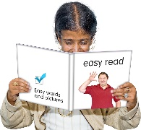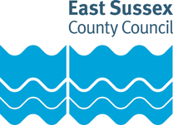



# What do you think about our plans for sexual health services?

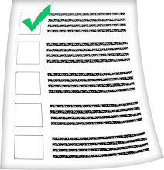

The Council wants to know your views.

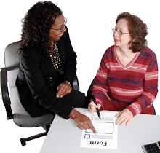The survey is not in Easy Read. You may want to ask for help to take part in the survey or tell us what you think. You could ask:

* A carer
* A support worker
* A friend
* A member of your family



You can find the survey here:

[www.eastsussex.gov.uk/sexualhealth](http://www.eastsussex.gov.uk/sexualhealth)

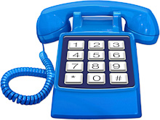

If you do not have anyone to help you, please call on **01273 336 036** between 9am and 12pm from Mon to Thurs and we will try to help.

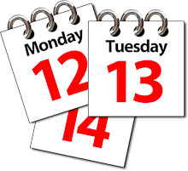

**The survey will close on 22 July 2021.**