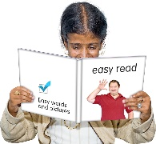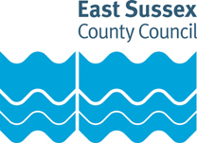



# We are asking people what they think about our plans for our specialist sexual health services.

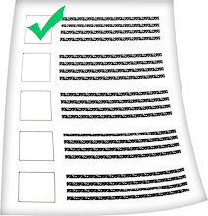

We (the Council) are giving people the chance to share their views.

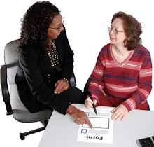The information is not in Easy Read so you may want to ask for help to take part in the survey or send us your comments. You could ask:

* A carer
* A support worker
* A friend
* A member of your family



You can find the survey here:

[www.eastsussex.gov.uk/sexualhealth](http://www.eastsussex.gov.uk/sexualhealth)



If you do not have anyone to help you, please call on **01273 3360 36** and we will try to help.

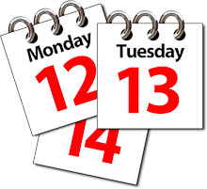

**The consultation will close on 22 July 2021.**